SPECCHIO

User Guide

Version: 3.0

Date: 13.06.2012

Status: Draft

Authors: P. Roberts (Intersect), A. Hueni & D. Kuekenbrink (Remote Sensing Laboratories, University of Zurich)

File: SPECCHIO\_UserGuide.docx

Pages: 159

Classification:

Distribution: SPECCHIO Users

::::RSL_logo_new.pdf

Table of Contents

Table of Contents 2

1 Introduction 6

1.1 Document scope 6

1.2 Intended audience 6

1.3 SPECCHIO ownership and access 6

1.4 Further information 6

1.5 Copyright and licensing 7

2 Glossary 8

3 Installation and Configuration 11

3.1 Before you install 11

3.2 The SPECCHIO Application Bundle 11

3.3 Microsoft Windows Installation 12

3.4 UNIX Installation 12

3.5 Apple Macintosh Installation 13

4 SPECCHIO Concepts 14

4.1 User Accounts 15

4.2 Administrator Access 18

4.3 Campaigns 18

4.4 Operational Dataflow 18

4.5 Research Groups and Accessing SPECCHIO Campaigns 19

4.6 Time Data 19

4.7 Data Links 20

4.8 Manufacturers, Sensors, Instruments and Calibrations 20

4.9 Supported Input Spectrum File Formats 22

4.9.1 ASD Binary Files 22

4.9.1 ASD Indico Version 7 Files 22

4.9.2 GER Signature Files 22

4.9.3 MFR OUT Files 23

4.9.4 SVC HR-1024 Files 24

4.9.5 Apogee Files 26

4.9.6 ENVI Spectral Library Files 27

4.9.7 Ocean Optics SpectraSuite Data Files 27

4.9.8 HDF5 Files containing FGI goniometer measurements 28

4.9.9 UniSpec Single Channel 28

4.9.10 UniSpec Double Channel SPU 28

4.9.11 SPECPR 29

4.9.12 Modtran Albedo File 29

4.9.13 Excel files 29

4.9.14 TXT Space Formatted Text Files 30

4.10 Supported Output Spectrum File Formats 31

4.11 Campaign-related Metadata 31

4.12 Spectrum-related Metadata 32

4.12.1 Campaign Details Group 32

4.12.2 Data Portal Group 33

4.12.3 Environmental Conditions Group 34

4.12.4 General Group 34

4.12.5 Generic Target Properties Group 35

4.12.6 Illumination Group 36

4.12.7 Instrument Group 36

4.12.8 Instrument Settings Group 37

4.12.9 Instrumentation Group 38

4.12.10 Keywords Group 39

4.12.11 Location Group 39

4.12.12 Names Group 40

4.12.13 Optics Group 40

4.12.14 PDFs Group 40

4.12.15 Personnel Group 40

4.12.16 Pictures Group 41

4.12.17 Processing Group 41

4.12.18 Sampling Geometry Group 43

4.12.19 Scientific References Group 44

4.12.20 Soil Parameters Group 44

4.12.21 Vegetation Biophysical Variables 46

4.13 Spaces, Space Factory and Data Processing using the Space Network 47

5 Design of Sampling Experiments and Data Structuring 49

5.1 Example Structure 1 49

5.2 Example for Reference and Target Spectra 50

6 SPECCHIO Basic Operation 52

6.1 Mac Operation 52

6.2 Unix Operation 52

6.3 Main Window 53

6.4 Logging In and Connecting to a Database 53

6.5 Logging Out 54

6.6 Changing your User Details 54

6.7 Browsing the Hierarchy Tree 55

6.8 SQL Matching Strings 56

6.9 Entering Dates and Times 56

6.10 Loading Data into SPECCHIO 57

6.11 Creating a new Campaign 58

6.12 Loading Campaign Spectrum Data 59

6.13 Loading Additional Spectral Data 60

6.13.1 Uploading Addition Spectral Data from the Same Computer 60

6.13.2 Uploading Additional Spectral Data from a Second Computer 61

6.13.3 Uploading Additional Spectral Data to a New Data Hierarchy 62

6.14 UTC Time Correction 63

6.15 Managing Target-Reference Links 64

6.15.1 Viewing or deleting existing Target-Reference links 64

6.15.2 Deleting Existing Target-Reference Links 67

6.15.3 Adding new Target-Reference links 68

6.16 Displaying and Editing Metadata 70

6.16.1 Displaying and Editing Campaign Metadata 72

6.16.2 Displaying and Editing Spectrum Metadata 72

6.17 Uploading Metadata from Excel files 77

6.18 Calculation of Sun Angles 85

6.19 Calculation of Goniometer Angles 86

7 Data Query and Output 89

7.1 The Spectrum Browser 89

7.2 Query Builder 90

7.3 Show Report 92

7.4 File Export 95

7.4.1 CSV Spectrum Export Format 97

7.5 Process 98

7.6 Spectral plot 98

7.7 Refl.calc 98

7.8 Publish Collection 98

8 Help Functions 99

8.1 List available Metadata Elements 99

8.2 About 99

9 Publishing Data to ANDS 100

10 Interactive Processing using Space Networks 103

10.1 Graphical Representations of Spaces and Modules 104

10.2 Adding Modules and linking with Spaces 105

10.3 Configuration of Modules 106

10.4 Processing Module Descriptions 106

10.4.1 Radiance to Reflectance Transformation 106

10.4.2 Reference Panel Correction Factors 106

10.4.3 Correct for Reference Panel Non-Idealness 107

10.4.4 Delta 108

10.4.5 Waveband Filter 109

10.4.6 Broadband and Narrowband Filters 110

10.5 Visualisation Modules 111

10.5.1 Spectral Line Plot 112

10.5.2 Spectral Scatter Plot 112

10.5.3 Gonio Sampling Points Plot 113

10.5.4 Gonio Hemisphere Explorer 113

10.5.5 Time Line Plot 115

10.5.6 Time Line Explorer 116

10.6 File Export Module 117

11 Data Administration 118

11.1 Removing data 118

11.2 Campaign Export 119

11.3 Campaign Import 119

11.4 Definition of new Sensors 120

11.5 Instrument Administration 122

11.5.1 Instrument Calibrations 125

11.6 Reference Panel Administration 126

11.6.1 Reference Panel Calibrations 127

12 Matlab Integration 130

13 Tutorial 132

13.1 SPECCHIO Online Test Database 132

13.1.1 Creating Campaigns on the Test Database 133

13.1.2 Downloading Test Data Sets 133

13.2 Part 1: Loading, Editing and Retrieving Data 134

13.2.1 Examine the Folder and File Structure 134

13.2.2 Creating a new Campaign and Loading the Spectra 134

13.2.3 Get to Know Your Data 135

13.2.4 Exporting Data to CSV 136

13.2.5 Exporting Data to ENVI Spectral Libraries 138

13.2.6 Editing Metadata 139

13.3 Part 2: GER Files 143

13.4 Part 3: Directional Data 144

13.5 Part 4: Data Querying, Processing and Exploration 147

13.5.1 Converting Radiances to Reflectances 147

13.5.2 Data Queries 150

14 References 152

15 Document History 154

Appendix A: Regular Expressions Tutorial 155

Appendix B: Predefined Manufacturer Table 157

Appendix C: Predefined Sensor Table 158

# Introduction

SPECCHIO is a spectral database combined with user-friendly interface software designed to store spectral data acquired by spectroradiometers and associated metadata.

SPECCHIO was first developed at the Remote Sensing Labs at the Geography Department, University of Zurich to support long term usability and data sharing between researchers. It was then further enhanced through a project run by the University of Wollongong in 2012/2013. This project was supported by the Australian National Data Service (ANDS). ANDS is supported by the Australian Government through the National Collaborative Research Infrastructure Strategy Program and the Education Investment Fund (EIF) Super Science Initiative.

SPECCHIO is an Italian word meaning “mirror” or “looking glass”. It can also be used to refer to a table of data or a scoreboard.

%%% Elaine: Scope of doc? **Target UOW, but release the .DOC to Andy et al to change those parts.**

## Document scope

SPECCHIO uses a Client-Server architecture. This User Guide covers operation of the Client component of SPECCHIO only. For information on the SPECCHIO Server and its administration see %%%

## Intended audience

This document assumes that readers are familiar with...

* remote sensing and the disciplines and processes related to it.
* the general operation of their own computer.
* the general concept of a client-server architecture.

## SPECCHIO ownership and access

%%% INSERT ACCESS RIGHTS INFO ONCE RECEIVED FROM UOW

## Further information

Please refer to the following sources for more information.

|  |  |
| --- | --- |
| **Location** | **For...** |
| Chapter | List of academic articles related to SPECCHIO and its use |
| SPECCHIO GitHub at <https://github.com/IntersectAustralia/dc10>  %%% This location is currently protected and not accessible. Nick suggests this may not be the final location. | Installation kits for University of Wollongong version of SPECCHIO Client and documentation for that version  SPECCHIO Server Installation kit and instructions |
| SPECCHIO web site [www.specchio.ch](http://www.specchio.ch) | General information about SPECCHIO.  Some of this information may be related to other non-UOW versions of SPECCHIO. |

%%% Will there also be some info on the UOW website somewhere too?

## Copyright and licensing

SPECCHIO is released under a Creative Commons licence. %%% which one? Therefore its source is readily available for inspection and development. It can be found at %%%where?.

%%%% Elaine will ask which CC licence version.

# Glossary

The explanations of words and terms in this glossary include both those terms which may not be familiar to some readers and those which have a specific meaning in the context of this SPECCHIO or this document.

|  |  |
| --- | --- |
| **ANDS** | Australian National Data Service  This body hosts the Research Data Australia (RDA) service. SPECCHIO supports publishing research data to this service. See <http://www.ands.org.au/> and Chapter . |
| **Calibration** | The process of linking on instrument's response to a defined physical input, for example, assigning the correct wavelengths to a band, or factors that describe the relationship between radiance and recorded digital numbers. |
| **Campaign** | Refers to an activity during which spectral samples were acquired. A campaign is defined in a contextual sense. It is not restricted by any temporal or spatial properties. |
| **Client-server** | A commonly used networked computer architecture which involves a “server”, which hosts a main computing facility such as a database or computation facility, and a number of “clients”, which access the server facility using a network, such as an intranet or the internet. SPECCHIO uses this architecture. |
| **FOR Codes** | Field of Research Codes  This coding system was designed and developed by the Australian Research Council (<http://www.arc.gov.au/>) to categorise areas of research. FOR Codes are widely used across Australian research bodies, such as universities and the CSIRO, and government departments, such as the Bureau of Census and Statistics. Lists of FOR Codes can be found at sites such as <http://www.abs.gov.au/ausstats/abs@.nsf/Products/6BB427AB9696C225CA2574180004463E?opendocument>. |
| **HTTP/HTTPS** | Hypertext Transfer Protocol  HTTP is a very widely used network protocol which is also used by SPECCHIO Clients to communicate with the SPECCHIO Server. HTTPS is the secure version of this protocol. |
| **Instrument** | In the context of this document, an individual spectroradiometric instrument. Such an instrument will have a serial number and an owner. |
| **Instrument Type** | A model or type of spectroradiometric instrument. It will be described by a model number and manufacturer. In this document and the SPECCHIO client, this term is used interchangeably with the terms “Instrument Model”, “Sensor” and “Sensor Type”. |
| **MySQL** | The world’s most widely used relational database management system (RDMS) (according to Wikipedia). It is the RDMS used by the SPECCHIO Server. (See SQL.) |
| **RDA** | Research Data Australia  Australian National Data Service’s (ANDS) flagship service, which provides a comprehensive window into the Australian Research Data Commons. It is an Internet-based discovery service designed to provide rich connections between data, projects, researchers and institutions, and promote visibility of Australian research data collections in search engines. See <http://researchdata.ands.org.au/>. |
| **Reference Panel** | A calibrated reflective panel with known reflectance properties. It is usually white, but may be grey or even close to black. A Reference Panel can be measured under the same lighting conditions as a target sample in order to get an approximation of the spectrum of the solar irradiance or to collect data for the conversion of a target radiance to reflectance factors. |
| **Reference Spectrum** | A spectrum acquired over a Reference Panel. |
| **Regular Expression** | In computing, a regular expression (often abbreviated “regex” or “regexp”) is a sequence of text characters, some of which are understood to be metacharacters with symbolic meaning, and some of which have their literal meaning, that together can be used by a regular expression processor to identify textual material of a given pattern. See <http://en.wikipedia.org/wiki/Regular_expression> and <http://docs.oracle.com/javase/tutorial/essential/regex/index.html> for more information. |
| **Sample** | A Sample taken from a Target and measured, often at some later time, under controlled conditions. A sample will generally have a collection date/time and a measurement date/time, which will be different. |
| **Sensor** | See Instrument Type. |
| **Spectralon** | A particular brand of reflective reference panel, produced by LabSphere. Spectralon panels are available in various configurations, ranging from pure white to greyish and almost black. See Reference Panel. |
| **SQL** | Structured Query Language (sometimes pronounced “sequel”)  A [special-purpose programming language](http://en.wikipedia.org/wiki/Special-purpose_programming_language) designed for managing data held in a [relational database management system](http://en.wikipedia.org/wiki/Relational_database_management_system) (RDBMS). |
| **Target Spectrum** | Spectrum acquired by measuring the target, where the target is the object of interest. |
| **TCP/IP** | [Transmission Control Protocol](http://en.wikipedia.org/wiki/Transmission_Control_Protocol)/[Internet Protocol](http://en.wikipedia.org/wiki/Internet_Protocol)  The common designator to refer to the protocols used for internet communication. |
| **White Reference Spectrum** | A spectrum acquired over a reference panel that has a reflectance of close to 100%. |

# Installation and Configuration

%%% Revamp this chapter to complement final configuration of release doc.

## Before you install

SPECCHIO requires that Java Runtime Environment (JRE) version 1.6 or higher is already installed on your computer before installing SPECCHIO itself. %%% Confirm required Java version just prior to release.

To check the Java version on your system open a command window under Windows, or a terminal for Macintosh or UNIX systems, and type:

java -version

The output will be similar to:

java version "1.7.0\_17"

Java(TM) SE Runtime Environment (build 1.7.0\_17-b02)

Java HotSpot(TM) Client VM (build 23.7-b01, mixed mode, sharing)

If you do not have Java installed, or the version number is less than 1.6, you should install an appropriate version of the Java Runtime Environment (JRE) from the internet at <http://www.oracle.com/technetwork/java/javase/downloads/index.html>.

## The SPECCHIO Application Bundle

The SPECCHIO application plus the libraries it uses are supplied as an application bundle in ZIP file format. The installation bundle is usable on Windows, Mac and Unix systems.

%%% The following was not consistent with my experience of installation. Is a doc change needed here, or will the production system actually match this process? Re-evaluate when the installation process is settled.

The files contained in the bundle are…

|  |  |
| --- | --- |
| Category | Purpose |
| Application Files | The SPECCHIO application is contained in a Java archive file: SPECCHIO\_App\_V<x.xx>.jar. <x.xx> stands for the version tag, e.g. 1.0c, i.e. the jar file would be named SPECCHIO\_App\_V1.0c.jar.  The file db\_config.txt contains database connection configurations. |
| Java Library Extensions | The following files are needed to run SPECCHIO:  jcommon-1.0.5.jar  jfreechart-1.0.2.jar  jgraph.jar  mysql-connector-java-3.1.13-bin.jar  qcchart3djava.jar  jhdf.jar  jhdf5.jar  jhdf5obj.jar  jhdfobj.jar  jsch-0.1.44.jar  ganymed-ssh2-build251beta1.jar  jcalendar.jar  The extensions are supplied in the same folder as the SPECCHIO application file. |
| Matlab Integration Files | The following files are supplied to simplify the access of SPECCHIO databases from Matlab:  get\_spectral\_data\_from\_specchio.m  getquery.fig  getquery.m  %%% Andy says these are not up to date for the new UOW version. |

## Microsoft Windows Installation

%%% What permissions are required to install, and which users can use it afterwards?

To install SPECCHIO on Microsoft Windows, unzip the entire contents of the ZIP file into a new directory on your computer. It is recommended to create a new folder in C:\Program Files, for example C:\Program Files\SPECCHIO V3.

To launch the SPECCHIO Application double click the SPECCHIO\_App\_V<x.xx>.jar icon or file.

You may wish to create a shortcut on your desktop. The process varies depending on your Windows version, but will be similar to the following.

* Right click on your desktop and select New and Shortcut from the menu which appears.
* Follow the prompts, entering C:\Program Files\SPECCHIO V3\SPECCHIO\_App\_V<x.xx>.jar as the location of the item, and the description of your choice.
* Move the new shortcut to your desired location, for example, your task bar.

## UNIX Installation

This installation procedure installs the software in a user directory. This implies that only users with access to this user account can run the software. To install so that all users can run SPECCHIO, you need administrator rights on the computer or need to have it installed by the system administrator. Alternatively, each user who wants to run SPECCHIO can install it separately themselves.

Copy the entire contents of the ZIP file to a new directory on your user account.

The preferred way to launch the software is to double-click the SPECCHIO\_App\_V<x.xx>.jar file. However this may not work on all UNIX systems. If it does not work, open a shell (terminal), navigate to the directory containing the applications and type...

java –jar SPECCHIO\_App\_V<x.xx>.jar

For remote execution when having installed the application in your home drive which is mapped on to the servers, type...

ssh –X <server\_name> java -jar <path>/ SPECCHIO\_App\_V<x.xx>.jar

E.g. to use terra as server with version 1.0c of the SPECCHIO application:

ssh –X terra java -jar /home/rsl1/ahueni/SPECCHIO/SPECCHIO\_App\_V1.0c.jar

You must be using XWindows on your local computer for the above ssh command to work.

## Apple Macintosh Installation

%%% Is there a file access permission issue here too?

Double click the ZIP file. This will create a new folder and copy the entire ZIP file contents into it.

Copy the unzipped folder into the Applications (or some other directory of your choice).

Double click the SPECCHIO\_App\_V<x.xx>.jar file to run SPECCHIO.

# SPECCHIO Concepts

SPECCHIO is a distributed client-server system. The client, which operates on the user’s computer, has been written using Java. No SPECCHIO data is stored locally on the client computer. The server uses MySQL to manage its database. Communication between the client and the server is done over an intranet or the internet using the HTTPS protocol.

This system architecture allows for multiple servers, each with their own database, but each site will generally access only a single server.

**User A’s Computer**

**Web Application Server**

**Intranet or Internet**

SPECCHIO Web Application  
Server

SPECCHIO User Application

User A’s Campaign Data Directories

**SPECCHIO MySQL Database**

Data uploaded for User A’s Campaign data

**User B’s Computer**

SPECCHIO User Application

User B’s Campaign Data Directories

Data uploaded for User B’s Campaign data

Campaign data kept in both locations after uploading

Figure : The SPECCHIO distributed processing model

Each User identifies the database they are accessing using the following three fields.

**Web Application Server**  A URL string which indicates the computer on which the SPECCHIO database server is running.

**Port** The TCP/IP port number on which the Web Application Server must be accessed.

**Application Path** The path of the application on the Web Application Server.

You should check the SPECCHIO release notes for the version of SPECCHIO which you have installed, or you should contact your site’s database administrator to find out the values of these three fields for your site.

## User Accounts

In order to log in to a SPECCHIO server database, you will need a User Name and Password. These are assigned automatically, so anyone who has downloaded the SPECCHIO Application and knows the URL, Port Number and Path for a SPECCHIO database server can create a User Name and Password for that database.

All data that you upload to SPECCHIO will be tagged with your User Name.

Notes User Accounts are not intended to be secure. It is assumed that SPECCHIO will be run from computers in safe environments.

There is nothing preventing anyone who knows the Web Application Server’s URL, Port and Path from creating a User Account and accessing all of the data in that Server’s database. However, they will not be able to remove or change any data except the data which they upload.

User Names and Passwords are stored in plain text in the db-config.txt file to support convenient logging in. Therefore, anyone with access to your computer can easily log in to SPECCHIO as you.

To create a User account…

|  |
| --- |
| Start the SPECCHIO Application on your local computer. (See the instructions specific to your computer – sections , or for Microsoft, Unix or Windows.)  Select the Database and Create new user account menu items to display the following dialog box.    Figure : Create User Account dialog  Enter the Web Application Server, Port and Application Path strings that have been supplied to you by your database administrator.  Click on Connect .  The remaining fields on the screen will become active. If ANDS Publishing is supported for your database, ANDS related fields will appear in the dialog box as shown below. See Chapter for more information about the ANDS service and its operation.    Figure : Create User Account dialog for ANDS users  Select your Title and enter your First and Last Names. These will be used to identify the data which you upload to SPECCHIO to other SPECCHIO users.  Select the name of your Institute from the dropdown list.  If the name of your Institute is not present in the list, click on  Add new institute…  This will cause the following dialog box to appear.    Figure : Create new institute dialog  Fill out all the details of your Institute. After checking it is complete and correct, click Create . This will create an entry for your institute on the SPECCHIO server.  Enter your email address and a URL which other SPECCHIO users can use to contact you and access information about you. The URL is an optional field.  If your server’s database supports ANDS Publishing and you already have an ANDS Party Identifier, set the checkbox and enter your ANDS Party Identifier in the relevant field. Take care when entering this field. You cannot change it once entered. If you do not have an ANDS Party Identifier, leave the checkbox unchecked and SPECCHIO will create one for you.  Click on  Create . The dialog box will close. |

Warning Take care to enter the details for a new Institute correctly. There is no function to change an Institute record nor to remove an Institute record from the SPECCHIO server. If there is a need to change or remove an Institute record, you will need to request your database administrator to do it for you. It is also possible to create a totally blank institute record.

The process above will generate the following additional information and store it in the server database’s User list along with the information that was entered.

**User Name** A short unique name constructed from your own name which will be used to identify you when you log into the SPECCHIO server.

**Password** A password that is required when you log into the SPECCHIO server.

**ANDS Party Identifier** If your database supports ANDS Publishing, this string is generated. It identifies data which you Publish to ANDS. To view your ANDS Party Identifier, follow the procedure shown below for editing your User Account details.

A line is also added to the db-config.txt file on your computer. This line holds sufficient information for you to log into your database. If you edit this file, you can add other known accounts to it. The account which appears as the first non-comment line is the default account in the login dialog. Follow the instructions in the comment lines in the file if you wish to make manual changes.

When you are logged on to SPECCHIO, you can edit the User Account information which is stored in the SPECCHIO database.

Note You cannot change the short username or password which SPECCHIO assigned to you.

To edit your User Account information...

|  |
| --- |
| Select the Database and Edit user information menu items from the Main Window. The following dialog box is displayed.  %%% Confirm what user data should be in this screen dump.  Figure : Edit User Account dialog  Update the details as you require and click on  Update . All fields can be changed on this dialog box except the ANDS Party Identifier. |

## Administrator Access

Certain SPECCHIO functions, such as uploading Instrument definitions and Calibrations, require administrator permission. For normal Users, these menu operations are greyed out.

When the SPECCHIO database is created, it has an Administrator account defined. The User Name and Password for this account are not generally advertised. See your SPECCHIO Administrator if you require access to these administration functions.

## 

SPECCHIO organises the Spectra for each new sampling experiment into Campaigns. The spectral data in each Campaign can be operated on simultaneously.

On your computer, the Spectral data files for a Campaign must be placed into a sub-directory structure which organises the Spectra according to their context or sampling design. SPECCHIO does not impose any restrictions on the complexity of campaign and sub-directory hierarchies. (For more information see Chapter .) This sub-directory structure will be replicated in the SPECCHIO database when the Campaign data are uploaded.

New data can be added to ongoing Campaigns by first storing that data in the already existing Campaign sub-directory data structure on your computer’s disk and then invoking the SPECCHIO loading operation for the entire Campaign again. Only new Spectra discovered in the sub-directory hierarchy will be added to the database. Existing data will not be duplicated.

## Operational Dataflow

A typical dataflow is illustrated in Figure 6. A spectroradiometer is used to capture the radiance of field objects. Optionally a GPS connected to the field laptop (where supported by the capturing software) records the spatial position of the field object. This is a recommended setup as the spatial position can later be automatically loaded into the database. Spectra and metadata are saved on the field laptop.

These files are transferred to a laboratory computer where they are read by the SPECCHIO application and stored in the relevant tables in the spectral database.



Figure 6: Dataflow and involved hardware

Typically, the operations carried out for each campaign are:

* Creation of a new Campaign in SPECCHIO and linking it to the sub-directory of spectra on your computer’s disk
* Uploading of spectra data from your local disk to the SPECCHIO database
* Entering of metadata into the SPECCHIO database for the uploaded spectra
* Repeated data query, visualisation, processing and file output based on the uploaded data

## Research Groups and Accessing SPECCHIO Campaigns

When you upload data for a Campaign to SPECCHIO, all Users of your SPECCHIO database can access your Campaign. However, only you can modify or delete it unless you specifically allow others to have write access to it. This access is controlled by setting a Research Group of Users for each Campaign that you upload. Just as you can add other Users to the Campaign’s Research Group, so you can remove them too.

The membership of each Research Group is stored as metadata for the Campaign. Each Research Group applies only to one Campaign. (See for more information about metadata and for instructions for updating it.)

When you add another SPECCHIO User to the Research Group for your Campaign, that User gets all the rights that you have for that Campaign. That is, they can modify the data, add to it or remove it. They can also change the membership of the Research Group. It is not possible to remove the original uploader of the Campaign from the list of Users in the Research group.

## Time Data

SPECCHIO expects acquisition times for Spectra acquisition to be in UTC (Coordinated Universal Time). For practical purposes UTC is considered equivalent to GMT. However, the term UTC is recommended for technical contexts (Astronomical Applications Department of the U.S. Naval Observatory, 2003).

The above implies that all computers capturing data for use in SPECCHIO should have their time zone set to GMT and their system time adjusted to UTC. However, this is not usual, so the Spectrum acquisition date/time can be modified in the database if a time different from UTC was used.

Other times, such as spectra upload times and calibration times, are usually stored in local time.

## Data Links

For some calculations on Spectra, such as the conversion of a Radiance Spectrum to a Reflectance Factor Spectrum, SPECCHIO needs to know the related White Reference Spectrum for each Target Spectrum. Data links are used to define these relationships.

A data link is a reference from a Target Spectrum to its related Reference Spectrum. There are two types of calculation for which SPECCHIO uses Reference Spectra. The type is selected automatically based on Target Spectrum’s Metadata Attributes.

White Reference The linked Spectrum is the Radiance Spectrum of a white Reference Panel, such as a Spectralon panel, in the same illumination conditions. If a Target Spectrum has its Measurement Unit Metadata Attribute set to Radiance, the link will be created as a White Reference link.

Cosine The linked Spectrum is an Irradiance Spectrum, usually acquired with a cosine receptor. If a Target Spectrum has its Measurement Unit Metadata Attribute set to Radiance, then a Cosine link will be created.

In some cases data links are set up automatically during Campaign data loading. For example, GER signature files include the Spectra of both target and white reference.

Note Data links do not make sense for Target Spectra with Measurement Units other than Radiance and for Reference Spectra other than Radiance or Irradiance. In other cases the results are undefined and they should not be set.

Warning The Data Link type is set up when the link is created. If the Spectrum measurement type is changed after the Data Links are set up, then the Data Links will not be correct and incorrect calculations could result. The Data Links should be deleted and set up again in order for calculations to be correct.

## Manufacturers, Sensors, Instruments and Calibrations

SPECCHIO defines Manufacturers, Sensors, Instruments and Calibrations, which each have their own table in the database.

Manufacturer A manufacturer of spectroradiometric instruments.

The list of possible Manufacturers is a fixed table in SPECCHIO. Users cannot add to it, change it or even view it. If you require a new Manufacturer to be added, you must contact your System Administrator. The table as released with this version of SPECCHIO can be found in of this document.

Each Manufacturer is assigned an integer Manufacturer ID.

Sensor A description of a physical setup of a sensor or a model of a spectroradiometric instrument. A sensor is usually identified by a sensor type designator (also referred to as a “instrument type” or “instrument model”) which is generally defined by the manufacturer.

Each sensor has a fixed number of bands, average wavelengths and FWHM (Full Width at Half Maximum) per channel, and a sensor type number (usually a numeric code given by the manufacturer). Each Sensor Type is defined only once in the database. As released, SPECCHIO has a standard set of Sensors already defined in its database. The table as released with this version of SPECCHIO can be found in of this document. However, new Sensors can be added to this list.

Each Sensor is assigned a unique integer Sensor ID by SPECCHIO.

Instrument An instance of a certain Sensor Type. There can be several different Instruments that are all of one Sensor Type. Each Instrument has a defined owner. Each Instrument record in the Instrument Table refers to its related entry in the Sensor table so that its standard sensor technical details can be accessed.

Each Instrument is assigned a unique integer Instrument Number.

Calibration Instruments optionally have a history of Calibrations. There are generally multiple Calibrations in that history, each Calibration being identified by either a date, and/or a Calibration Number which is a sequence number incremented each time the Instrument is sent for calibration. Calibration Numbers are unique for an Instrument. An Instrument Calibration defines an updated set of average wavelengths per band. When a Calibration is available, its information overrides the information in the Sensor record for the Instrument.

Example

**Calibration 1**

**Calibration 2**

**Instrument “Joe’s GER 3700”**

Instrument Number,

Name,

Owning Institute,  
Serial Number,  
Sensor ID,  
Picture

**Sensor “GER 3700”**

Sensor ID,  
Name,

Description,

Manufacturer ID,

Type No,

No of Bands,

Wavelength at each band

**Calibration 3**

Date,

Calibration Number, Comments,

Measured wavelength at each band

Calibration History

**Manufacturer “GER”**

Manufacturer ID,

Name,  
URL,

Short Name

Figure 7: Relationship between an Instrument, its Calibrations, Sensor and Manufacturer

Consider the example of Joe’s GER 3700 Instrument. This Instrument is an instance of a GER 3700 Sensor. The Sensor defines the average wavelength per band. In turn, the Sensor has a reference to the Manufacturer record for that Sensor’s Manufacturer.

As long as no Calibration for the Instrument has been entered into the database the channels defined in the Sensor will be used for plotting and exporting spectral data. When Calibrations are entered for Instruments, the measured wavelengths override the Sensor specifications. For further information please refer to (Hüni & Kneubühler, 2007).

Note Changing the number of stored spectral bands based on user configurations (such as is possible with the new SVC HR-1024) is not yet supported.

## Supported Input Spectrum File Formats

The following Spectrum file types are supported for loading into SPECCHIO Campaigns.

Each of the 14 file categories listed below is read by a separate file loader. Once the file type in a directory has been determined, the related file loader is activated and it reads all files in that directory. Therefore, you must not place the files of more than one file type in any input directory. Note that ASD Binary and ASD Indico 7 are different files types and cannot be mixed. Similarly, UniSpec and UniSpec SPU are different file types and cannot be mixed.

### ASD Binary Files

|  |  |
| --- | --- |
| Standard or Format Owner | Analytical Spectral Devices |
| Devices | ASD FieldSpecPro/FS3 spectroradiometers |
| Supported Formats | Old file format – ASD FS3, ASD FS PRO and ASD FSVNIR binary files |
| Comments | Indico Version 7 files are read by a different file reader and so cannot be mixed in the same directory as ASD binary files. |

Note ASD Calibration files (\*.raw) as stored on ASD laptops can also be loaded using SPECCHIO’s Spectrum load functions. This permits advanced users to explore the information content of the Calibrations they describe. (In the current release, loading \*.ILL, \*.REF files will cause an error.)

### ASD Indico Version 7 Files

|  |  |
| --- | --- |
| Standard or Format Owner | Analytical Spectral Devices |
| Devices | Indico Pro Software |
| Supported Formats | New file format – Indico Version 7 |
| Comments | ASD Binary files are read by a different file reader and so cannot be mixed in the same directory as Indico 7 format files. |

Note Loading of ASD Calibration files of this version using the Spectrum load functions has not been tested and may not work.

### GER Signature Files

|  |  |
| --- | --- |
| Standard or Format Owner | Spectra Vista Corporation |
| Devices | GER 3700 |
| Supported Formats | GER 3700 signature text files  (Files produced by other GER instruments are untested) |
| Comments | These files hold two spectral measurements at once: the Target Spectrum and the white Reference Spectrum. When read, two sub-directories named targets and references are created. The input file name is used as both the Target Spectrum’s name in the targets directory and the Reference Spectrum’s name in the references directory. A data link is created linking the Target Spectrum to the Reference Spectrum.    Figure : Automatically created hierarchies for GER files |

### MFR OUT Files

|  |  |
| --- | --- |
| Standard or Format Owner |  |
| Devices | MFR Sun Photometer |
| Supported Formats | MFR Photometer OUT files  MFR 7 |
| Comments | These files contain the capture time, the sun zenith angle and the spectral data for total, diffuse and direct irradiance. The sun angle and the direct irradiance data are discarded and only the total and diffuse spectra are stored.  When read, two sub-directories named total and diffuse are created. The input file name is used as both the name of the total Spectrum’s name in the total directory and the diffuse Spectrum’s name in the diffuse directory.    Figure : Automatically created total and diffuse hierarchies for MFR data |

### SVC HR-1024 Files

|  |  |
| --- | --- |
| Standard or Format Owner | Spectra Vista Corporation |
| Devices | SVC HR-1024 |
| Supported Formats | SVC HR-1024 files captured using a PDA  (Files acquired with a laptop are a different file format and are not recognised by the current file loading routine.) |
| Comments | The HR-1024 stores radiances of reflectance panel, target and the computed target reflectance.  During the data loading, SPECCHIO generates a hierarchical structure to store these files (see ), setting up data links that connect the reflectance to the target radiance and connecting the target radiance to the reference radiance. If the instrument was set to acquire radiances only (i.e. no white reference taken), then no special structure will be created.    Figure : Automatically generated hierarchy for HR-1024 files |

Note It is highly recommended to enter the instrument into the database and load a wavelengths calibration. The wavelengths between instruments differ quite a lot and the standard sensor definition pre-stored in SPECCHIO is only a poor representation of the real wavelengths.

Examples of two valid files are given below:

/\*\*\* Spectra Vista HR-1024 \*\*\*/

name= \My Documents\HR1024\_Data\HR.071710.0017.sig

instrument= HR: 0761008

integration= 2, 22, 20, 12, 50, 30

scan time=1, 1

optic= LENS14, LENS14

temp= 31.29, 0.41, -5.71, 31.53, 0.41, -5.77

battery= 7.7, 7.7

error= 0, 0

units= Radiance, Radiance

time= 7/18/10 9:47:09 AM, 7/18/10 9:47:31 AM

longitude= 11121.2335,W, 11121.2324,W

latitude= 5330.5955,N, 5330.5964,N

gpstime= 154336.000, 154356.000

comm=

memory slot= 0, 0

factors=

data=

344.2 56023.55 4381.86 7.82

345.8 54418.00 4186.00 7.69

347.3 56037.65 4365.57 7.79

348.9 59474.63 4568.75 7.68

…

/\*\*\* Spectra Vista SIG Data \*\*\*/

name= \My Documents\HR1024\_Data\HR.080910.0010.sig

instrument= HR: 0971030

integration= 20, 19.2, 30, 200, 60, 30

scan time= 3, 3

scan settings= AD, AI, AD, AI

external data set1= 8224, 8224, 8224, 8224, 8224, 8224, 8224, 8224, 8224, 8224, 8224, 8224, 8224, 8224, 8224, 8224

external data set2= 8224, 8224, 8224, 8224, 8224, 8224, 8224, 8224, 8224, 8224, 8224, 8224, 8224, 8224, 8224, 8224

external data dark= 0,0,0,0,0,0,0,0

external data mask= 0

optic= LENS 4, LENS 4

temp= 36.21, 9.08, -5.30, 36.45, 9.08, -5.37

battery= 7.5, 7.4

error= 0, 0

units= Radiance, Radiance

time= 8/9/10 10:49:47 AM, 8/9/10 10:52:36 AM

longitude= 01116.9879,E, 01116.9933,E

latitude= 4806.4988,N, 4806.5075,N

gpstime= 084748.000, 085034.000

comm=

memory slot= 0, 0

factors=

data=

350.6 127369.73 4658.17 3.66

352.1 130962.30 4815.39 3.68

353.7 132239.65 4916.35 3.72

355.3 128726.40 4836.48 3.76

356.8 124030.10 4677.99 3.77

358.4 123421.08 4677.13 3.79

359.9 130810.10 4966.42 3.80

…

### Apogee Files

|  |  |
| --- | --- |
| Standard or Format Owner | Apogee Instruments |
| Devices |  |
| Supported Formats | Apogee text files (restricted to one tested file format only – see example below) |
| Comments | The SPECCHIO Apogee file loader was added to SPECCHIO for one special case. That is the only Apogee file example that has been available for testing. Therefore, this file reader has not been well tested. It is provided “as is” and should be used with caution. |

Example of supported Apogee format text file

" File: cachimbalito2\p5\_2.TRM

" TRANS-> Wave:733.53nm Pix:1050 Val: 25.767 Time:23ms Avg:7 Sm:0 Sg:0 Tc:on Xt:1 Ch:1

400.00 1.102E+000

400.50 1.131E+000

401.00 1.205E+000

401.50 1.257E+000

402.00 1.260E+000

402.50 1.336E+000

403.00 1.341E+000

403.50 1.418E+000

404.00 1.451E+000

404.50 1.444E+000

405.00 1.488E+000

…

### ENVI Spectral Library Files

|  |  |
| --- | --- |
| Standard or Format Owner | Exelis Visual Information Systems |
| Devices | ENVI Software Library |
| Supported Formats | ENVI Spectral library files (SLB and SLI) |
| Comments | The import routine reads each .hdr file in the directory. Each .hdr file refers to either an .slb or .sli file for the body of the Spectrum data. That is, Spectrum data are stored in pairs of files. For example:  my\_spectra.hdr  my\_spectra.slb  or  my\_spectra.hdr  my\_spectra.sli  Both .slb and .sli files can be mixed in the one sub-directory.  Each file pair can contain more than one Spectrum. If present, Spectrum names are read from the header file and stored in the database in the Filename Metadata Attribute.  The File Type Metadata Attribute is set to ENVI Hdr.  The sensor definition (i.e. central wavelengths) is not read from the ENVI header file. You should define the correct Sensor using the Data Maintenance/Load sensor definition menu functions. See . |

### Ocean Optics SpectraSuite Data Files

|  |  |
| --- | --- |
| Standard or Format Owner | Ocean Optics |
| Devices | Ocean Optics Spectra Suite |
| Supported Formats | Ocean Optics Spectra Suite text files |
| Comments | The required file extension is .csv, although the files are not comma separated. |

Example file

SpectraSuite Data File

++++++++++++++++++++++++++++++++++++

Date: Wed Sep 15 19:14:15 CEST 2010

User: telerilevamento

Dark Spectrum Present: No

Reference Spectrum Present: No

Number of Sampled Component Spectra: 1

Spectrometers: HR4C1076

Integration Time (usec): 1000000 (HR4C1076)

Spectra Averaged: 10 (HR4C1076)

Boxcar Smoothing: 0 (HR4C1076)

Correct for Electrical Dark: No (HR4C1076)

Strobe/Lamp Enabled: No (HR4C1076)

Correct for Detector Non-linearity: No (HR4C1076)

Correct for Stray Light: No (HR4C1076)

Number of Pixels in Processed Spectrum: 3648

>>>>>Begin Processed Spectral Data<<<<<

Wavelength(nm); radiance(W\*m-2\*sr-1\*nm-1)

717.00000;0.17904775

717.02000;0.17878146

717.04000;0.17849983

717.06000;0.17820124

…

### HDF5 Files containing FGI goniometer measurements

|  |  |
| --- | --- |
| Standard or Format Owner | Finnish Geodetic Institute proprietary format |
| Devices | ASD in combination with the FIGIFIGO goniometer |
| Supported Formats | HDF5 files and XML files containing measurement data from FGI (Finish Geodetic Institute) goniometer measurements  The newest data structure version (with a coupled xml-file, containing all the metadata) is still experimental and is not yet not fully supported. |
| Comments | As there is more than one spectrum per file, each spectrum is saved separately. The name of each spectrum is constructed from the campaign name, the beam geometry (if HDRF or BRF), a data structure identifier and an auto numbered identifier (e.g. Snow7.HDRF.lib2.14). |

### UniSpec Single Channel

|  |  |
| --- | --- |
| Standard or Format Owner | PP Systems |
| Devices | UniSpec SC |
| Supported Formats | UniSpec Single Beam text files |
| Comments | Note that UniSpec and UniSpec SPU files are read by different file readers and so cannot be mixed in the one input Spectrum directory. |

### UniSpec Double Channel SPU

|  |  |
| --- | --- |
| Standard or Format Owner | PP Systems |
| Devices | UniSpec DC |
| Supported Formats | UniSpec Dual Beam text files |
| Comments | Note that UniSpec and UniSpec SPU files are read by different file readers and so cannot be mixed in the one input Spectrum directory. |

### SPECPR

|  |  |
| --- | --- |
| Standard or Format Owner | U.S. Geological Survey |
| Devices | USGS PRISM software |
| Supported Formats | SPECPR |
| Comments | Search for more information about PRISM software and the SPECPR file format from the U.S. Geological web site. |

### Modtran Albedo File

|  |  |
| --- | --- |
| Standard or Format Owner | Spectral Sciences Inc. and U.S. Air Force Research Laboratory |
| Devices | Modtran5 atmospheric radiative transfer model software |
| Supported Formats | Modtran Albedo files |
| Comments | More information can be found on the Modtran web site at <http://www.Modtran5.com>. |

### Excel files

|  |  |
| --- | --- |
| Standard or Format Owner | Microsoft Excel Spreadsheet files |
| Devices | N/A |
| Supported Formats | .XLS files only - .CSV, .XLSX etc are not supported  (.CSV files may be erroneously read as Ocean Optics SpectraSuite Data Files. See section .) |
| Comments | The first column of the Excel file must contain the Wavelength values in increasing order, with a heading in the first row.  Each of the second and subsequent columns contains the data for a single spectrum. The first row is the name of the spectrum. Subsequent rows in the column contain the spectrum values for the wavelengths specified in the first column.  The Spectra “file names” are constructed from the Excel file name and the spectrum name in the first row of the spreadsheet, separated with a “\_” character.  There can be no other data in the spreadsheet and the table of data must be rectangular with no gaps. Excel formatting is ignored.  Only the first datasheet is read. |

Example file



Figure : Top-left corner of example spreadsheet

### TXT Space Formatted Text Files

Note TXT files are deprecated, except in the case where Reference Panel calibrations are loaded as Spectra. Please use the Excel file format instead.

|  |  |
| --- | --- |
| Standard or Format Owner | N/A |
| Devices | IDL (Interactive Data Language) or ENVI text file output |
| Supported Formats | White space separated text files (as produced by IDL programs or ENVI when writing spectral data to text files) |
| Comments | TXT Spectrum files can be created or viewed with a text editor.  Each file can hold one or more Spectra.  Values in each line are white space separated. Tabs are OK.  Starting each line with whitespace is optional.  The first line of the file is a heading line. The first value on this heading line must be “wvl”. Its subsequent values are used as the names of the Spectra in SPECCHIO.  Spectrum names cannot include spaces.  All values on subsequent lines must be numeric. The first column is the wavelength in nanometres. Subsequent columns are the Spectrum values for each Spectrum at that wavelength. |

Example

The following TXT Spectrum file example defines two Spectra named mean\_090499 and mean\_020599. They each have observations at wavelengths from 350nm to 361nm.

wvl mean\_090499 mean\_020599

350.000 0.0246756 0.0229771

351.000 0.0246917 0.0228430

352.000 0.0247316 0.0229652

353.000 0.0248502 0.0231014

354.000 0.0250081 0.0232272

355.000 0.0250736 0.0232273

356.000 0.0249883 0.0233005

357.000 0.0249174 0.0233962

358.000 0.0250481 0.0234734

359.000 0.0252141 0.0235376

360.000 0.0253346 0.0236057

361.000 0.0253806 0.0236832

## Supported Output Spectrum File Formats

Spectrum data can be written in two data formats.

* CSV (Comma Separated Values) for subsequent import into various 3rd party applications like spreadsheets or statistical packages
* ENVI Spectral Library (SLB)

## Campaign-related Metadata

SPECCHIO allows Users to store metadata about the spectral data they have uploaded into SPECCHIO Campaigns. It is stored at two levels: Campaign-related Metadata and Spectrum-related Metadata.

The following metadata attributes can be set independently for each Campaign.

|  |  |
| --- | --- |
| Campaign name | The name under which the Campaign is stored in the SPECCHIO database |
| Description | A free format description of the Campaign |
| Investigator | The person in charge of this Campaign (i.e. the User defining and loading the campaign). This field is filled automatically and cannot be changed. |
| Path | The file system path pointing to the main directory from which this Campaign was uploaded.  Multiple Paths can be defined to support uploading of subsequent spectral data from multiple computers. This is intended to assist when further data is uploaded for this Campaign. |
| Research Group Members | A list of Users of this SPECCHIO database who have permission to modify this Campaign. Each of these Users must be registered with a SPECCHIO User account. |

## Spectrum-related Metadata

For more information on the metadata parameters supported by SPECCHIO please refer to (Hüni & Kneubühler, 2007).

When Spectra are uploaded to a Campaign, the SPECCHIO upload process identifies metadata found in the Spectrum files and copies it into SPECCHIO Spectrum Metadata fields for each Spectrum it uploads. Once uploaded, this Metadata can be viewed, edited, removed or added to.

Similar Metadata Attributes are grouped into named sections to facilitate management.

A few Metadata Attributes are permitted to take multiple values, such as Keywords or Processing Group Attributes. The SPECCHIO’s Metadata Editor does not support addition of more than a single value, but does support viewing them. Multiple values for non-image Attributes can be added from Excel files. (See section .) The Metadata Attribute tables below indicate those Attributes which are permitted to take multiple values. All others are limited to a single value.

Users cannot enter Metadata except into these already defined fields. If new Metadata Attributes are required, they can generally be defined easily. Contact your System Administrator with a detailed description of the Metadata field you need added and a specification for the data that it can contain.

Also see section for instructions for producing a machine readable list of Spectrum-related Metadata Attributes.

A number of the Metadata Attributes below take an element of a dropdown list for their value. The definition of these lists is either taken from user-managed SPECCHIO tables, such as Sensor or Instrument lists, or the definition is parameterised within the SPECCHIO database. Such parameterised lists can generally be changed. See your SPECCHIO system administrator if you require a change in any of these lists. The source of the dropdown list is explained for each relevant Metadata Attribute.

### Campaign Details Group

Some formats for Spectrum files contain Campaign-related information, particularly HDF formatted files. When spectrum files of these formats are loaded, the Campaign-related Metadata that they contain is loaded into these Attributes for each Spectrum. This allows you to review it and, if necessary, manually transfer it to the Campaign-related metadata fields described in section .

Note The fields in this Group can store different values for each Spectrum in a Campaign. It is not recommended to generally enter Campaign metadata into these Spectrum-related metadata fields. Instead, use the Campaign Metadata fields described in section .

|  |  |
| --- | --- |
| Agency Code | [Alpha string] Agency identifier of entity involved in the sample collection  Copied from the Agency Code field if it is set in the related input spectrum file when it is loaded. |
| Campaign Name | [Alpha string] Further specification of a particular campaign. Mainly used where a SPECCHIO campaign comprises several original sampling campaigns  Copied from the Campaign Name field if it is set in the related spectrum file (particularly HDF files) when it is loaded. |
| Project ID | [Alpha string] Any project identification applying to this campaign  Copied from the Project ID field if it is set in the related input spectrum file when it is loaded. |

### Data Portal Group

These Metadata Attributes relate to the Publishing of the Spectrum on the Australian National Data Service (ANDS). See Chapter for more information about the use of the Attributes in this Group.

|  |  |
| --- | --- |
| ANDS Collection Key  %%% Multiple values?? | [Alpha string] The ANDS Collection Keys under which this Spectrum has been Published.  This Metadata Attribute is only available when accessing a SPECCHIO Server which is ANDS-enabled.  This Attribute supports multiple values, with a new additional value written each time the Spectrum is part of a Collection which is Published to the ANDS.  It is possible to edit this Metadata Attribute, but it is strongly recommended not to. |
| Data Usage Policy | [Alpha string] String that defines the usage policy, for example “Please cite XXX et al” or “Inform the principal investigator”  The value of this Attribute is copied to the Published Collection when this spectrum is published to ANDS. |
| FOR Code | [Dropdown List] SPECCHIO supports selection from a small relevant subset of the Field of Research codes defined by the Australian Bureau of Statistics (Australian Research Council, 2008).  This Metadata Attribute is only available when accessing a SPECCHIO Server which is ANDS-enabled.  The value of this Attribute is copied to the Published Collection when this spectrum is published to ANDS. |
| Digital Object Identifier | [Alpha string] %%% How should this be described? Elaine  This Metadata Attribute is only available when accessing a SPECCHIO Server which is ANDS-enabled. %%% Is this true? Nick  The value of this Attribute is copied to the Published Collection when this spectrum is published to ANDS. |

### Environmental Conditions Group

These metadata describe the environmental conditions at the time the Spectrum measurements were taken.

|  |  |
| --- | --- |
| Air Pressure | [hPa] Ambient air pressure |
| Ambient Temperature | [Degrees Celsius] Ambient air temperature |
| Cloud Cover | [Percentage] Cloud cover as a percentage of the hemisphere |
| Relative Humidity | [Percentage] Relative air humidity |
| Sampling Environment | [Drop down list] Describes where data were spectrally acquired, i.e. Field or laboratory |
| Weather Conditions | [Alpha string] Description of weather conditions |
| Wind Direction | [Degrees] Direction where wind is coming from  Enter a bearing, that is, clockwise from North. |
| Wind Speed | [Metres/second] Speed of the wind |

### General Group

This metadata group collects together information about the Spectrum’s file.

|  |  |  |
| --- | --- | --- |
| Acquisition Time | [Date/Time 24h] UTC time when spectrum was measured  If the acquisition system’s time was not set to UTC, then adjust the time to UTC using the Special functions/Correct local time to UTC function described in section Uploading Additional Spectral Data to a New Data Hierarchy  There are often cases when a new set of Spectra is required to be uploaded, and this set does not relate to the existing Spectra in the Campaign. In this case, a new directory structure can be created at the top level of the Campaign.    Figure 27: Data Hierarchy of GER example after initial load  In the above example, there is one sub-folder of the GER Example. If the user has performed a second largely independent part of the experiment, its results may be loaded as a new top level folder in the Campaign.  Figure 28: Data Hierarchy of GER example after loading second part  To upload a new data hierarchy to an existing Campaign...   |  | | --- | | Prepare the second upload directory tree of Spectra on your computer and ensure it has a different name from the first one. It does not need to be in the same directory as the first one, owned by the same user as the first one, or even on the same computer as the first one.  Select Data Input and Load campaign data from the menu on the Main Window.    Figure 29: File upload dialog showing multiple paths  SPECCHIO stores every path name that has been used to upload data to this Campaign. However, in this box it will only display those paths which point to locations which exist on your computer.  From the drop down list for the Campaign name: control, select the name of the Campaign you are uploading to. The list of paths in the Path: box will change to be those defined for the selected Campaign.  Click on  New Path . A file selection dialog will open.  Navigate to the directory that created with the second data hierarchy and select it. This new path will be added to the list of paths in the Path: box. Be sure to select the right level directory.  Click  Load . The dialog box will close and progress messages will be shown in the left hand part of the Main Window indicating the total number of files that have been found, and the number of new Spectra which have been loaded. |   Warning If you select the directory above or below the one selected when the Campaign was first loaded, it will not be recognised as the same directory and will cause all of the existing data to be duplicated in your SPECCHIO Campaign.  UTC Time Correction. |
| File Comments | [Alpha string] Comments about spectrum  SPECCHIO sets any comments entered when capturing the spectrum into this field on spectrum upload. Only some input file formats support this feature, for example, ASD’s R3 capturing software. |
| File Format | [Selected from dropdown list] The format of the file from which this spectrum was uploaded.  This Attribute is always present and is generally set by SPECCHIO when the spectrum is read. If no data is available, it should be set to Nil.  Although this value can be changed, it is not advised.  (All Spectra are stored internally in the database in SPECCHIO’s internal Spectrum format.) |
| File Name | [alpha string] The name of the file from which this Spectrum was uploaded. In the case of input file formats which support multiple Spectra per file, such as XLS or TXT, the name of the Spectrum within the file is appended to this file name.  Although this value can be changed, it is not advised. Changing it may result in duplicate Spectra when a subsequent spectrum upload is performed for this Campaign. |
| File Version | [alpha string] Version of the input file format |
| Loading Time | [Date/Time 24h] The system time when the spectrum was loaded into database  This value is automatically set to the SPECCHIO server’s system time when the Spectrum is uploaded to SPECCHIO. Note that this may not be the same as the client’s system time.  Note that the Special functions/Correct local time to UTC function does not operate on this time. |
| Measurement Unit | [Selected from dropdown list] Describes the nature of the measurement - select from: Reflectance, Radiance, Transmission, Absorbance, DNs, Irradiance, Mueller10, Mueller20, Wavelength.  This Attribute is mandatory and cannot be deleted.  This Attribute is set automatically depending on the file format being read. However, for some formats it is not known and is therefore set to Nil. If it is not set, or is set incorrectly, plotting may not be correct. |
| Spectrum Number | [Integer] Some recording devices and file formats apply a number which is recorded in the Spectrum file. If a Spectrum is loaded from such a file format, the number will be placed into this Metadata field.  If the file does not define a Spectrum Number, this Metadata Attribute remains unset. (Some file loaders may generate an artificial number. This behaviour is deprecated and should not be relied upon.)  Note that this number is not the Spectrum ID and usually does not hold the same value as the Spectrum ID. The integer numbers which are displayed when Spectra are selected in the Query Builder or when a Spectrum is highlighted in the Hierarchy Viewer are Spectrum IDs.  Spectrum Numbers can be changed in the Metadata Editor (but probably shouldn’t be). Spectrum IDs cannot be changed. |

### Generic Target Properties Group

The Generic Target Properties group holds data related to a Target or Sample. It could apply to both soil and vegetation studies.

In this context, a Sample is regarded as a sample taken from the Target and measured. Multiple Samples can be taken from any Target and measured independently. They may have been taken from the Target in the field, or the Target may have been transported to a separate measuring facility and the Sample taken from the Target at that facility.

Typically, for each Campaign, there should be PDF uploaded to the Experimental Design Metadata item in the PDFs Metadata Group to explain the Target and Sample structure and the reasons for that structure.

|  |  |
| --- | --- |
| Sample Collection Date | [Date/Time 24h] Time when the original sample was collected in the field. This will generally be a different from the time it was measured. The time zone is not specified.  Note that the Special functions/Correct local time to UTC function does not operate on this time. |
| Sample Number | [alpha string] Identification of the sample as collected  This will not in general match the Spectrum Number or Spectrum ID. A Sample Number may be common to a variety of Spectra. |
| Site ID | [alpha string] Identification of the site from which the sample was collected |
| Target Description | [alpha string] Description of the Target |
| Target ID | [alpha string] Identification of the Target that was collected |

### Illumination Group

|  |  |
| --- | --- |
| Polarization | [alpha string] Description of illumination polarisation, typically “Horizontal” or “Vertical”, but other comments may be used as well. |
| Polarization Angle | [Degrees] Polarisation direction, usually measured clockwise from vertical. |

### Instrument Group

This Group of Attributes describes the specific **spectroradiographic** Instrument which was used to measure this Spectrum.

|  |  |
| --- | --- |
| Instrument | [Dropdown list] The name of the **specific** Instrument used to take these measurements  The drop down list is a list of Instruments which is created using the Data maintenance/Instrument admin. function.  This Attribute is always present and cannot be deleted. It should be set if known. If no data is available, set it to Nil.  This Attribute is generally set when Spectra are loaded, but should be checked to ensure that SPECCHIO has been determined correctly. |
| Sensor | [Dropdown list] The name of the Sensor used in the specific Instrument used to take these measurements  The drop down list is a list of Sensors which is created using the Data maintenance/Load sensor definition function.  If the Instrument Attribute above is set, this Sensor Attribute is ignored and the value stored in the Instrument record is used instead.  This Attribute is always present and cannot be deleted. If not required, it can be set to Nil.  This Attribute is generally set when Spectra are loaded, but should be checked to ensure that it has been set correctly. |
| Calibration Number | [integer] Calibration number of the most recent calibration for the Instrument at the time the measurements were taken  Generally, the Acquisition Time is compared against the Calibration Time in the Instrument Calibration List to select the most appropriate calibration to use. This value is used if there is insufficient information available to use the dates.  For some Spectrum file formats, this value is set automatically on Spectrum loading. Otherwise, it can be set manually. |
| Extended Instrument Name | [alpha string] Instrument name  Users do not have permission to add new Instruments to SPECCHIO’s Instrument table. When a Spectrum is being loaded and the Instrument it refers to is not already in SPECCHIO’s Instrument table, then SPECCHIO writes the name of the Instrument into this field and leaves the Instrument field above set to Nil. This provides the information needed for the user to resolve the Instrument information at after the Spectrum load is completed.  %%% Andy says in his review comments, “Unknown instruments are now automatically inserted into the database.” How can they be if the user doesn’t have administrator permission? |
| Instrument Serial Number | [alpha string] Serial number of the instrument  As for Extended Instrument Name above, enter this value if the specific Instrument is not shown in the drop down lists. |

### Instrument Settings Group

These attributes describe the settings of the Instrument at the time the Spectrum was acquired.

For some Instruments and file formats, the following Instrument settings are read from the Spectrum input file and set into the Spectrum metadata. For others, these values must be recorded manually.

|  |  |
| --- | --- |
| Automatic Dark Current Correction | [Alpha string] Indicates if Dark current has been compensated for by the instrument  If SPECCHIO loads this value from the input Spectrum file it will set one of the values “ON” or “OFF”. |
| Capturing Software Name | [Alpha string] Name of the instrument operation or data capture software |
| Capturing Software Version | [Alpha string] Version of the instrument operation or data capture software |
| Gain SWIR1 | [Integer] ASD specific gain |
| Gain SWIR2 | [Integer] ASD specific gain |
| Instrument Channel | [Alpha string] Channel designation for multi-channel instruments, e.g. irradiance and reflected radiance channels |
| Integration Time | [ms] Integration time |
| Number of Internal Scans | [Integer] Number of spectra recorded internally and averaged over by the instrument |
| Offset SWIR1 | [Integer] ASD specific offset |
| Offset SWIR2 | [Integer] ASD specific offset |
| Time since last DC | [Integer] Seconds since last dark current measurement  Not currently filled, even if it’s in the input file. |
| UniSpec Spectral Resampling | [Alpha string] UniSpec specific setting; indicates if the resampling was ON or OFF  If SPECCHIO loads this value from the input Spectrum file it will set one of the values “ON” or “OFF”. |

### Instrumentation Group

These attributes describe the Instrumentation used at the time the Spectrum was acquired.

For some file formats (particularly HDF files), the following Instrumentation settings are read from the Spectrum input file and set into the Spectrum metadata. For other formats, it must be set manually.

|  |  |
| --- | --- |
| Azimuth Sensor Type | [Alpha string] Sensor name used to measure the azimuth on a goniometric facility |
| Contact Probe | [Drop down list] Contact probe instrumentation name, usually includes a light source and provides optical input to the spectrometer. |
| Goniometer | [Drop down list] Goniometer name |
| Illumination Sources | [Drop down list] Illumination source name, e.g. Sun or Hg lamp |
| Integrating Sphere | [Drop down list] Integrating sphere name |
| Light Source Parameters | [Alpha string] Settings of artificial light source |
| Reference | [Drop down list] Selected from the list of References defined in the SPECCHIO database.  This Attribute is mandatory and cannot be deleted. If it is not relevant or no data is available, set it to Nil. |
| White Reference Panel Name | [Alpha string] Name of the white Reference Panel.  Users do not have permission to add to SPECCHIO’s Reference Panel table. When a Spectrum is being loaded and the Reference Panel it refers to is not in SPECCHIO’s Reference Panel table, then the name of the Reference Panel will be written into this field. This provides the information needed for the user to resolve the Reference Panel link information at after the Spectrum load is completed. |

### Keywords Group

Keywords can be used to search for particular spectra in the SPECCHIO’s Spectrum Query function.

|  |  |
| --- | --- |
| Keyword  Multiple permitted | [Alpha string] Freely chosen keyword that describes a spectrum or a spectral collection  Take care with spelling and avoid leading or trailing spaces to avoid confusion when searching. Keyword searching is not case sensitive. |

### Location Group

This group collects information about the capturing location. WGS84 (World Geodetic System of 1984) should be used as the reference Geoid for these measurements.

|  |  |
| --- | --- |
| Altitude | [Metres] Altitude of spatial position |
| Latitude | [Degrees] Latitude of spatial position  Northern hemisphere coordinates are positive, southern hemisphere coordinates are negative. Coordinates are entered as floating point numbers for degrees and fractions of degrees. |
| Longitude | [Degrees] Longitude of spatial position  Locations west of Greenwich are positive, east of Greenwich are negative. (That is, longitudes in Australia are negative.) Coordinates are entered as floating point numbers for degrees and fractions of degrees. |
| Location Name | [Alpha string] Usual name of the spatial position where the sampling took place |
| State | [alpha string] Identifier of the State in which the observations were made.  To avoid confusion in searching later, it is suggested to use the standard abbreviation for the state – for example, in Australia use NSW, Qld, Vic... Do not use periods, leading, embedded or trailing spaces in the field. Searching is not case sensitive. |

### Names Group

This group collects the possible names for the species or objects in the spectrum sample.

|  |  |
| --- | --- |
| Common | [alpha string] Common name given to target (applies particularly to plants) |
| ENVI Header | [alpha string] Name extracted from ENVI header  When ENVI Files are loaded (see ), the content of the Spectrum Names tag is copied here if it is set in the input file. |
| Latin | [alpha string] Latin (or scientific) name given to target |

### Optics Group

This group permits describing specific optics which are attached to the recording instrument.

|  |  |
| --- | --- |
| FOV | [Integer degrees] Field of view of the instrument used for the sampling. This may vary as a result of using a special foreoptic |
| Optics Name | [alpha string] Designator given to the optics attached to the instrument |

### PDFs Group

**SPECCHIO supports uploading of up to two PDF files for each Spectrum. To optimise storage in the database, select all spectra that a PDF file applies to and upload just once. Depending on your internet access speed, uploading large PDF files may be slow.**

|  |  |
| --- | --- |
| Experimental Design | [Attached PDF] Document describing the experimental design and the scientific reasons for doing so |
| Field Protocol | [Attached PDF] Copy of the field protocol filled in during data capture |

### Personnel Group

|  |  |
| --- | --- |
| Investigator  Multiple permitted | [Alpha string] Investigator’s name  It is not necessarily related to any SPECCHIO User’s name and is not checked against the list of Users’ names. Nor is this field checked against the Investigator field provided in the Campaign Metadata.  This Metadata attribute is supported to receive the Investigator name which is provided in some Spectrum file formats – for example, some HDF files.  Users are generally encouraged to rely on the Campaign Metadata (either the Investigator, Research Group Members or Description fields) for this function. |

### Pictures Group

**SPECCHIO supports uploading of up to four images for each Spectrum. To optimise storage in the database, select all spectra that an image applies to and upload it just once. Depending on your internet access speed, uploading large images may be slow.**

The supported uploadable image formats may vary between PC, Linux and Mac. JPEG is supported on all operating systems. GIF, PNG or TIFF may also be supported on some users’ computers. When uploaded, all image formats are converted and stored as JPEG images. **These images can be viewed directly on the Metadata Editor screen.**

Note Pictures should be reduced in size before loading to the database. An appropriate size is around 400 to 500 pixels width or height.

|  |  |
| --- | --- |
| Sampling Environment Picture  Multiple permitted | [Uploaded image file] Picture showing the general sampling environment in vicinity of the target |
| Sampling Setup Picture  Multiple permitted | [Uploaded image file] Picture showing the positions of sensor and illumination in relation to the target |
| Sky Picture  Multiple permitted | [Uploaded image file] Picture of the sky, ideally taken hemispherically |
| Target Picture  Multiple permitted | [Uploaded image file] Picture showing the target |

### Processing Group

These Attributes describe processing which has been performed on the Spectrum. These Attributes are added or set when that processing is done. This processing may be done by SPECCHIO, or it may be processing done by some other function connecting to the SPECCHIO database. This may be a Matlab program, a Java program, or a program written using any other tool or language.

While it is possible, generally these Attributes should not be edited manually.

|  |  |
| --- | --- |
| Data Ingestion Notes  Multiple permitted | [Alpha string] Notes produced by the data ingestion module during data loading into SPECCHIO  Multiple Data Ingestion Notes may be added to each spectrum. |
| DC Flag | [Integer] Designates this spectrum as dark current spectrum  The Metadata Attribute’s value should be either 0 indicating False, or 1 indicating True. If the Metadata Attribute does not exist, this implies False. |
| Garbage Flag | [Integer] Designates this spectrum is not intended for inclusion in the main experimental evaluation  The Metadata Attribute’s value should be either 0 indicating False, or 1 indicating True. If the Metadata Attribute does not exist, this implies False.  If you create a node named “Garbage”, all Spectra in the sub-tree below this node will have this flag set to 1 when they are loaded. The test for the node name is case sensitive.  This flag can be set to exclude specific spectra from processing. However, negative tests cannot be performed by the Query Builder, so this is intended for automated processing control. For manual management, Spectra which are not intended for processing should be placed in specific sub-directories.  There are currently no SPECCHIO processes which test this flag. It is generally intended for use by non-SPECCHIO processes, such as processes written using Matlab. |
| Processing Algorithm  Multiple permitted | [Alpha string] Description of processing algorithm applied to spectrum  Multiple Processing Algorithm fields may be added to each spectrum.  Each process which modifies a Spectrum should set an informative message into a new Metadata Attribute of this type for each Spectrum it modifies.  There are currently no SPECCHIO processes which set this flag. It is generally intended for use by non-SPECCHIO processes. |
| Processing Level | [Floating point] Numeric designator of a specific processing level.  This Metadata Attribute is provided to permit non-SPECCHIO programmatic processes to keep track of the level or amount of processing which they have performed on the related Spectrum.  SPECCHIO does not use this value. |
| Processing Module  Multiple permitted | [Alpha string] Name of processing module applied to spectrum  Multiple Processing Module fields may be added to each spectrum.  This Metadata Attribute is provided to permit non-SPECCHIO programmatic processes to keep track of the level or amount of processing which they have performed on the related Spectrum.  SPECCHIO does not use this value. |
| Source File  Multiple permitted | [Alpha string] Name of file that provided the original data  This applies if data is processed outside of SPECCHIO.  This Metadata Attribute is provided to permit non-SPECCHIO programmatic processes to keep track of the level or amount of processing which they have performed on the related Spectrum.  SPECCHIO does not use this value. |
| Time Shift  Multiple permitted | [Alpha string] This records the time shift processing that was applied to the spectrum using the Special functions/Correct local time to UTC operation. See Uploading Additional Spectral Data to a New Data Hierarchy  There are often cases when a new set of Spectra is required to be uploaded, and this set does not relate to the existing Spectra in the Campaign. In this case, a new directory structure can be created at the top level of the Campaign.    Figure 27: Data Hierarchy of GER example after initial load  In the above example, there is one sub-folder of the GER Example. If the user has performed a second largely independent part of the experiment, its results may be loaded as a new top level folder in the Campaign.  Figure 28: Data Hierarchy of GER example after loading second part  To upload a new data hierarchy to an existing Campaign...   |  | | --- | | Prepare the second upload directory tree of Spectra on your computer and ensure it has a different name from the first one. It does not need to be in the same directory as the first one, owned by the same user as the first one, or even on the same computer as the first one.  Select Data Input and Load campaign data from the menu on the Main Window.    Figure 29: File upload dialog showing multiple paths  SPECCHIO stores every path name that has been used to upload data to this Campaign. However, in this box it will only display those paths which point to locations which exist on your computer.  From the drop down list for the Campaign name: control, select the name of the Campaign you are uploading to. The list of paths in the Path: box will change to be those defined for the selected Campaign.  Click on  New Path . A file selection dialog will open.  Navigate to the directory that created with the second data hierarchy and select it. This new path will be added to the list of paths in the Path: box. Be sure to select the right level directory.  Click  Load . The dialog box will close and progress messages will be shown in the left hand part of the Main Window indicating the total number of files that have been found, and the number of new Spectra which have been loaded. |   Warning If you select the directory above or below the one selected when the Campaign was first loaded, it will not be recognised as the same directory and will cause all of the existing data to be duplicated in your SPECCHIO Campaign.  UTC Time Correction for more information on changing the times.  Multiple Time Shift fields will be added if the Time Shift function is applied multiple times. |

### Sampling Geometry Group

Numbers in this group can all be entered as floating point numbers.

|  |  |  |
| --- | --- | --- |
| Beam Geometry | [Drop down list] SPECCHIO supports the nine fundamental beam geometry types describing the incoming and reflected beams.  For further information about the beam geometry types, please refer to (Schaepman-Strub, et al., 2006) and Figure 12 below. | |
| Illumination Azimuth | [Degrees] Absolute illumination source azimuth angle measured clockwise from geographic North | |
| Illumination Distance | [Metres] Distance between the illumination source and target (for artificial illumination) | |
| Illumination Zenith | [Degrees] Illumination source zenith angle measured from nadir  This angle will always be between 0 and 90 degrees. If the Illumination is directly over the target, the value will be zero. | θ |
| Sensor Azimuth | [Degrees] Sensor azimuth angle relative to the illumination angle  The angle is measured clockwise from the Illumination Azimuth. A negative angle implies an anti-clockwise measurement direction.  In this example, the Sensor Azimuth is approximately 300°. | θ |
| Sensor Distance | [Metres] Distance of sensor from the target | |
| Sensor Zenith | [Degrees] Sensor zenith angle measured from nadir  This angle will always be between 0 and 90 degrees. If the Sensor is directly over the target, the value will be zero. | θ |

`

Figure : The nine beam geometry cases

### Scientific References Group

|  |  |
| --- | --- |
| Citation  Multiple permitted | [Alpha string] Publication to be cited when using these spectral data |
| Publication  Multiple permitted | [Alpha string] Publication relevant to these spectral data |

### Soil Parameters Group

The Attributes in this Group have been provided to allow specification of the soil type according to the Australian Soil Classification.

The table below shows the list of Metadata Attributes provided by SPECCHIO and the type of data they hold. Please refer to the documents defining that classification system to see a detailed explanation of the meaning of each item.

At the time of writing this document, an explanation of this classification system can be found at <http://www.clw.csiro.au/aclep/asc_re_on_line/soilhome.htm>.

|  |  |  |  |
| --- | --- | --- | --- |
| Australian Soil Classification parameters | ASC Order | [Alpha string] | |
| ASC Sub-Order | [Alpha string] | |
| Sampling Lower Depth | [Metres] | |
|  | Sampling Upper Depth | [Metres] | |
|  | Horizon Desig. Master | [Alpha string] | |
|  | Horizon Desig. Sub. Division | [Alpha string] | |
|  | Horizon Name | [Alpha string] | |
|  | Horizon Number | [Integer] | |
| Measurements | Each of the following measurements has two Metadata Attributes – the measurement itself and a description field which holds an alpha string describing the method used to determine that measurement. The table below lists the expected measurement unit, and gives a brief explanation where the name is not self-explanatory. | | |
|  | Air Dry Water Content | | [g/g] Water content of air dried soil |
|  | Available P | | [%] Available phosphorus |
|  | Bulk Density | | [g/cm2] |
|  | Carbon | | [%] |
|  | CEC | | [cmol/Kg] |
|  | Clay | | [%] |
|  | Coarse Sand | | [%] |
|  | Electrical Conductivity | | [Deci-Siemens/Metre] |
|  | Exchangeable Acidity | | [cmol/Kg] |
|  | Exchangeable Ca | | [cmol/Kg] |
|  | Exchangeable K | | [cmol/Kg] |
|  | Exchangeable Mg | | [cmol/Kg] |
|  | Exchangeable Na | | [cmol/Kg] |
|  | Extractable Fe | | [mg/Kg] |
|  | Fine Sand | | [%] |
|  | Geothite | | [%] |
|  | Gibsite | | [%] |
|  | Hematite | | [%] |
|  | Illite | | [%] |
|  | Kaolinite | | [%] |
|  | Montmorillonite | | [%] |
|  | pH CaCl2 | | [pH] |
|  | pH Water | | [pH] |
|  | Silt | | [%] |
|  | Smectite | | [%] |
|  | Total K | | [%] |
|  | Total N | | [%] |
|  | Total P | | [%] |
|  | Water Content 0\_1 Bar | | [cm2/cm2] |
|  | Water Holding Capacity 15 Bar | | [%] |

### Vegetation Biophysical Variables

|  |  |
| --- | --- |
| % Crown Cover | [Percentage] Tree Crown Cover Percentage |
| Approx. Crown Diameter | [Metres] Estimated tree crown diameter |
| Chlorophyll Content | [ugrams/cm2] Chlorophyll content of the collected vegetation sample |
| Crown Class (FPMRIS) | [Drop down list] SOP 13 Measuring a Large Tree Plot |
| DBH | [Metres] Diameter at breast height |
| Dry Weight | [Grams] Dry weight of the collected vegetation sample |
| Height | [Metres] Height of vegetation |
| Leaf Area | [cm2] Leaf area of the sampled vegetation |
| Specific Leaf Area | [cm2/gram] Calculated by: LeafArea[cm2]/DryMass[g] |
| Water Content | [Grams/cm2] Water content of the collected vegetation sample |
| Wet Weight | [Grams] Wet weight of the collected vegetation sample |

## Spaces, Space Factory and Data Processing using the Space Network

SPECCHIO offers interactive, configurable data processing. The concept is based on the feature spaces (Landgrebe, 1997) and complex process flows can be realised by building networks consisting of spaces and processing modules. For detailed information please refer to: (Hueni, et al., 2009).

Spaces are used throughout the system for processing, visualisation and file output. In all these cases, vector data must be related to spectral dimensions and this information is held by the space. Moreover, a space can hold only spectra that are of the same dimension.

The Space Factory is a conceptual, central component of the SPECCHIO system. It creates new spaces based on given inputs and contains the logic to form ‘non-mixed’ spaces.

Assume the use case of displaying spectral plots of a number of spectra. In a first step, the user will select the spectra to be plotted by effecting a subspace projection (Hüni, et al., 2007). Internally, this will yield a number of record IDs that are matching the user’s selection. These IDs are now handed to the Space Factory. Internally, spaces are created for all existing combinations of the respective sensors, instruments, calibrations and measurement units associated with the spectra (see Figure 13).

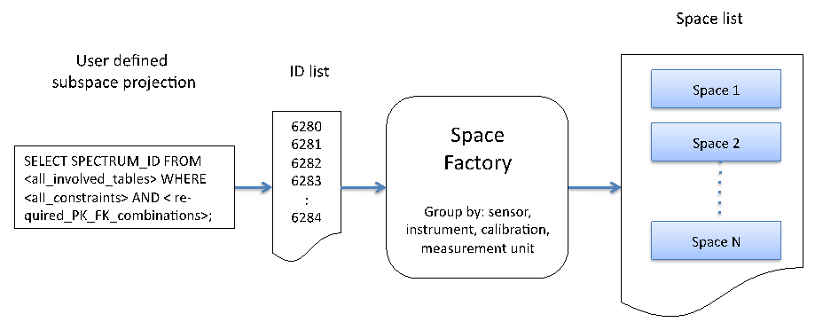

User search conditions – Query builder or Data Hierarchy Browser

Figure : Building spaces based on user defined subspace projections

The Space Factory returns a list of the created spaces. Each space can now in turn be used as an input argument of a plotting class instance. Utilizing the Space Factory ensures that all spectra contained by a space have a common wavelength per band and the same measurement unit, i.e. the following processing modules do not need to carry out uniformity checks but can apply their algorithms directly, e.g. plotting of spectral vectors against the common wavelengths of the space.

Interactive, flexible and configurable data processing is based on the concept of the Space Network. Such networks consist of processing modules and data sinks/sources, connected by directed edges.



Figure : Transformation into a new space by a processing module

Processing modules are effecting a transformation on a space, i.e. the spectral data vectors of the input space are transformed to an output space. The algorithm of the processing module defines the dimensionality of the resulting space. This is illustrated in Figure 14 with an input space of dimensionality N being transformed into another discrete space of dimensionality M. Although processing modules tend to have singular input/output in most cases, they may have multiple inputs and generate multiple outputs.

# Design of Sampling Experiments and Data Structuring

The data collected during sampling campaigns must be organised in a structured way in order to allow for automated upload into SPECCHIO’s spectral database, to permit use of SPECCHIO’s automated processing and to facilitate optimal use SPECCHIO’s data management tools.

The concept of hierarchical data structure that is used in SPECCHIO has been adapted from SpectraProc (Hueni, 2006), which was built on a fixed hierarchy of three levels. However, SPECCHIO supports hierarchies of arbitrary shape and number of levels.

Preferably the design of sampling experiments should include hierarchical data structuring from the beginning. However, existing data can be re-arranged to meet these requirements.

While SPECCHIO supports a hierarchical organisation of data, it does not enforce any particular way of using this hierarchical structure. The hierarchy tree structure can have any number of levels and can be unbalanced, if desired.

Campaigns can contain spectra measured with different instruments and sensors, including instruments of different sensor types and measurements done at different times using an instrument which has been calibrated one or more times between these measurements.

The SPECCHIO hierarchy is defined by replicating a file system sub-directory tree from the user’s computer. There are some specific restrictions on the hierarchy tree structure.

* No other files can be in the tree except spectral files. Keep images, PDF files and other files in another directory, probably next to your hierarchy structure.
* All of the files in a directory must be of the same data format and version, although the sub-directories of a directory may have files with a different data format.

However, for FGI-HDF files it is possible to have an .h5-file as well as a .xml-file in one folder.

* To conveniently use SPECCHIO’s goniometer angle calculation, all of the spectra measured at the different angles should be put in one directory and observed in the defined sequence. There should be no other spectra in that directory. The goniometer angle calculation has been designed for the use of the FIGOS and LAGOS goniometers system (RSL, University of Zurich).

The provided examples are suggestions based on experience. You may decide to choose a different approach, provided it conforms to the restrictions documented above.

## Example Structure 1

%%% The example web site needs to be defined so this can describe exactly what is available. Elaine

|  |  |
| --- | --- |
| Species: | Multiple |
| Sites: | Multiple sites for each species |
| Measurements: | Multiple measurements per site using ASD file format |
| Example files: | Vegetation\_example %%% SPECCHIO’s web site or UOW web site or... Elaine. |

The spatial extent where a specimen is sampled is termed a sample site, thus a species contains a number of sample sites. The sites are numbered in the order of sampling. At each site, several readings are taken to capture the variation exhibited by the specimen in question. A site therefore contains a number of spectra. This leads to a hierarchical directory structure (Figure 15).



Figure 15: Hierarchical directory structure

Although the term “species” is used it essentially represents the different classes found in a study. These classes can either be assigned due to already existing classification systems for e.g. plants or minerals. In other cases a hypothesis might exist that a number of objects can be separated into classes. If so the setup of the experiment should mirror this hypothesis. If no such assumption exists all objects can be put into the same class (i.e. species) and the identification of classes could then be carried out by a technique such as cluster analysis.

Figure 16 shows an example of a directory structure containing ASD spectral files. The main directory ‘Vegetation\_example’ holds all species directories of the study. This main directory is the folder that needs to be specified in the Path in the Campaign Creation dialog.

The three species directories contain their related site directories.

The site directories contain all spectral files collected at these sites for that species.

The spectral files are auto-numbered by the ASD capturing software within each site directory.



Figure 16: Example of a directory structures holding spectral files

## Example for Reference and Target Spectra

|  |  |
| --- | --- |
| Species: | Multiple |
| Sites: | Multiple sites for each species |
| Measurements: | Radiance spectra measured with use of a reference panel |
| Example files: | Vegetation\_example %%% SPECCHIO’s web site or UOW web site or... Elaine |

If a spectroradiometer is configured to acquire radiances, the irradiance will commonly be characterised indirectly by measuring the radiance reflected by a reference panel. This may be preferable to the direct acquisition of reflectance data as information about the irradiance can be retrieved from the dataset.

The structure must therefore hold target and the related reference radiance spectra in adjacent directories.



Figure 17: A possible structure for the storage of target and reference radiance spectra

In this example, the Reference sub-directory holds the reference spectra which relate to Plant A, Plant B and Plant C.

# SPECCHIO Basic Operation

SPECCHIO has been setup to comply as much as possible with the look and feel of the operating system on which it is running.

The screenshots provided in the following sections have been taken on Windows Vista and MacOS X. Depending on your operating system, the windows and widgets may look a little different. %%% Consider a change to this comment after screenshots are redone.

## Mac Operation

On Mac systems, the SPECCHIO client application menus do not appear at the top of the screen. Instead, they appear at the top of the SPECCHIO Main Window as shown in the screen shots in this document.

This document uses the term right-click to indicate clicking on the mouse’s right button. Mac users with an old Apple mouse should set their mouse preferences to turn on right-click. Otherwise, they will need to hold the control key while clicking to activate the right-click menus. On Macs fitted with a standard mouse or magic mouse, right-click is always available.

## Unix Operation

The functionality of the GUI is generally consistent across all tested operating systems. However, there is a difference in the selection of directory pathnames under UNIX. As a filename is required in the Open dialog, enter a dot ‘.’ in the filename box (Figure 18). Alternatively, on some UNIX machines just click the folder but do not double click, in this fashion the folder will be selected and no ‘.’ has to be inserted in the filename box.



Figure 18: Specifying a pathname under UNIX using the dot ‘.’ as entry in the filename box

Depending on the UNIX windowing system, some of the dialogs are not properly displayed unless they are maximized.

## Main Window

SPECCHIO’s Main Window opens when the application is started. It is used to launch all of SPECCHIO’s functions.

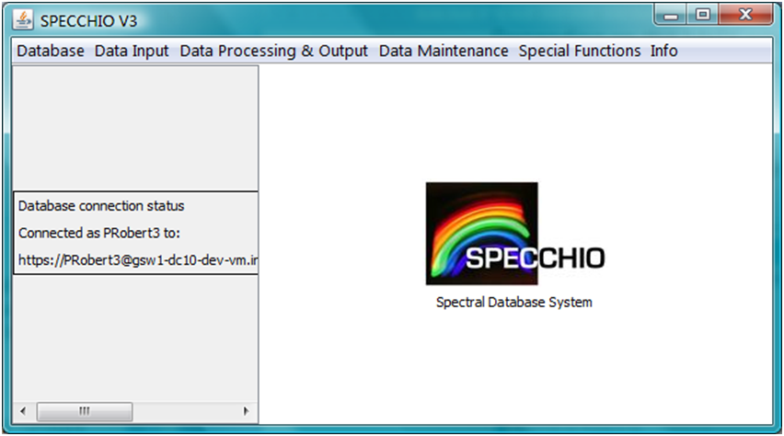

Database Connection Info

Progress Report Panel

Main Menu

Figure 19: Main window

**Main menu** Select the SPECCHIO functions you wish to run from here.

**Progress Report Panel** Displays the database connection information and information about the progress of many of SPECCHIO’s processes (e.g. file loading).

**Database Connection Status** This information is displayed in the Progress Report Panel and shows the User Name you are logged in as, and the database you are logged in to.

The panel on the right side of this window is not used in this version of SPECCHIO.

## Logging In and Connecting to a Database

Because the user account details are kept in the database, connecting to the SPECCHIO database and logging in are performed as one operation.

Preconfigured information for your database and the log in accounts you have created on your computer is stored in the db-config.txt file on your computer. See section for instructions on creating a User Account.

To log in to a SPECCHIO Server...

|  |
| --- |
| Start the SPECCHIO Application. (See the instructions specific to your computer in sections , or for Windows, UNIX or Mac respectively.)  Select the Database and Connect to database menu items from SPECCHIO’s Main Windows to display the following dialog box.    Figure : Connect to Database dialog  From the Known connections dropdown list, select the connection with your User Name following the https:// characters. The User Name will be a contraction of your own First and Last Names.  Inspect the values which are updated in the dialog box. It should not be necessary to change anything unless specifically requested by your database administrator.  Click on  Connect . The dialog box will close and there will be short delay while the database is read. The details of your database and log in account will be displayed in the left hand panel of the Main Windows and the sub-menu items for SPECCHIO functions will now be active. |

You can repeat this process at any time and log in as a different User, or even log in again as the same User.

## Logging Out

There is no specific log out function for SPECCHIO. Closing the Main Window will close your database session. If you restart SPECCHIO, you will need to log in again.

If you select Database and Connect to database from the SPECCHIO Main Window menus while you are logged in, SPECCHIO will log you out before logging in again as the new User.

## Changing your User Details

After you have logged in and connected to your database, you can adjust your User Information.

To edit your User Information...

|  |
| --- |
| Select Database and Edit user information from the menu items from the main SPECCHIO screen. The following dialog box will be displayed showing your current User information.    Figure : User Information update dialog  Update the information as required. You cannot change the ANDS Party Identifier.  Clink on  Update  to cause the changes to be written back into the database. |

This process does not change your User Name or Password, so there is no requirement to modify anything in the db\_config.txt file.

## Browsing the Hierarchy Tree

There are many places in the SPECCHIO operation when a Campaign Hierarchy browse control, such as the one below, is displayed as part of an operation dialog.

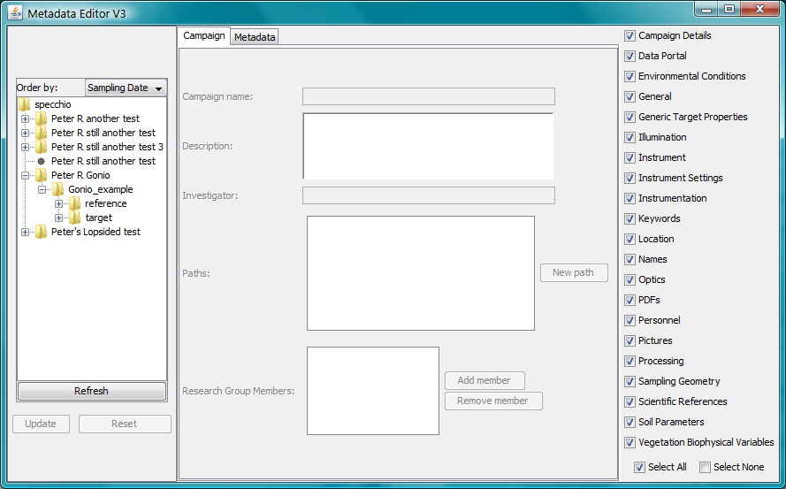

Figure : Campaign Hierarchy browse box

%%% Should we have a Mac screenshot here too? Maybe yes, as the + & - are little triangular arrows.

This browse control operates much like a normal directory and file browser.

* Click on the “+” and “-” icons to cause the hierarchy levels to be expanded or collapsed.
* Select an individual spectrum by clicking on it.
* Select a node in the hierarchy by clicking on it. This effectively selects all Spectra under this node.
* Select a second node or spectrum by holding the Control key and clicking on it.
* Select a range of spectra, by clicking on the first spectrum to select it, holding the Shift key, and clicking on the last spectrum.
* Change your selection by clicking on the new item you want to select (without Control or Shift keys).

In addition, there are two options:

Order by: Use the drop down menu to choose the sort order for Spectra within the lowest hierarchy level. The options are:

Sampling date The Spectra are sorted in increasing order of the date and time in the Acquisition Time Metadata Attribute.

Filename The Spectra are sorted in increasing alphabetical order of the string in the Filename Metadata Attribute.

Insert order The Spectra are sorted in increasing order of the date and time in the Loading Time Metadata Attribute.

Often these three orders are the same, or at least, similar, so you may not notice any change of sequence.

 Refresh  Click this button to cause the Hierarchy Tree to be reloaded from the database. Use this button if the operation you have just performed, some background operation, or some other user has changed the database since this dialog box was opened.

## SQL Matching Strings

When matching text strings, SPECCHIO uses the MySQL Query LIKE clause. This SQL feature supports wildcard characters for matching variable strings.

Therefore, the following is supported in most SPECCHIO searching or matching strings.

% Matches zero or more characters.

\_ Matches exactly one character.

\ Causes the next character to be matched. That is, \% will match a % sign and \\_ will match an underscore character.

Note There is just one case where Regular Expressions are used instead of SQL Matching Strings. This case is described separately.

## Entering Dates and Times

SPECCHIO uses a Date and Time selection dialog which is similar to many others. Here are a few tips for using it.



Down triangular arrow in the data input field

Time selector up and down triangular arrows

Figure : Date and Time picker dialog

* Select the Time first. (Because selecting the Date closes the dialog.)
* To change the Hours, click on the hour number in the Date and Time Picker (it will not be highlighted and the cursor will not move, but trust me) and then click on the time selector up and down triangles to adjust the number. (You cannot type in the number directly.)
* To change Minutes and Seconds, do as for Hours.
* Clicking on the required Date closes the dialog box, but only if the date is not already highlighted.
* If you do not want to change the date, click on the down triangle in the data input field to close the date picker.

## Loading Data into SPECCHIO

The process of loading data into SPECCHIO involves a number of steps. Depending on your acquisition device, some of these steps may not be needed because the information is recorded by your device and uploaded with the spectral data.

|  |  |
| --- | --- |
| Create a Campaign | This establishes a name for your Campaign and sets up structures in the SPECCHIO database to receive the Campaign spectra and other information. See section . |
| Load Campaign Data | This examines the format of the Spectral data on your hard disk, parses its content from your hard disk and inserts into the SPECCHIO database. See section . |
| Correct Acquisition Times to UTC | SPECCHIO expects Acquisition Times to be UTC, but many devices record a local time. SPECCHIO provides a function to change local times to UTC. See section Uploading Additional Spectral Data to a New Data Hierarchy  There are often cases when a new set of Spectra is required to be uploaded, and this set does not relate to the existing Spectra in the Campaign. In this case, a new directory structure can be created at the top level of the Campaign.    Figure 27: Data Hierarchy of GER example after initial load  In the above example, there is one sub-folder of the GER Example. If the user has performed a second largely independent part of the experiment, its results may be loaded as a new top level folder in the Campaign.  Figure 28: Data Hierarchy of GER example after loading second part  To upload a new data hierarchy to an existing Campaign...   |  | | --- | | Prepare the second upload directory tree of Spectra on your computer and ensure it has a different name from the first one. It does not need to be in the same directory as the first one, owned by the same user as the first one, or even on the same computer as the first one.  Select Data Input and Load campaign data from the menu on the Main Window.    Figure 29: File upload dialog showing multiple paths  SPECCHIO stores every path name that has been used to upload data to this Campaign. However, in this box it will only display those paths which point to locations which exist on your computer.  From the drop down list for the Campaign name: control, select the name of the Campaign you are uploading to. The list of paths in the Path: box will change to be those defined for the selected Campaign.  Click on  New Path . A file selection dialog will open.  Navigate to the directory that created with the second data hierarchy and select it. This new path will be added to the list of paths in the Path: box. Be sure to select the right level directory.  Click  Load . The dialog box will close and progress messages will be shown in the left hand part of the Main Window indicating the total number of files that have been found, and the number of new Spectra which have been loaded. |   Warning If you select the directory above or below the one selected when the Campaign was first loaded, it will not be recognised as the same directory and will cause all of the existing data to be duplicated in your SPECCHIO Campaign.  UTC Time Correction. |
| Add Target-Reference Links | For acquisition devices which do not put this information into the spectral files, you will need to enter this information manually. See section . |
| Complete Metadata upload | The Spectral Metadata that was not included in the Spectral files must be uploaded, either from an Excel file or manually entered using SPECCHIO’s Metadata editor. See sections and |
| Calculate Sun Angles | SPECCHIO provides a function to calculate sun angles based on the UTC date and time of the spectrum acquisition and the latitude and longitude of the acquisition location, and to write them into the spectra metadata. See section . |
| Calculate Goniometer Angles | If you have used a supported goniometer and collected the spectra in the correct sequence, SPECCHIO provides a function to calculate the sensor orientation parameters and write them into the spectra metadata. See section . |

After these steps, your Campaign’s spectral data is complete and ready for use, export or publishing to ANDS.

## Creating a new Campaign

|  |
| --- |
| Select Data Input and Create new campaign from the Main Window menus. This brings up the new Campaign dialog.    Figure : New Campaign dialog  Enter the name you have selected for this Campaign. The maximum length is 45 characters.  To set the Main directory, select the  Browse  button to display a directory tree.  The Main directory path is a file system pathname pointing to the directory that contains all hierarchies and Spectra for this Campaign. When you load Spectral data, it will be loaded from this directory. To set the Main directory:, click on the  Browse  button to display a directory tree browser. Navigate to the required path on your hard disk. (When using a UNIX system you may have to enter a dot as filename – see section .)  Click  Create  to create the new empty Campaign in the database.  A message box will appear once the Campaign has been successfully created. Click  OK  to close it.  Click  Cancel  to close the Campaign creation dialog. |

Note It is not advisable to have two Campaigns with the same name. There is no check for the existence of a Campaign of the same name, so please check the names of the existing Campaigns before you create your own in order to avoid multiple Campaigns with identical or confusing names.

You can now load Spectral data into that Campaign using the Data input/Load campaign data menu item from the Main Window menu.

It is also possible to use the  Create and Load  button to combine the operations of creating the Campaign and uploading the data. Read the following section before using the combined operation.

## Loading Campaign Spectrum Data

All spectral data in the sub-directory tree at the disk location you specify will be loaded from your computer to the database as a single operation.

On your local disk drive, prepare a sub-directory structure which reflects the hierarchy you require for your data in SPECCHIO and put your Spectrum data files into this structure. See Chapter for more information on designing this structure.

The entire sub-directory tree must contain only Spectrum files, and each sub-directory within the tree must contain only files of one Spectrum file format.

When you start the Spectrum load process, SPECCHIO will process all sub-directories and files within this sub-directory tree and create a matching structure for your Campaign in the database. For each sub-directory, it will use the various Spectrum File loaders listed in section until one reports that it can read a file in the sub-directory. It then processes all files in that sub-directory using that file loader. If any file cannot be read, it will report an error giving the name of the file that failed. Correct the offending file (either by removing it if it is not a spectrum file, sorting it into a sub-directory with similarly formatted files, or finding an uncorrupted version of the file). Then restart the upload process. Those Spectra which have already been successfully uploaded will not be processed a second time.

|  |
| --- |
| Select Data Input and Load campaign data from the SPECCHIO Main Window.    Figure : Load Spectral Data dialog  From the list of Campaign names in the dropdown box, select the name of the Campaign into which you want to load data.  Highlight the Path name which contains the Campaign data sub-directory tree on your computer. If the path name is not in the list, click on  New Path , navigate to the path on your computer and select it. It will now be highlighted.  Click the  Load  button. The dialog box closes and the loading progress is shown in the left panel of the Main Window. A message box will appear once all data has been loaded to the system. Do not perform other operations on this Campaign until the load has completed.  Click  OK  to clear the message box. |

Note After uploading your Spectral data to SPECCHIO, do not change the sub-directory structure on the hard disk that you set up and used. You will need this again if you wish to upload further spectral data to this Campaign in the future.

Instrument, Sensor and Reference Panel selection

If SPECCHIO does not find a match for any of these three in the current SPECCHIO tables, it will set the related Metadata Attribute value to Nil, and attempt to store the Instrument Name in the Extended Instrument Name Metadata Attribute and the Reference Panel name in the White Reference Panel Name Metadata Attribute.

%%% Andy claims in his review comments that new instruments are now set into the Instrument table, but how can this be if the user doesn’t have Admin permission. Is this related to the problem of many duplicated instruments appearing over time?

After uploading Spectra, use the Metadata Editor to check the settings of the Instrument, Sensor Type and Reference Panel which SPECCHIO has tried to determine from the input Spectra.

If they are not set or not correct, use the Metadata Editor to correct them.

See for more information on the Metadata Editor.

Handling Spectrum upload errors

Warning If the message box advising successful completion does not appear, the upload did not complete normally. Check the count of uploaded spectra to determine how much was completed. See below for information on recovering from upload errors.

If a directory contains unknown file types, mixed file types or files with invalid data, the loading process will stop. A dialog box will generally appear, indicating the offending file and the cause of the problem.

You should check the cause of the problem, rectify it and attempt the upload again. Spectra which successfully uploaded the first time will not be uploaded again.

## Loading Additional Spectral Data

If further spectral data becomes available for your Campaign, it is possible to conveniently add it to your existing SPECCHIO Campaign.

There are a number of different scenarios which may apply.

### Uploading Addition Spectral Data from the Same Computer

In this case, add the new spectral data to the existing sub-directory structure on your computer’s disk from which you uploaded the original spectral data.

* Do not add any files other than Spectral data and ensure that all files within each sub-directory have the same file format.
* Do not change the file names of any of the original files.
* Do not change or rename the sub-directories, but you may add new sub-directories.

To upload the new Spectral data, follow the process described in section . Only new data will be loaded.

Note Do not add additional Spectra to files that hold multiple Spectra, such as TXT and XLS files. The loading process checks for existing data at the file level, so the existing file will be detected and not loaded, missing the new data.

After uploading new data you may need to set the metadata for the new data. Depending on your Campaign Hierarchy design, the new data may be interspersed with your existing data. Take care not to delete or corrupt the metadata on your existing data by ensuring that you select only your new Spectra when you update the metadata.

Warning This particularly applies to UTC time changes, where applying the same time change a second time will add or subtract the time difference again, yielding an incorrect result.

### Uploading Additional Spectral Data from a Second Computer

SPECCHIO permits multiple Paths to be stored against each Campaign. This permits the same data to me managed and augmented from multiple computers.

To upload from a second computer...

|  |
| --- |
| On the second computer, make an exact copy of the entire Campaign directory tree as it was uploaded from the first computer. It does not have to be in the same location as it was on the first computer, but the sub-directory structure, sub-directory names and file names must be identical.  Add the new hierarchy sub-directories and files into the existing sub-directory structure.  Select Data Input and Load campaign data from the menu on the Main Window.    Figure : File upload dialog showing multiple paths  SPECCHIO stores every path name that has been used to upload data to this Campaign. However, in this box it will only display those paths which point to locations which exist on your computer.  From the drop down list for the Campaign name: control, select the name of the Campaign you are uploading to. The list of paths in the Path: box will change to be those defined for the selected Campaign.  Click on  New Path . A file selection dialog will open.  Navigate to the directory that you copied to your computer and select it. This new path will be added to the list of paths in the Path: box. Be sure to select the right level directory.  Click  Load . The dialog box will close and progress messages will be shown in the left hand part of the Main Window indicating the total number of files that have been found, and the number of new Spectra which have been loaded. |

Warning If you select the directory above or below the one selected when the Campaign was first loaded, it will not be recognised as the same directory and will cause all of the existing data to be duplicated in your SPECCHIO Campaign.

### Uploading Additional Spectral Data to a New Data Hierarchy

There are often cases when a new set of Spectra is required to be uploaded, and this set does not relate to the existing Spectra in the Campaign. In this case, a new directory structure can be created at the top level of the Campaign.

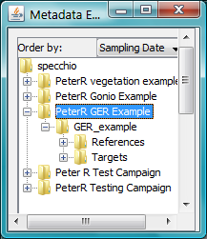

Figure : Data Hierarchy of GER example after initial load

In the above example, there is one sub-folder of the GER Example. If the user has performed a second largely independent part of the experiment, its results may be loaded as a new top level folder in the Campaign.

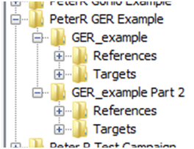

Original GER Example Campaign upload top-level folder which relates to original upload path

Second GER Example Campaign upload top-level folder which relates to a new upload path

Main GER Example Campaign folder

Figure : Data Hierarchy of GER example after loading second part

To upload a new data hierarchy to an existing Campaign...

|  |
| --- |
| Prepare the second upload directory tree of Spectra on your computer and ensure it has a different name from the first one. It does not need to be in the same directory as the first one, owned by the same user as the first one, or even on the same computer as the first one.  Select Data Input and Load campaign data from the menu on the Main Window.    Figure : File upload dialog showing multiple paths  SPECCHIO stores every path name that has been used to upload data to this Campaign. However, in this box it will only display those paths which point to locations which exist on your computer.  From the drop down list for the Campaign name: control, select the name of the Campaign you are uploading to. The list of paths in the Path: box will change to be those defined for the selected Campaign.  Click on  New Path . A file selection dialog will open.  Navigate to the directory that created with the second data hierarchy and select it. This new path will be added to the list of paths in the Path: box. Be sure to select the right level directory.  Click  Load . The dialog box will close and progress messages will be shown in the left hand part of the Main Window indicating the total number of files that have been found, and the number of new Spectra which have been loaded. |

Warning If you select the directory above or below the one selected when the Campaign was first loaded, it will not be recognised as the same directory and will cause all of the existing data to be duplicated in your SPECCHIO Campaign.

## UTC Time Correction

This tool is provided to adjust the capture time in cases when it was not recorded in local time instead of UTC. It applies a time shift to the Acquisition Date metadata attribute based on the number of hours entered by the user.

If times are not correct in UTC, the calculation of sun angles will be wrong.

To adjust local times to UTC...

|  |
| --- |
| Select Special Functions and Correct local time to UTC from the menu in the Main Window.    Figure : UTC Time Correction dialog  Select the hierarchy node containing the spectra that need to be time shifted, or select the individual Spectra files. The first selected hierarchy name and the number of Spectra are shown on the right in read only fields.  Enter the number of hours to adjust in the Hours East of GMT field. Use positive numbers for longitudes East of GMT (that is, the number for Australia will be positive).  Click on the  Apply  button.  Close the dialog using the  Close  button. |

Warning Do not click the UTC dialog’s  Apply  button a second time. This will cause the time shift to be applied a second time and a second Time shift processing message to be added to each Spectrum. You can time shift back by applying a third time shift with a negated time shift value, but removing the extra time shift processing messages is more difficult.

As date/time fields are stored in milliseconds, the time shift is implemented as:

Date\_time\_in\_milliseconds = Date\_time\_in\_milliseconds – hours\_east\_of\_gmt\*milliseconds\_per\_hour.

Therefore, if a time shift happens across midnight, the calendar date of the capture time will also be shifted back or forth, depending on whether hours\_east\_of\_gmt is positive or negative. For example, for a local capture time around 10am in Oceania a time shift of around 12 hours East of GMT is needed. The UTC time will then be 10pm the previous day.

A Time Shift Metadata Attribute value in the Processing Metadata group is added to each Spectrum that has its Acquisition Time adjusted by this function.



Figure : Time Shift Metadata Attribute after applying a UTC Time Shift

## Managing Target-Reference Links

You will need to add links from your target spectra to the related reference spectra if you want to use some of the Processing options of SPECCHIO.

Note The dialog boxes for viewing existing links and adding new links appear similar, but there are important differences. Please compare the two dialog boxes carefully in the following sections.

In these dialogs, users with Administrator permission can view and change any data. Other users can view and operate on only the Campaigns they uploaded or for which they are in the Research Group.

### Viewing or deleting existing Target-Reference links

Select Special Functions and Target-references links from the menu of the Main Window. The following dialog will be displayed. Ensure that the Show existing links tab is selected in the centre panel.

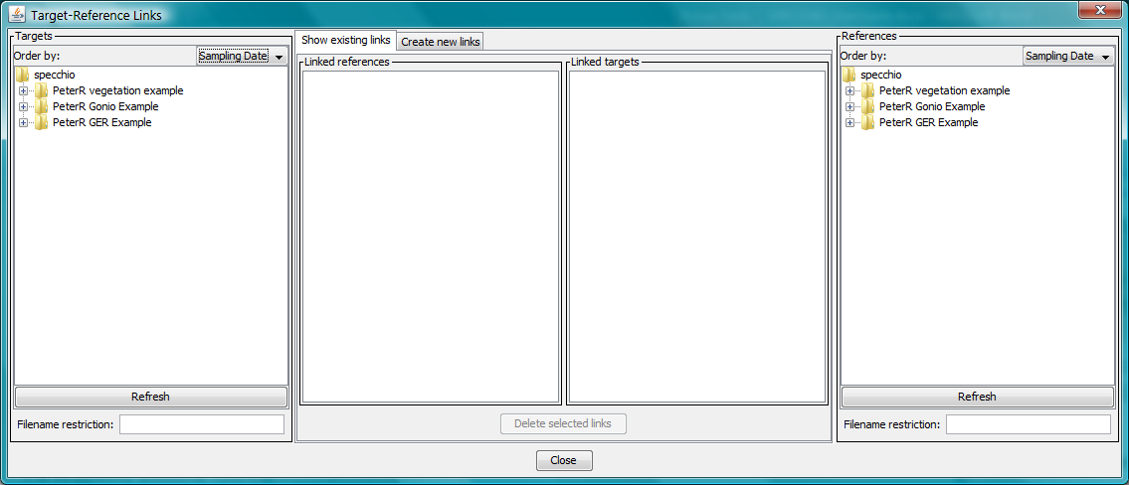

Figure : Viewing Target-Reference links

Selecting and expanding nodes within these data hierarchy browsers requires many database accesses, and so can take a little time to complete.

There are two halves to this dialog, which function completely independently.

Left hand side

Use this side to select Target Spectra and see their related Reference Spectra.

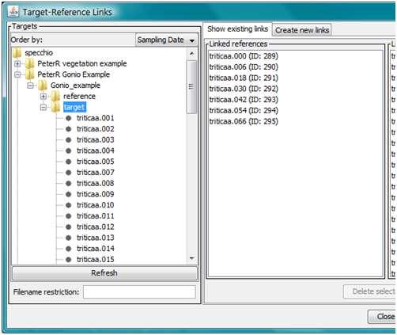

These Target Spectra

…link to…

These Reference Spectra (duplicates are removed from this list)

To see the Reference Spectrum for just one Target Spectrum, click on that Spectrum here.

To see the Reference Spectrum for a selection of Target Spectra, enter an SQL search string to select them in this box.

Figure : Viewing Target Spectra and their related Reference Spectra

Use this Hierarchy tree browser to select one or more Spectra. Enter an SQL matching string in the Filename restriction: control to restrict the Target Spectra selected. (See section .) This control does not affect the display of the Spectra in the hierarchy tree browser display. It only reduces the effectively selected Spectra to those that also match the SQL matching string.

The File Names of all Reference Spectra linked to the selected Spectra will be shown in the Linked references box. If you select the Campaign node and clear the Filename restriction: control, all linked Reference Spectra in the Campaign will be displayed.

If any Target Spectrum is displayed in the Linked References box, a link has been set up in the wrong direction.

Because each Target Spectrum should not be linked to more than one Reference Spectrum, the number of Reference Spectra displayed should be less than the number of Target Spectra selected.

Right hand side

Use this side of this dialog to select Reference Spectra and show their related Target Spectra. It operates in the same way as the left-hand side, but views the links in the reverse direction.

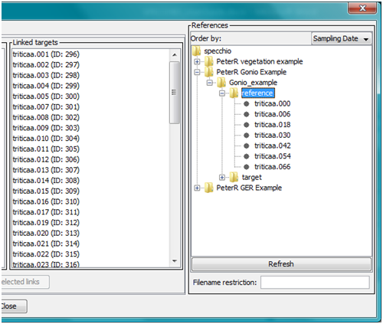

These Target Spectra (duplicates are removed from this list, although there shouldn’t be any)

…link to…

These Reference Spectra

To see the Target Spectra for just one Reference Spectrum, click on that Spectrum here. There can be more than one linked Target Spectrum.

To see the Target Spectra for a selection of Reference Spectra, enter an SQL search string to select them in this box.

Figure : Viewing Reference Spectra and their related Target Spectra

If you select the Campaign node on the right hand side and clear the Filename restriction: control, all Target Spectra with Reference Spectra links will be displayed.

If any Reference Spectrum is displayed in the Linked targets box, a link has been set up in the wrong direction.

Because each Reference Spectrum can be linked from many Target Spectra, the number of Spectra shown in the Linked targets box can be many more than the number of selected Spectra.

### Deleting Existing Target-Reference Links

The option to delete existing links works simultaneously, but independently, on the two halves of the Show existing links dialog.

When the  Delete selected links  button is clicked, all links to and from the Spectra highlighted in the Linked references **and** Linked targets boxes will be deleted. It is possible to highlight Spectra in one box only.

After deleting, the Linked references and Linked targets boxes will be updated. This may take a little time.

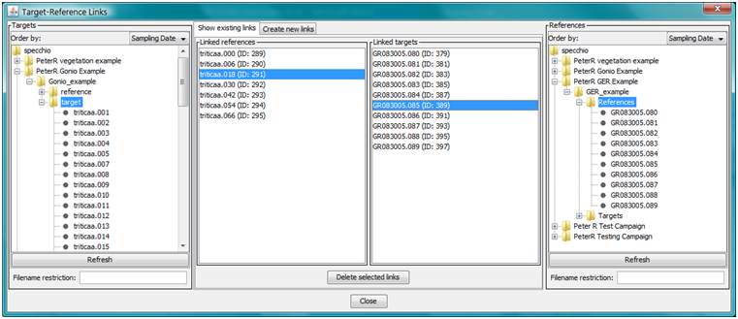

When the Delete button is pressed, all links to and from these highlighted Spectra will be deleted.

The two halves of this dialog still operate independently. In this example, the two selected Campaigns are not even the same.

Figure : Deleting Target-Reference Spectra links

### Adding new Target-Reference links

Select Special Functions and Target-references links from the menu of the Main Window. Click on the Create new links tab in the centre panel to display the following dialog. (You can switch back and forth between the Create new links and Show existing links tabs at any time.)

The example shown in this section is taken from a goniometer sample campaign.

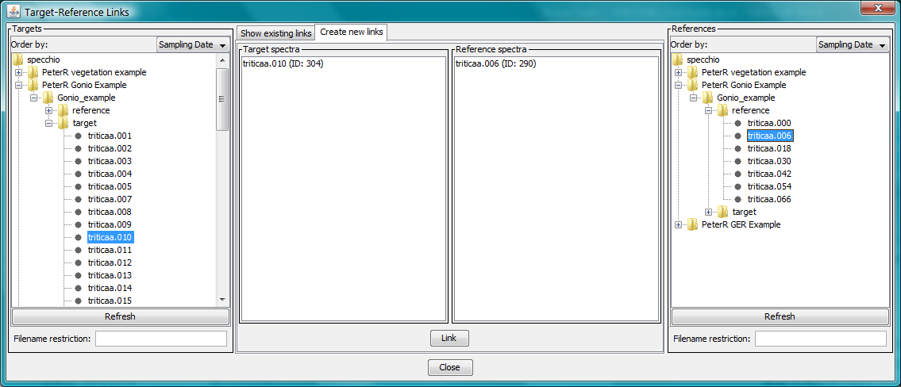

Figure : Creating a single new Target-Reference Spectra link

Notes The left and right sides of this dialog do not operate independently, unlike the dialog which displays links in the previous section.

The positions of the Target Spectra and Reference Spectra boxes in the central panel are reversed when compared with the position of these boxes in the previous section.

To link a single Target and Reference Spectrum...

|  |
| --- |
| Using the left-hand side Targets hierarchy tree browser, locate and select the Target Spectrum you wish to link. Its name will be displayed in the Target Spectra box.  Using the right-hand side References hierarchy tree browser, locate and select the Reference Spectrum you wish to link. Its name will be displayed in the Reference Spectra box.  Verify that the correct Target and Reference Spectra are displayed in the central Target Spectra and Reference Spectra boxes respectively. Ensure that they are also each in the correct box and not reversed.  Click  Link  to create the link. |

Warnings Do not click the  Link  button twice. This will add the link twice, even though it is still displayed only once. However, duplicated links generally do not cause problems in later processing.

Before creating any link, check that the link does not already exist so you do not duplicate it.

It is also possible to create multiple links simultaneously by selecting multiple Target Spectra.

In addition, if multiple Reference Spectra are highlighted, as each Target Spectrum is processed, the Reference Spectrum with the closest Acquisition time Metadata Attribute is selected for linking.



Figure : Referencing of reference panel spectra by target spectra based on timeline information

This function is useful for campaigns where Target and Reference Spectra are collected in separate Spectral files, for example, when using the ASD spectroradiometer in radiance mode.

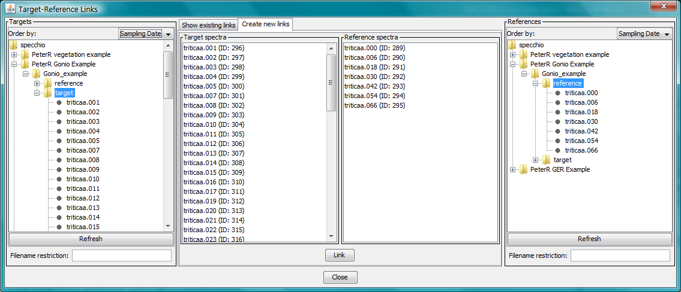

Figure : Creating multiple new Target-Reference Spectra links

To create links between multiple targets and references...

|  |
| --- |
| Using the left-hand side Targets hierarchy tree browser, locate and select the Target Spectra you wish to link. You can do this by highlighting multiple spectra or by highlighting a hierarchy node.  If required, refine your selection by entering an SQL matching string in the related Filename restriction control. (See section .)  Using the right-hand side References hierarchy tree browser, locate and select the Reference Spectra you wish to link. You can do this by highlighting multiple spectra or by highlighting a hierarchy node.  If required, refine your selection by entering an SQL matching string in the related Filename restriction control. (See section .)  Verify that the correct Target and Reference Spectra are displayed in the central Target Spectra and Reference Spectra boxes respectively. Ensure that they are also each in the correct box and not reversed.  Click  Link  to create the links according to the method described above. |

## Displaying and Editing Metadata

The SPECCHIO Metadata Editor allows you to enter and modify both Campaign and Spectrum Metadata. Refer to sections and 4.12 for detailed information about Metadata stored by SPECCHIO.

Metadata is most easily displayed using SPECCHIO’s Metadata editor.

To open the Metadata Editor select Data Input and Edit metadata from SPECCHIO’s Main Window menu. The following Metadata Editor window is displayed.

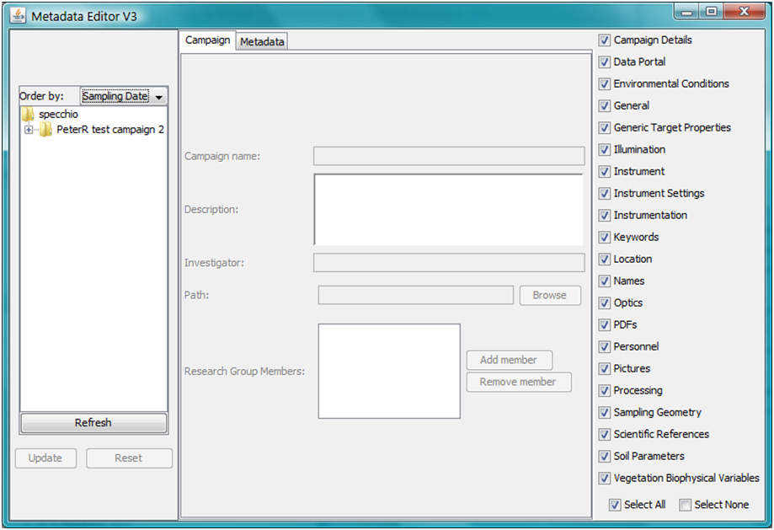

Hierarchy Tree Browser

Order By Indicator

Metadata selection tabs

Metadata display area

Spectrum Metadata Group selection area

Figure : Metadata editor dialog

|  |  |
| --- | --- |
| Hierarchy Tree Browser | Shows the Campaigns present in the database and allows selecting of Campaigns, sub-trees and Spectra. |
| Order By Indicator | Select the sort order to use for Spectra in the left hand Campaign navigation window. |
| Refresh  button | Click this button to update the Campaign Tree Navigator after making changes which affect it. |
| Update  button | Click this button to write all changed Metadata back into the database. |
| Reset  button | Click this button to ignore all changes made since the last time the Update button was clicked and redisplay the Metadata panel from the database. |
| Metadata selection tabs | Select either Campaign, to display and edit Campaign Metadata, or Metadata to display and edit Spectra Metadata. |
| Metadata display area | This will show the Metadata selected by the Metadata selection tab. |
| Spectrum Metadata Group selection area | Click on these checkboxes to display or suppress the various Groups of Spectrum Metadata. Select All displays them all, and Select None hides them all. |

In this editor, whenever changes are made to any Metadata entries, they are saved in an action list. They are not written immediately to the database. When the  Update  button is clicked, the action list is processed and the database is updated. When the  Reset  button is clicked, the action list is discarded without being processed and the content of the Metadata display area is redisplayed from the database.

Warning Click on  Update  after every change to a metadata item. If you make multiple changes before clicking  Update , these changes are written to the database, but not necessarily in the order in which you made them. This can yield unexpected results, as the last change you made may not be the last one to be written.

Metadata entry fields are of various types, including integer, floating point, alpha string, date/times or special lists. Generally, the editor restricts you to entering values which are consistent with the data type. However, the editor does not perform validation checks on entered data. For example, while you must enter a valid number for the Relative Humidity, the editor will not reject negative values or values greater than 100.

Warning Take care to enter numbers which are within the valid range for the Metadata attribute you are entering. The editor will permit you to store values which are outside the valid range, which can be misleading or lead to unpredictable results later.

### Displaying and Editing Campaign Metadata

See section for detailed information about individual Campaign Metadata fields, their meanings and operation.

To edit a Campaign’s Campaign-related Metadata...

|  |
| --- |
| Click on the Campaign tab to highlight it and display Campaign-related Metadata.  In the Campaign Tree Navigator, click on the Campaign for which you wish to edit the Metadata, or click on anything in that Campaign’s sub-tree. The Metadata for that Campaign will be read from the database and displayed in the Metadata display area. Refer to .  After making changes to the Campaign Metadata for a Campaign, click on  Update  to cause these changes to be written to the database.  You can now click on another Campaign name and repeat this procedure. |

Clicking on Metadata group names in the Spectrum Metadata selection area does not affect the Campaign editing tab.

If you change the Campaign Name Attribute, click on the  Refresh  button to cause that change to be shown in the Campaign Tree Navigator.

### Displaying and Editing Spectrum Metadata

See section for detailed information about individual Campaign Metadata fields, the way they are organised into Metadata groups, their meanings and operation.

In order to understand the operation of this Editor, it is helpful to understand how Spectrum Metadata are stored by SPECCHIO. There are two storage methods.

Mandatory Metadata The following attributes are stored for all Spectra and are always displayed – Measurement unit, File format, Sensor, Instrument and Reference. If they are not relevant or no data is available, set them to Nil.

EAV Metadata So that space is optimised, for all other Metadata attributes SPECCHIO stores only those values which are set. They are stored in an Entity/Attribute/Value table, where one Metadata value is stored in each row of the table as an Attribute=Value pair (such as Latitude=‑35.33943, or Ambient Temp=23.5). The Entity field in that row stores a list of those Spectra which are associated with this particular Attribute and Value.

Note SPECCHIO allows changing of most Metadata fields, but for some Metadata attributes it does not make sense. It could often be confusing and should not be done, except in unusual circumstances. For example, changing the File Name or File Format for a Spectrum does not make sense and may case unexpected results in subsequent Spectrum upload operations. There are other cases too.

#### Displaying a Single Spectrum’s Metadata

Displaying Metadata values is done using the Metadata editor window.

To display a single Spectrum’s Metadata...

|  |
| --- |
| Using the hierarchy browser, select the Spectrum or Spectra for which you wish to display the Metadata values.  Click on the Metadata tab to display Spectrum Metadata.    Figure 40: Metadata editor dialog   * Select or de-select the check boxes for the Metadata Groups. The check boxes are displayed on the right in the Spectrum Metadata Group selection area. * Scroll to the required Metadata Group to see the values of the Metadata attribute in that group. |

Metadata Attributes which do not have values are not displayed.

#### Editing Metadata for a Single Spectrum

When you navigate to a Spectrum in the Campaign hierarchy browser and click on it to highlight it, that Spectrum’s Metadata is displayed.

Values will only be shown for Metadata which are set for that Spectrum. Usually one or more Metadata group boxes will be empty for most Spectra.

Click on the Metadata group check boxes in the right hand panel to show or hide the various Metadata groups.

In each of the processes in this section, after you change or delete any Metadata value click  Update  to write your change back into the database. If that metadata value is shared by another unselected Spectrum, the following dialog will be displayed. The first sentence in the dialog box will change to “You are about to delete a shared record...” if you have deleted the Metadata value rather than changed it.

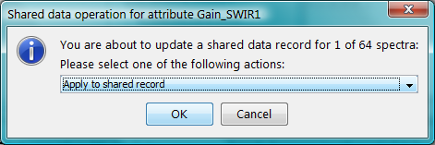

Figure : Shared data operation selector dialog

This dialog allows you to select how you want the Entity/Attribute/Value table to be updated when the OK button is clicked. The exact choice of options will depend on whether you performed a change or a delete.

Apply to shared record The shared record in the Entity/Attribute/Value table will be updated or deleted and therefore all Spectra which share this Metadata value will be affected by this change. Understand how widely the shared record is referenced when you use this option. It is possible for the value to be used for any other Spectrum in the entire database, although it is usually just used by other Spectra in the same Campaign.

Create new record for selected spectra Only the selected spectrum will be affected. To achieve this, SPECCHIO will create a new entry in the Entity/Attribute/Value table and link only the selected Spectrum to it. For a delete operation, only the reference to the current Spectrum will be removed from the Entity list. No other Spectrum will be affected.

Delete record of selected spectra The reference to the selected Spectrum or Spectra will be removed from the Entity list in this Metadata value’s Entity/Attribute/Value field. Therefore, the Metadata Attribute value will be deleted from the selected Spectrum or Spectra only. No other Spectrum will be affected.

Cancel update operation No changes for this Metadata value will be made when the  OK  button is clicked. You should then click on  Reset  to cause the original database values to be redisplayed.

If the  Cancel  button is clicked, no changes are made regardless of the selection made in the dialog. In this case too you should click on  Reset  to cause the original database values to be redisplayed.

**To modify a Metadata value...**

|  |
| --- |
| * Ensure the value to be modified is displayed by navigating to the correct Spectrum, ensuring that the check box for the required Metadata group is ticked and scrolling to that Metadata group. * Click in the field and type in the required value. When the field contains a valid value the  Update  button will become valid. * Click on the  Update  button to write the modified value back to the database. If the Metadata is shared by more than one Spectrum, the dialog in Figure 41: will be displayed. Select your desired action and click  OK . |

**To delete a Metadata value...**

|  |
| --- |
| * Ensure the value to be modified is displayed by navigating to the correct Spectrum, ensuring that the check box for the required Metadata group is ticked and scrolling to that Metadata group. * Right click on the name of the field you wish to delete. A  Delete  button will appear. * Click on this  Delete  button. The Metadata field will disappear from the display and the  Update  button will become valid. * Click on the  Update  button to write the change back to the database. If the Metadata is shared by other Spectra, the dialog in Figure 41: will be displayed. Select your desired action and click  OK . |

**To add a new Metadata value...**

|  |
| --- |
| * Ensure the required Metadata group for the correct Spectrum is displayed, by navigating to the correct Spectrum, ensuring that the check box for the required Metadata group is ticked and scrolling to the Metadata group. * Right click on any blank space within the Metadata Group’s display box. A menu of Metadata items that can be added for that group will be displayed. * Click on the menu entry for the Metadata item you wish to add. A data entry field for the Metadata entry will be displayed. * Enter the value you require for this Metadata field. * Click on the  Update  button to write this change back to the database. |

#### Editing Metadata for All Spectra in a Sub-tree of the Campaign tree

SPECCHIO allows for simultaneous updating of Metadata for multiple Spectra. This feature is typically used when multiple Spectra have just been uploaded and a selection of their Metadata items shares the same values. This is a common scenario, as metadata of spectra are often highly redundant, especially when multiple measurements of the same object were acquired.

When multiple Spectra are selected (either by selecting a node in the Campaign Tree or by selecting multiple Spectra individually), the Metadata values that are common across all selected Spectra are displayed. For any Metadata Attribute for which even one Spectrum has a different value, or is missing that Attribute, the string -- Multiple Values -- is displayed. For Metadata Attributes which are selected from dropdown lists, the value Nil is shown if the values are not the same for all Spectra.

**To change a specific Metadata item for all Spectra under a node...**

This method requires that the Metadata attribute has the same value for all Spectra. See the next procedure if that is not the case.

|  |
| --- |
| * Navigate to the correct Campaign hierarchy node and click on it to highlight it. * Ensure that the check box for the required Metadata group is ticked and scroll to that Metadata group. * Click in the field to be changed and type in the required new value. When the field contains a valid value the  Update  button will become valid. * Click on the  Update  button to write the change back to the database for all Spectra for this node. If the Metadata value is shared other Spectra not under the scope of this node, the dialog in will be displayed. If you select Apply to shared record the change will apply to all Spectra which share this Metadata value. If you select Create new record for selected spectra SPECCHIO will create a new Metadata value which will be shared only by the Spectra which are under this node. Select your desired action and click OK. |

**To delete a Metadata value from all Spectra under a node...**

|  |
| --- |
| * Navigate to the correct Campaign hierarchy node and click on it to highlight it. * Ensure that the check box for the required Metadata group is ticked and scroll to that Metadata group. * Right click on the name of the field you wish to delete. A  Delete  button will appear. * Click on this  Delete  button. The Metadata field will disappear from the display and the  Update  button will become valid. * Click on the  Update  button to write the change back to the database. If the Metadata is shared by other Spectra, the dialog in Figure 41: will be displayed. Select your desired action and click  OK . |

Warning If you delete a Metadata Attribute which shows -- multiple values – in the current view, **all** values of this Metadata Attribute will be deleted from **all** selected Spectra, even if some Spectra have multiple values of the Attribute.

**To reset a specific Metadata item for all Spectra under a node to have the same value...**

|  |
| --- |
| * Navigate to the correct Campaign hierarchy node and click on it to highlight it. * Ensure that the check box for the required Metadata group is ticked and scroll to that Metadata group. The value displayed in the Metadata field should be -- Multiple Values -- to indicate that the values are not the same for all Spectra. * Right click on the Metadata field name to show a  Delete  button. Click on the  Delete  button. The Metadata field will disappear from the screen. * Click the  Update  button to write this change into the database. (This step is critical – don’t skip it!) * Right click within the Metadata Group box to display a menu of Metadata Attributes that can be added to this Metadata group. Click on the Metadata Attribute to be added back. * Enter the value you require for this Metadata Attribute. * Click on the  Update  button to write this change back to the database. |

#### Editing Metadata for Multiple Unrelated Spectra

The operations in the preceding section can be applied to multiple unrelated Spectra.

It is possible to select multiple Spectra by holding the Control key while clicking on each additional Spectrum to be selected. It is also possible to select a range of Spectra by selecting the first Spectrum and then holding the Shift key while you click on the last Spectrum in the range. (This is consistent with common usage of the Control and Shift keys.) The operations in the preceding section will then apply to all selected Spectra.

%%% Nick says in review, “From my experiments on Mac OS X Mountain Lion:

shift+click -> same as Windows

apple key+click -> like control-click in windows

control+click -> same as normal click

shift+click -> same as normal click”

Similarly, it is possible to select multiple nodes in the Campaign hierarchy and operate on all Spectra in those nodes.

Warning Do not select multiple Spectra or nodes across different Campaigns and then update all selected Spectra to share the same Metadata values. If subsequent users select the Apply to shared record option when editing Metadata, it will change the Metadata across both Campaigns, which is a very unexpected and confusing result.

## Uploading Metadata from Excel files

SPECCHIO supports uploading Metadata to your Campaign from Excel spreadsheet files saved as an .XLS file. (It does not support loading form.CSV, .XLSX or other Excel file formats.)

The operation of this process is selectable as described below.



… the row data are copied to that Spectrum’s Metadata



Nominated **Matching Column**

Data for one Spectrum

When the **Matching Column** matches, …



Matches

Input .XLS file format

Metadata Excel files must conform to the following conventions in order to be loaded correctly.

* Only the first data sheet is loaded.
* The first row must contain column headings. It will be displayed and referenced during the upload process, but it will not be uploaded. The column headings do not need to match Metadata Attribute names.
* Each row holds data which is uploaded to one Spectrum.
* The rows do not need to be sorted.
* One column, identified at upload time, is used as the Matching Column. It identifies which Spectrum will receive the data from each row.
* If a Spectrum is selected in the Matching Column in more than one row, all of these rows are ignored.
* Other columns contain the Metadata that will be uploaded.
* You can select to ignore some columns during the upload process.

Column selection operation

After you have selected the XLS file to upload, the following control is displayed as part of a larger dialog.



1st Row – Select one Matching Column

2nd Row – Select Metadata Group

3rd Row – Select Metadata Attribute

Entire contents of selected XLS file displayed for reference

Figure : Matching & Element Assignment Control

This control shows the contents of the XLS file you have opened and allows you to select how it will be used.

The three rows of dropdown boxes are used as follows:

|  |  |  |
| --- | --- | --- |
| First row | Selecting the Matching Column  In one of the columns only, select Matching Column from the drop down list. This indicates the column that will be used to search for the Spectrum to receive the metadata for each row. |  |
| Second Row | Selecting the Metadata Group  In all columns that you want to use, select the Metadata Group that contains the Metadata Attribute which is listed in that column. |  |
| Third Row | Selecting the Metadata Attribute  In all columns that you want to use, select the Metadata Attribute which is listed in that column. |  |

After you have set up these three rows of selection parameters, the Assignment Details and Matching Details controls will show how the XLS data will be uploaded. Use these controls to check that the upload is set up correctly before proceeding.

|  |  |
| --- | --- |
|  | Number of assignable columns: The number of columns in the XLS file which remain unused  Number of assigned columns: The number of columns in the XLS file which will be copied into Metadata Attributes  Number of spectra: The number of Spectra selected in the hierarchy tree browser (see below)  Number of matches: The number of selected Spectra which match data in the Matching Column of the XLS file  Spectrum (First column) The Spectrum IDs of all selected Spectra  DB Value (Second column) The value from the SPECCHIO database of the Metadata Attribute which you have identified in the Matching Column  Table Value (Third column) The matched value from the Matching Column of the XLS file. The data in this row will be loaded into the metadata for this Spectrum. |

To upload Metadata…

You must already have an Excel file containing the Metadata to upload.

|  |
| --- |
| Select Data input and Get metadata from XLS from the menus on the SPECCHIO Main Window. The following dialog will be displayed. Only those Campaigns to which you have write permission will be displayed.    Figure : Metadata upload initiation dialog  Select the Campaign, hierarchy node or Spectra to which you want the Metadata to be uploaded.  Select File and Open file... from the menu bar on this screen. A standard file selection dialog will be displayed. Browse to the .XLS file you have previously prepared and Open it. The file will be read and the dialog will be augmented and appear similar to the following.    Figure : Metadata upload dialog after file open  Set up the dropdown boxes in the Matching & Element Assignment Control according to the instructions under **Column selection operation** above.  Verify that the Matching & Assignment Control is set up correctly by checking the contents of the Assignment Details and Matching Details boxes.  Click on the  Insert selected metadata  button in the left panel to cause the metadata to be loaded. |

If SPECCHIO finds a Metadata Attribute already exists for any Spectrum, SPECCHIO will ask how you wish to proceed by displaying the following dialog box, which lists the Metadata Attribute name that already exists (in this example, File Comments).



Select one of these three options from the dropdown list.

Skip this parameter No data from this column of the XLS file will be loaded into the SPECCHIO database.

Insert anyway Add another value for this Metadata Attribute. This option is not supported for some Metadata Attributes. For example, adding a second File Name or Spectrum Number is not permitted.

Delete existing and insert new values The Metadata values in the XLS file will replace those in the Spectra.

Click  OK  to continue processing using the action you have selected.

Click  Cancel  to skip processing of this column. This has the same result as selecting Skip this parameter.

Adjusting the matching strings

If the data in the Matching Column of the XLS file is a partial match the Metadata Attribute values in the database, you can use the REGEX box to assist in the match.



triticaa\.0\*

5

^triticaa\.0\*5$

$

^

The regular expression matches this DB Value, so this Spectrum is the one that will receive the new Metadata values

Start and end markers always used

Start and end markers always used

Concatenated to form a regular expression

Figure : Using Regular Expressions for selecting Spectra

For each row of the XLS file, the data in the Matching Column is concatenated with the REGEX start and REGEC end contents to form a Regular Expression. The matching process is then performed using regular expressions. (See for information on regular expressions.) In the above example: the ^ forces the matching to start at the beginning of the string; . is a special character so \ must be used to escape it, so \. matches the . in the file name; 0\* matches any number of 0 characters; 5 matches 5; and the $ forces the match to complete at the end of the string.

Note If a value in the DB Value column matches more than one row in the XLS file, no matching row will be shown in the Table Value column, and no Spectrum will be updated.

Using preconfigured column information

If you often load Metadata from XLS files, you can pre-configure the XLS column mappings you want to use. This will be more efficient and reduce your chance of making a mistake.

Create an extra XLS spreadsheet which lists the Column Names you’ve used in your spreadsheet along with the matching names SPECCHIO uses for these fields.



Put XLS Column heading names in first column

Put corresponding SPECCHIO Attribute names in second column

A header row must be present, but is not used

Figure : Setup up pre-defined column allocations

* The table must be in the first datasheet of the spreadsheet.
* Each SPECCHIO Metadata Attribute name must be on the same row as its matching XLS column name.
* The names in both columns are case sensitive.
* Leading and trailing spaces must be avoided.
* There must be a header row, but it is skipped over.
* The rows do not need to be sorted into any sequence.
* The file must be saved as an .XLS file. .CSV, XLSX or other Excel file formats are not supported.

To use a pre-configured column matching spreadsheet…

|  |
| --- |
| Select Data input and Get metadata from XLS from the menus on the SPECCHIO Main Window. The following dialog will be displayed. Only those Campaigns to which you have write permission will be displayed.  Select the Campaign, hierarchy node or Spectra to which you want the Metadata to be uploaded.  Select File and Open file... from the menu bar on this screen. Browse to the .XLS metadata file you have previously prepared and Open it.  Select File and Open Column-Element Matching File… from the menu bar on this screen. The name of file you have opened will be shown in the Element – Column Auto-Matching control.    Click on the  Apply Auto-Matching  button. The information from the column matching XLS file will be read and the drop down boxes in the second two rows of the Matching & Element Assignment Control box will be updated.  In the column that you wish to use as the Matching Column, in the top row dropdown box select Matching Column.  Carefully review the information shown in the Assignment Details and Matching Details boxes and ensure it is correct.  Click on the  Insert Selected Metadata  button. |

## Calculation of Sun Angles

The sun angles can be stored for each Spectrum as Metadata in the Illumination Group as Illumination Zenith and Illumination Azimuth.

Sun angles can be calculated for a Spectrum if the spatial position in Latitude and Longitude and the capture time in UTC are known and stored in the Spectrum’s Metadata.

To Calculate Spectra’s Sun Angles...

|  |
| --- |
| Ensure that the Acquisition Time has been correctly adjusted to UTC for all Spectra.  Ensure that the Spectra’s locations are correctly set in the Location Group’s Latitude and Longitude Metadata Attributes.  Select Special Functions and Sun angle calculations from the menu in the Main Window. A Hierarchy Tree Browser is displayed.    Figure : Sun Angle Calculation dialog  Select the Spectra to be processed. A single Spectrum or multiple Spectra can be selected. The Number of Selected Spectra: field will be updated.  Click on  Apply  to calculate the sun angles and write them into the Spectra’s Metadata.  Click  Close  to close the dialog. |

Applying this function twice is safe, as the calculated sun angles will always be the same.

Spectra which do not have Latitude and Longitude values will not have sun angles calculated for them. If the Latitude or Longitude is outside of the normal ranges (for example, a Latitude value of 115 degrees), sun angles will be calculated, but they will not be meaningful. If UTC times are during the night, sun angles below the horizon will be calculated.

## Calculation of Goniometer Angles

If a set of Spectra has been captured in a standard way using a supported goniometer, the sensor Zenith and Sensor Azimuth Metadata Attributes for these Spectra can be computed and assigned using this function. The supported goniometers are those that use the following measurement pattern.



Figure : Data capture sequence of the RSL FIGOS/LAGOS system

A full directional set consists of 66 Spectra. These Spectra must be grouped under a single node in the Data Hierarchy Tree.

To calculate goniometer angles for a set of spectra...

|  |
| --- |
| Select Special Functions and Gonio angle calculation from the menus in the Main Window.    Figure : Goniometer angle calculation dialog  In the Spectral data browser of the Metadata Editor select the hierarchy that contains the spectrodirectional measurement spectra that you wish to calculate the Sensor directions for.    If you have selected a valid node, SPECCHIO will scan the Spectra to extract the required information. It will take a few seconds. Valid nodes have 66 or fewer ASD Binary Radiance Spectra. You cannot select the Spectra directly.  If there are fewer than 66 Spectra, enter the sequence numbers of the missing Spectra, separated by commas, in the Gaps field.  Click the  Calculate  button. This will fill the Spectra + dummes: box with the total number of Spectra after the gaps are inserted. It should be exactly 66. It will also fill the calculation box with the Spectra names, sequence numbers and angles. For example,  1: 0/75 triticaa.001  where the gonio sequence of triticaa.001 is “1”, its Sensor Azimuth is “0” and its Sensor Zenith is “75”.  Review the results in these boxes carefully to see that they are correct. If not, you can repeat any of the steps above and click again on  Calculate .  When the results in this box are correct, click  Apply  and the results will be written to the database.  Click  Close  to close this dialog box. |

It is OK to repeat this process. It will overwrite any previous results.

# Data Query and Output

## The Spectrum Browser

The SPECCHIO Spectrum Browser allows users to browse the Campaign hierarchy to locate spectral data, and then to launch operations on the selected data. Those operations are selected by clicking the one of the row of six buttons in the right hand panel. The operations of these buttons is explained in sections with those names in this chapter.

Select Data Query & Output/Browse data hierarchy from the Main Window to see the following window.

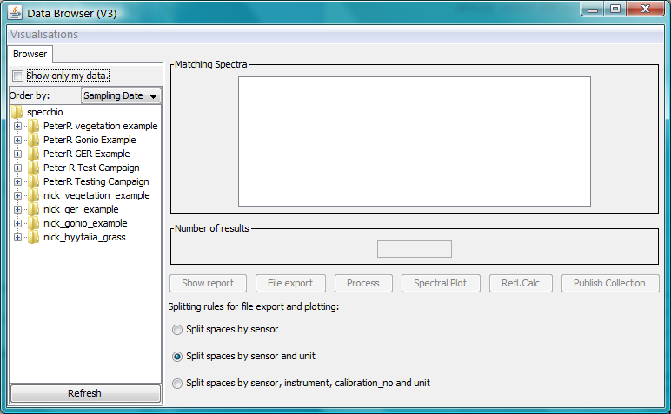

Figure : The main Browse data hierarchy window

Visualisations This menu item displays a drop down list of graphic visualisation options which you can apply to the Spectra listed in the Matching Spectra box. These options match those listed in section . Depending on the option and Spectra selected, some of these Visualisation options may take several minutes to process.

Show only my data Set this check box to restrict the display in the Hierarchy Tree browser to Campaigns which were uploaded by you or Campaigns for which you have been added to the Research Group.

Browse hierarchy tree The hierarchy tree is displayed and various Campaigns, nodes or spectra can be selected. See for information on using this control.

Matching Spectra The Spectrum IDs of the Spectra which are highlighted in the browse panel are listed in this box.

Number of results The number of Spectra IDs listed in the Matching Spectra box is shown in this box.

Six action buttons Of these six action buttons,  Show report ,  File export ,  Process ,  Spectral plot , and  Refl.calc  will become active when you have selected one or more Spectra. The  Publish Collection  button is only present if you are accessing an ANDS-enabled SPECCHIO Server and is only active if you are the owner or in the Research Group for the Spectra you have selected. The operations these buttons initiate will be performed on the selected Spectra. Each of these buttons has a section in this chapter.

Splitting rules for file export and plotting: Click on the radio buttons to select one of the options: Split spaces by sensor, Split spaces by sensor and unit or Split spaces by sensor, instrument, calibration\_no and units. This selection will affect the operation if you select the  Process ,  Spectral  Plot  or  File export  buttons.

## Query Builder

SPECCHIO’s Query Builder provides a way to select one or more Spectra based on their Metadata, and then perform operations on all of these selected Spectra. The operations which can be performed on the selected Spectra are the same as for the Spectrum Browser, and are explained in the later sections of this Chapter.

To Launch the Query Builder select Data Processing & Output/Build query from the menu on SPECCHIO’s Main Window.

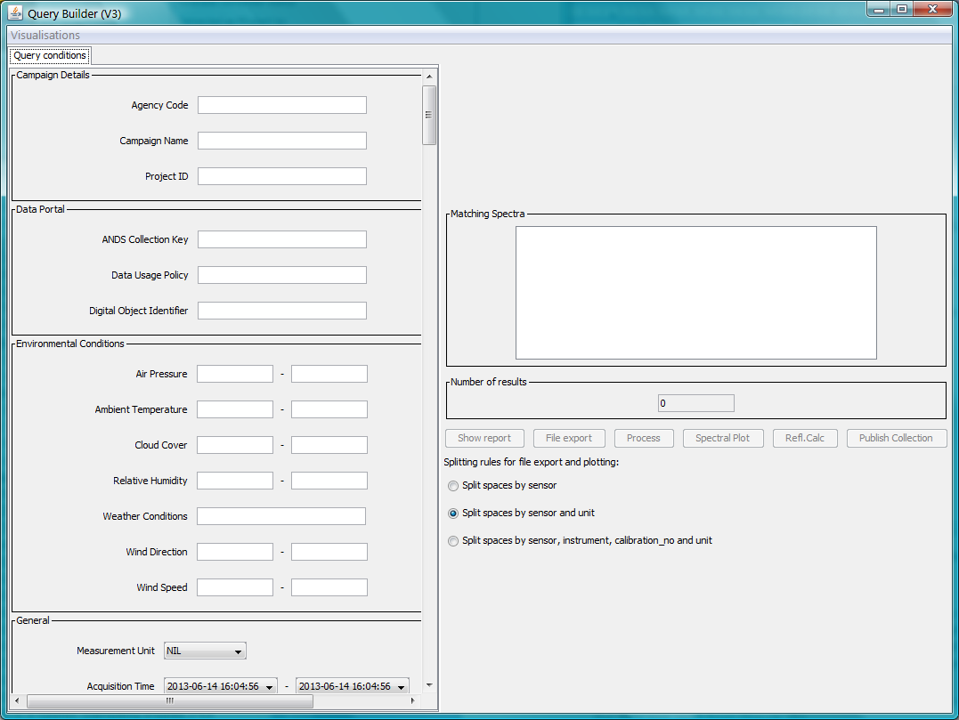

Figure : The main Query Builder window

The parts of this window are:

Visualisations This menu item displays a drop down list of graphic visualisation options which you can apply to the Spectra listed in the Matching Spectra box. These options match those listed in section . Depending on the option and Spectra selected, some of these Visualisation options may take several minutes to process.

Left panel There is one box for each SPECCHIO Spectrum-related Metadata Group and within each box, all of the metadata attributes for that group are listed with a data entry box.

Matching Spectra The Spectrum IDs of the matching Spectra are listed in this box.

Number of results The number of Spectra IDs listed in the Matching Spectra box is shown in this box.

Six action buttons The six action buttons,  Show report ,  File export ,  Process ,  Spectral plot ,  Refl.calc  and  Publish Collection  will become active when you have selected one or more Spectra. The operations they imply will be performed on the selected Spectra. Each of these buttons has a section in this Chapter.

Splitting rules for file export and plotting: Click on the radio buttons to select one of the options: Split spaces by sensor, Split spaces by sensor and unit or Split spaces by sensor, instrument, calibration\_no and units. This selection will affect the operation if you select the  Process ,  Spectral Plot  or  File export  buttons. See the relevant option description section in this chapter for more information.

Queries are created by entering selection criteria into the Metadata Attribute controls in the left panel. A new query is performed every time any change is made in any Metadata entry box. Initially, no query is active so the Matching Spectra box is empty.

The searching follows these rules.

* A search condition is created by making the search conditions for a Metadata attribute non-empty. Empty fields do not trigger any search conditions.
* Initially all Metadata query fields are empty. Even the data/time fields are empty, but the date/time dialog displays the current date and time in this case.
* Once a date/time selection field is modified, it cannot be made empty again. Therefore, searching will be done on this date/time until the dialog box is closed. This applies independently to the start and end date/times.
* A new query is performed every time any field is changed. Even if only one character is typed or removed, a new query is performed. For date/time fields, a new query is performed each time the date/time picker is closed.
* To be selected, a spectrum must satisfy all search criteria entered.
* The minima and maxima search conditions for a numeric or date/time Metadata Attribute are independent. That is, it is valid to enter just a minimum or just a maximum value.
* Numeric and date/time search ranges are inclusive. That is, if you enter a minimum Spectrum Number of “20”, Spectra with Spectrum Number greater or equal to 20 will be selected.
* If a search condition for a Metadata Attribute is present, Spectra without that Metadata Attribute will never be selected.
* When matching text strings, SPECCHIO uses a MySQL Query LIKE clause. Therefore, the following is supported.

% Matches zero or more characters.

\_ Matches exactly one character.

\ Causes the next character to be matched. That is, \% will match a % sign and \\_ will match an underscore character.

* For dropdown lists, the test is not performed if Nil is set. Otherwise, only those Spectra with exactly that value will be selected.

Notes Text Metadata Attributes which are present, but empty, can be selected by using %, but not by \_.

Text Metadata Attributes which contain only a single space can be selected by using %, \_ or a space.

It is common for some Spectrum file formats to have a File Comment field which contains only a space. This is not so for other Metadata Attributes.

Warning There is no option to search by Campaign Name, except for the Campaign Name in the Spectrum-related metadata group, Campaign Details. This is NOT the Campaign’s name and will generally not be present. See section for more information on the Spectrum-related Campaign Details Group of metadata attributes.

After you have entered search criteria for the Spectra you wish to operate on, click one of the six action buttons. See the following sections for details of the operation of these buttons.

## Show Report

Reports are generated by clicking on the  Show report  button in the Query Builder or Spectrum Browser. It operates on all Spectra which are selected at the time this button is clicked.

Reports are shown in a window in the following form.



Figure : Spectrum report frame

Just below the Spectrum graph, the number of Spectra graphs in the report is shown with a control to allow you to select which Spectrum graph you wish to display.



Figure : Spectrum Graph selection control

Click on the up and down arrows to cause the spectrum graph display to cycle through the available Spectra. The selected graph is displayed after a short processing delay.

Click on the Metadata Group check boxes to enable or disable display of the respective Metadata Group.

Click on the  Close  button to close this window.

There are four action buttons at the top of this window.

|  |  |  |
| --- | --- | --- |
|  | Print | Click on this button to Print the graph. The Metadata are not printed. It is recommended that you set the plot parameters first using the  button to add a title and identifying information to your printed graph. |
|  | Reset | Click on this button to reset the graph to its originally displayed form. |
|  | Set plot parameters | Click on this button to change the display parameters for the graph. The following Dialog is displayed.    Figure : File output dialog  Title: Enter a Title you want to appear at the top of the printed page.  Caption: Enter text that you want to appear under the graph.  X/Y Label: Enter the labels that you want to use to label the X and Y axes.  X/Y Range: Enter the lowest and highest values that you want to appear on the X and Y axes. The two values in each question must be separated by a comma.  Marks: Select the way you want the data points represented on the graph.  X/Y Ticks: Place specific labels along the X and Y axes. For example, entering “Threshold 450.3, Maximum 670.23” will place the string “Threshold” at the point 450.3 along the axis and “Maximum” at 670.23.  Grid: If checked, the graph will include a grid.  Stems: If checked, each data point will be joined to the X axis by a straight line.  Connect: If checked, the data points will be joined by straight lines. If you check this option, it is probably best to select the option None for the Marks: question in order to show a thin clean line.  Use Color: If checked, the various data lines on the graph will be given different colours. If not checked, they will all be black.  Use Line Styles: If checked, the data points will be connected with dashed lines. This option has no effect unless Connect: is checked.  These details are not remembered once you move away from viewing this graph. |
|  | Fit data | Click on this button to set the graph axis parameters to values which fit the displayed axes to the data. |

SPECCHIO scales the graph’s Y Axis for Spectra with Measurement unit set to Reflectance to display correctly even when there is strong atmospheric noise in the usual regions of 1350-1440nm, 1790-1980nm and 2360-2500nm. For these graphs, the maximum Y value is set by calculating the mean and standard deviation in the wavelength region 300-1200nm and then setting...

Max Y Axis value = Mean + 3 \* StdDev

When Spectra having no sensor definition are plotted, the X-axis will represent bands and not frequency.

For sensors comprising broad and narrow band elements (e.g. MFR) only the narrow bands will be plotted.

## File Export

Files are exported by clicking on the  File export  button in the Query Builder or Spectrum Browser. It operates on all Spectra which are selected at the time this button is clicked. The following window will open.



Figure : File output dialog

Controls are as follows:

File format: Select from the drop down list.

CSV: Data is written to a text file in comma separated value format. This file type can be read into Excel. A full description of the way CSV files are used can be found below at section .

ENVI SLB: ENVI spectral library file consisting of two files: a header file (<file\_name>.hdr) and a body file (<file\_name>.slb). Spectral data are written as floating point values, either 32 bit or 64 bit depending on the architecture of the machine. The datatype field in the header file is set accordingly (datatype 4 or 5 respectively).

Target directory: Click on  Browse  to select the directory into which the output files will be written. Note that when using a UNIX system you may have to enter a dot as filename (see section ).

Base name: Enter a character string which will be prefixed to the file name. This name should contain only characters that are allowed in filenames (depends on your operating system). The base name is used to build the real filenames according to one of the following patterns:

<base name>\_<sensor\_name>.<file extension>

<base name>\_<instrument\_name>[cal<calibration sequence number>].<file extension>

The actual choice of naming pattern depends on the selection made in the Splitting rules for exporting and plotting: question in the previous Query builder dialog or Data browser dialog.

If no instrument has been defined the sensor name will be used.

Split header and body Applies to CSV files only. The spectra data will be split into two separate CSV files. The body file will have the string \_BODY appended to the file name and \_HDR is appended to the file name for the header file. (ENVI SLB files are always split into header and body.) The data is also split according to the selection made on the Splitting rules for file export and plotting: question in the Query Builder or Spectrum Browser dialogs. See comment below about file naming.

Time format: Select your desired time format. Selecting milliseconds makes it easier if want to use the timestamp as an X axis value in Excel plotting.

The data file names are constructed using the following components.

Campaign name The Campaign name is always used in the output file name. It is not recommended to export data from multiple Campaigns at one time. The results are undefined.

Sensor name The Sensor name is always used in the output file name. There will be separate files for each Sensor.

Unit type If you select Split spaces by sensor and unit or Split spaces by sensor, instrument, calibration\_no and units, there will be separate files for each value of the Unit Metadata Attribute.

Calibration number If you select Split spaces by sensor, instrument, calibration\_no and units, there will also be separate files for each Calibration for each Sensor and Unit combination.

Example

Consider a campaign containing Spectra captured with:

* An ASD instrument belonging to the Institute of Natural Resources, Massey University (named INR ASD) with calibration sequence number 1
* An ASD instrument belonging to the Remote Sensing Laboratories, University of Zurich (named RSL ASD 1) with no calibrations entered in the database
* A GER 3700 instrument belonging to the Remote Sensing Laboratories, University of Zurich (named RSL GER 3700) with no calibrations entered in the database

A CSV file output of this campaign with the option ‘Split header and body’ results in the following files:



### CSV Spectrum Export Format

Multiple spectra are written into a single CSV file, with the data for each spectrum in a separate column.

If the Split header and body option is selected, then the header and body are written into separate CSV files. Otherwise, they are written into a single CSV file header first.

The header contains as many lines as there are Metadata Attributes defined in all of the selected Spectra. The first column of each row is the Metadata Attribute name.

The body contains one row for each wavelength. The first column is the wavelength in nanometres and the subsequent columns are the values at those wavelengths for each selected spectrum.

The following figure shows an Excel view of a CSV file created with three spectra and the header and body written into the same file.



Figure 56: CSV file example (loaded into Excel)

## Process

A separate chapter is devoted to this topic. Please see Chapter .

## Spectral plot

Using this option, plots of all currently selected Spectra are displayed.

Separate plots are created based on the setting of the Splitting rules for file export and plotting: question in the Query Builder or Spectrum Browser dialogs.

This example shows six Spectra plotted on a single graph.



Figure : Spectral plot graph

The four plot options that are described on page 93 in the section are also available for the Spectral Plot option. They relate to the four buttons shown at the top right of the above window.

## Refl.calc

This function is the same as Process, except that if you have a set of Spectra selected which all have Data Links to white Reference Spectra, it will set up a transformation from Radiance to Reflectance for those spectra as default operations in the Process window.

Refer to Chapter for further information.

## Publish Collection

A separate chapter is devoted to this topic. Please see Chapter .

# Help Functions

The Info functions do not read or affect your data or the SPECCHIO Database. They are selected from the menu on the Main Window.

## List available Metadata Elements

This function will launch your computer’s default text editor and open a text file which lists all of the Metadata Attributes.

It shows the Metadata Groups, the Attributes in each Group, and the data type for each Attribute.

The data type values and their meanings are:

binary\_val The value is a binary stream of data representing an image, such as a JPEG image file.

datetime\_val The value is selected from a date and time picker.

double\_val A floating point value

int\_val An integer value

string\_val An alphanumeric string or a PDF file

taxonomy\_id The value is chosen from a drop down list.

## About

This function shows the version of the SPECCHIO Client that you are running.

%%% It presently shows UOZ Remote Sensing Labs and the [www.specchio.ch](http://www.specchio.ch) website. Is there a need to change this? Elaine I assume so.

# Publishing Data to ANDS

Data from SPECCHIO can be published to the Research Data Australia (RDA) service of the Australian National Data Service (ANDS). From the ANDS website...

Research Data Australia, the flagship service of the Australian National Data Service ([ANDS](http://ands.org.au/)), provides a comprehensive window into the Australian Research Data Commons.

Research Data Australia is an Internet-based discovery service designed to provide rich connections between data, projects, researchers and institutions, and promote visibility of Australian research data collections in search engines.

ANDS is partnering with research institutions and data producing agencies to bring about four transformations to data - unmanaged to managed, disconnected to connected, invisible to findable and single use to reusable - that will enable Australia's research data to become a national strategic resource to support better, more efficient and defensible research, and improved policy input.

ANDS is funded by the Australian Government through the National Collaborative Research Infrastructure Strategy ([NCRIS](http://ncris.innovation.gov.au/)) and the Education Investment Fund (EIF) Super Science Initiative.

See <http://www.ands.org.au/> and <https://researchdata.ands.org.au/> for more information on ANDS and this service.

In SPECCHIO, you can only Publish data for which you are the owner or a member of the Research Group.

Publication from SPECCHIO involves these key steps.

1. Decide on the Spectra to be grouped together and published as a Collection. The Spectra can be all of a Campaign, part of a Campaign, or even be selected from multiple Campaigns.
2. Ensure that the Spectra in the Collection are complete and meet the minimum Metadata requirements for Publishing, including their Campaign Metadata.
3. Decide on the Principal Investigator, and ensure their SPECCHIO User information is correct and up-to-date.
4. Publish the Collection, indicating the Principal Investigator.
5. SPECCHIO generates an ANDS Collection Key for this collection and writes it to all Spectra in the collection key as a Metadata Attribute in the Data Portal Group.

The ANDS Collection Key can be used to identify the Spectra in this Collection by searching for it using SPECCHIO’s Query Builder. Each Spectrum will have one ANDS Collection Key Metadata value for each Collection in which it has been included.

Warning Once Published, there is no way to retract the Publication using the SPECCHIO client. You will need to approach your System Administrator if you have Published in error.

Note The RIF-CS file is a logical reference to your Spectral data, so it’s important to ensure that this data remains valid and accessible in the SPECCHIO database. This will ensure that it can be provided at a later time to those that request it based on the Published ANDS information.

In the Publication step, the following Metadata are copied from SPECCHIO to the files which are sent to ANDS. The values of the Metadata are taken from the Spectrum with the highest Spectrum ID, which will be the one from your Collection that was the last to be loaded into SPECCHIO. If these Metadata Attributes have multiple values for that last Spectrum, only the first Metadata Attribute value is used.

%%% Are any of these optional? DOI for example?

* Description (Campaign-related Metadata)
* Citation (Scientific References Metadata Group)
* Publication (Scientific References Metadata Group)
* Data use policy (Data Portal Metadata Group)
* FOR Code (Data Portal Metadata Group)
* Digital Object Identifier (Data Portal Metadata Group) %%% How do you get one of these. Elaine Currently we are figuring this out with the library.
* Location Name (Location Metadata Group)
* Acquisition Time (General Metadata Group) The Acquisition Times for all Spectra in the Collection are scanned and the maximum and minimum times are written to the RIF-CS file.

In addition, User Information for the nominated Principal Investigator is copied to the published files. (The User Information for the User doing the SPECCHIO publication operation is not used, unless of course, it’s the same User.) Values copied include the following...

* Title and Name
* Email address
* Department and Institute Name
* ANDS Party Identifier

Refer to for more information, especially information on the ANDS Party Identifier.

When data is published, SPECCHIO reformats the Metadata from the selected Spectra into the RIF-CS format, which is an XML format involving two files, and places those files in a discovery location on the server. On a regular basis (currently daily), the RDA service inspects this location. If there are any RIF-CS files present, it copies them, validates them and, if they pass validation, publishes the Collection description on RDA for discoverability. Information about the RIF-CS format can be found on the ANDS website referred to at the start of this Chapter.

To Publish a Collection to ANDS…

|  |
| --- |
| Ensure that all Spectra to be included in the Collection have their Metadata set correctly as described above.  Select either Data Processing & Output and Browse data hierarchy from the menu on the Main Window.  Set the Show only my data option.  Select the Spectra to be included in the Collection in the Data hierarchy browser.  Review carefully that you have selected the correct Spectra. (Important – do not skip this step, because you cannot retract once you have Published.)  Click on the  Publish  button. The following dialog, which shows all members of the Research Group, is displayed.    Select the principal investigator from the list by clicking on the name.  Click  Submit . If the Collection Metadata is successfully validated, the Publication will proceed and a dialog box will be displayed showing the ANDS Collection Key that was assigned to this Publication. (If validation is not successful, an error dialog will be displayed.)  Click  Close  to close the ANDS Collection Key dialog. |

Alternatively, you can select Build query instead of Browse data hierarchy in the above process, and build a query to select the Spectra you want included in your Collection.

If any mistake in the Metadata is detected for the Spectra in your Collection, SPECCHIO will display an error dialog and Publication process will not proceed. Correct the error and retry the Publication process.

# Interactive Processing using Space Networks

For an introduction to the concept of the Space Processing Network please refer to section .

Pressing the  Process  button in the Data Hierarchy Browser or Query Builder starts this processing tool. The window below appears.



Figure : Space Network Processor interface with the Query Builder in the background

A number of spaces are placed on the processing plane of the Space Network Processor, depending on the query built in Query Builder.

shows a space containing 66 spectra, created based on a selection in the Query Builder.

Figure 59 shows the common elements of the Space Network Processor: processing plane, spaces, edges, context sensitive menu of the processing plane and the Run button.

:::Plots and Graphs and Screenshots:Space Network Processor.pdf

Figure 59: Elements of the Space Network Processor

## Graphical Representations of Spaces and Modules

Spaces are depicted as rectangular boxes as shown here.



Figure 60: Examples of the graphical representation of a space (left) and a processing module (right)

Each space displays the following information:

[Integer] A unique number (zero in the example below)

Type A space type, which can be ‘Sensor/Instrument Space’ if loaded from the database or ‘Spectral Space’ if generated by a processing module.

D A dimension D, which is equal to the number of spectral bands of the spectra held by this space

# Vectors A number of vectors, which is equal to the number of spectra held by this space

Modules are also depicted as rectangular boxes, but their contents are quite different.



Figure 61: Examples of the graphical representation of a space (left) and a processing module (right)

Figure 62: Examples of the graphical representation of a space (left) and a processing module (right)

Proc. module A module name

Settings Information about the configuration (if applicable)

Status The current processing status (text and progress bar). During processing, the progress is shown by the progress bar.

Spaces and modules can be rearranged by dragging with the mouse. The edges are updated automatically.

A group of elements can be moved as single block. Select the elements by dragging a box around them using the mouse, then drag the selection (Figure 63).



Figure 63: Multiple-selection of elements after dragging a box around them

## Adding Modules and linking with Spaces

To add a module, click the mouse menu button over some empty area of the processing plane. This brings up the context sensitive menu shown in . Select ‘Add Module’ and a selection of the available modules will appear (). Select one of the modules, click ‘OK’ and a new module will be added to the processing plane.

To connect the module with an input space, click the menu button over the module. This displays the popup menu of the module (). Select ‘Set Input Spaces’ and in the ‘Input Space Selection’ dialog select the number of the space to connect and click ‘OK’ (). Note that all spaces are given a unique number, which is located on the top left of each space. Connecting an input space automatically generates an output space, which is added to the processing plane and connected with the module.



Figure 64: Module selection dialog

 

Figure 65: Popup menu of a module (left) and the input space selection dialog (right)

## Configuration of Modules

Some modules may need configuration. To display the configuration dialog of a module click menu over the module and select ‘Configure’.

The possible configuration settings of each module are detailed in the respective module description.

## Processing Module Descriptions

### Radiance to Reflectance Transformation

The module ‘Radiance to Reflectance’ is building ratios of target and reference panel radiances:



As a prerequisite, datalinks of the type ‘Spectralon’ must exist between the target spectra and the corresponding reference spectra. For an explanation of how such links are created please refer to .

### Reference Panel Correction Factors

This module retrieves the correction factors for all reference panels that were used during data acquisition of the spectra contained by the input space.

As prerequisites, a reference panel must be set for the input spectra using the Metadata Editor () and calibration data for the panel must have been loaded to the database. Calibration data loading is a task of the system administrator. For details on the reference panel administration see .



Figure 66: Reference panel setting in the Metadata Editor

If no calibration data can be found, a warning is displayed and the module creates no output space.

shows a processing chain that selects the panel correction factors and plots using a spectral line plot ().



Figure 67: Processing chain selecting the correction factors and plotting them as a spectrum.



Figure 68: Reference panel correction factors

### Correct for Reference Panel Non-Idealness

This module applies calibration factors to correct spectra for the reference panel non-idealness. These correction factors are selected from the database using the ‘Reference Panel Correction Factors’ module.

The module requires two inputs: the spectra to be corrected and the correction factors. The input space selection dialog offers the according choices ().



Figure 69: Input space selection for the ‘Correct for Panel’ module

Note that the dimensions of the spaces holding the spectra and correction factors must be identical (a check on the wavelengths is not carried out). In the example shown in a waveband filtering is applied to the correction factors as these were measured with a larger wavelength range.



Figure 70: Space Processing Network for reference panel correction

The panel correction can be applied to radiance or reflectance values. However, correcting radiances for the panel will only make sense if followed by a radiance to reflectance conversion such that:



The correction procedure can handle multiple reference panels and multiple calibration coefficients and will apply the correct coefficients to the appropriate spectra.

### Delta

This module calculates a delta value, i.e. the difference between two inputs A and B:

Delta = A – B

where:

A, B = MxN matrix of M spectra of dimensionality N

Thus, a delta vector is calculated by:



where m = {1…M}

This implies that the input spaces must have identical number of vectors and dimensionalities.

The delta module takes two input spaces ():



Figure 71: Input space selection for the Delta module

A possible use is the calculation of the difference between recorded reflectance and reference panel corrected reflectance. Figure 72 shows a processing network for this purpose and Figure 73 shows the according spectral plots generated by the network.



Figure 72: Space Processing Network for the panel correction and delta calculation

|  |  |  |
| --- | --- | --- |
|  |  |  |

Figure 73: Spectral plots of: input spectrum (left), panel corrected spectrum (middle) and delta spectrum (left)

### Waveband Filter

Waveband filtering is used to cut wavelengths regions from spectra. A typical example is the removal of noisy wavebands caused by water vapour absorption.

The wavebands are freely configurable. The ‘Configure’ menu brings up the ‘Filter configuration’ dialog ().



Figure 74: Filter configuration window

To add a new filter region, click ‘New’ and enter the upper and lower wavelengths in nanometres in the Filter Definition dialog (Figure 75).



Figure 75: Filter definition dialog

To remove an existing filter region, select the region in the list and click ‘Remove’.

### Broadband and Narrowband Filters

The filters act on the element type of sensor elements. They are useful to process data of sensors that contain bands widely differing spectral resolutions.

An example is the MFR sunphotometer, which features one panchromatic band and 6 narrower bands. The value ranges of the broad and narrow bands are very different and even a simple plot cannot be created satisfactorily (see ). The broadband channel has been placed at the likely centre wavelength of 673nm. As the bands of the MFR are defined in the order of the broadband followed by the narrowbands in the database, the plot shows two spectral lines. Mixing broad- and narrowbands should not be done from a physical point of view.



Figure 76: Spectral plot of broad- and narrowband MFR channels

Figure 77 shows a space processing network that illustrates the function of broad- and narrowband filters.



Figure 77: A space processing network demonstrating the function of broad- and narrowband filters

The plot shown in was generated by the ‘Spectral Line Plot’ of space number 0.

shows the plots of space 2 (Broadband value as a scatter plot) and space 3 (Narrowband channels as a spectral curve).



Figure 78: Plots of the narrowband channels (left) and of the broadband channel (right)

## Visualisation Modules

Visualisation modules can be attached to any space and do not generate an output space but display a new window containing the respective plot or data explorer. A visualisation module can be configured to produce a number of plots/explorers as listed in the following sections. Data explorers are graphical components that allow interactive data exploration.

The titles of the plot windows do contain information about the plot type and the space the data was read from ().



Figure 79: Information displayed in the window title

### Spectral Line Plot

Use this plot to display one or more spectra as continuous curves. Spectra are plotted with an automatic colour shift from red to blue for easier interpretation.



Figure 80: Spectral line plot of snow avalanche reflectance spectra

### Spectral Scatter Plot

Use this plot to display values per spectral band as singular points. This is useful to plot e.g. data of sensors with just one band, e.g. MFR broadband, as single values cannot be visualized as line plots. Scatter plots are also useful to show the variation of the values per band. shows an example of the variation per channel for several MFR sunphotometer readings.

**Note**: the generation of scatter plots of several spectra with high dimensionality tends to be quite slow.



Figure 81: Scatterplot showing the variation per channel for several MFR sunphotometer readings

### Gonio Sampling Points Plot

Use this plot to visualise the sampling positions of directional measurements acquired by a goniometer system. The plot is not expecting any specific number of points or particular geometry.

The sampling points are projected from their angular definition (zenith/azimuth) onto a 2d Cartesian coordinate system ().



Figure 82: Goniometer sampling point positions

### Gonio Hemisphere Explorer

The Hemisphere Explorer allows the interactive exploration of a spectrodirectional dataset, typically acquired by a goniometer system. shows an explorer window displaying a LAGOS (Laboratory goniometer system) dataset (Schopfer 2008).



Figure 83: Gonio Hemisphere Explorer window

The explorer window comprises a number of components interacting with each other as described hereafter.

The hemispherical plot () displays an interpolated surface of a specific wavelength. Clicking the icon in the top-left of the plot brings up a control panel for plot adjustments (rotations).

 

Figure 84: Interpolated 3D plot for a chosen wavelength (left) and rotation toolbox to manipulate the 3D plot

Use the band selection slider to select a spectral band for display (Figure 85). The wavelength text field below is reflecting the wavelength of the chosen band. Selecting a band triggers a re-plotting of both hemispherical plot and spectral plot.



Figure 85: Band selection slider and wavelength text field

The sampling points plot shows the sampling point positions projected onto a 2d Cartesian coordinate system (). One of these points is always selected (indicated by the little square around it). Information about the selected point is shown in the text fields on the right of the plot: filename of the respective spectrum, azimuth and zenith angles of the observation geometry. Changing the selected sampling point (by clicking the mouse on another point) changes the spectrum displayed in the spectrum plot automatically.

The azimuth angle is measured relative to the solar principal plane, i.e. 0° = principal plane opposite of the illumination source.



Figure 86: Sampling point position plot and information about the selected sampling point

The spectral plot component displays the spectrum of the selected sampling point (Figure 87). A red, vertical line indicates the current wavelength as selected by the band selection slider. The text fields on the right of the plot display spectral statistics of the current spectrum.



Figure 87: Spectral plot component with wavelength indicator and spectrum statistic information

### Time Line Plot

Use a time line plot to plot a spectral band versus time. Figure 88 shows showing the direct irradiance over time for an MFR sunphotometer band with centre wavelength 496.4nm. The channel to be plotted can be chosen in the list below the plot. Time information is retrieved from the sampling time of the spectra.



Figure 88: Time Line Plot showing the direct irradiance over time for centre wavelength 496.4nm

### Time Line Explorer

The time line explorer consists of a time line plot and a spectral plot (). The red bar in the time plot indicates what spectrum is plotted in the spectral plot, i.e. the spectral plot shows the spectrum taken at a certain time. The red bar in the spectral plot shows the currently selected instrument channel, which is plotted versus time in the time line plot.



Figure 89: Time Line Explorer window

The example given in Figure 89 is using MFR sunphotometer data. A removal of the broadband channel is needed for the spectral plot to work properly. The according processing chain is shown in Figure 90.



Figure 90: Processing chain for the exploration of the narrowband MFR channels in the Time Line Explorer

## File Export Module

File export modules can be attached to any space and do not generate an output space but write the data to a file.

A file export module must be configured using its configuration dialog (). The dialog is identical to the one described in .



Figure 91: File export configuration

The spectral data written to the file reflects the data content of the space. The metadata is however mainly read from the database and may show some contradictions to the state of the space.

# Data Administration

The Data Administration functions are useful for managing the integrity of the SPECCHIO database.

The following functions are restricted to users with Administrator permission.

|  |  |
| --- | --- |
| **Menu item** | **Operations Restricted to Administrators** |
| Data remover | Removing data belonging to other users |
| Export campaign | None |
| Import campaign | All functions |
| Load sensor definition | All functions |
| Instrument administration | Changing, adding or deleting any Instrument or Reference Panel information |

## Removing data

Spectra, hierarchies or entire Campaigns can be removed from the database using the Data Remover.

Users can only remove data from the database if they are a member of the Campaign’s Research Group (see ). A user with Administrator permissions can remove all datasets irrespective of their owner.

To remove data...

|  |
| --- |
| Select Data Maintenance and Remove data from the Main Window menus. The following window is displayed. Only the Campaigns which you have permission to remove will be displayed.    Figure : Data Remover dialog  Use the spectral data browser to select the nodes or spectra that you wish to remove. Multiple spectra and nodes can be selected by using the Shift and Control keys. You can select any node except the specchio root node. Selecting a Campaign node is valid.  Click the  Remove  button. All data that is below the selected node or nodes will be deleted. For example, if a Campaign is selected then all hierarchies and spectra belonging to this Campaign will be deleted. In addition, all metadata that has been entered for the deleted objects will be removed along with the objects.  Warning There is no further prompt to warn you. The data are deleted as soon as you click the  Remove  button. This action cannot be undone.  Close the dialog box by clicking on  Close . |

Removing data can take a long time. A progress bar shows which hierarchy is currently being removed.

## Campaign Export

The Campaign export functionality writes all data of a Campaign to a single XML file which retains the hierarchy and Metadata structure of the Campaign. The information from the Sensors, Instruments and Calibrations used by the Campaign is also copied into the XML file.

These XML files can be used to import the campaign into another SPECCHIO database instance.

The exported XML file will be named with the Campaign name, date and time of export.

To export a Campaign...

|  |
| --- |
| Select Data Maintenance and Export campaign from the menu of the Main Window.    Figure : Campaign Export Dialog  Select the Campaign you wish to export from the Campaign name: dropdown list.  Click the  Browse  button to open a file dialog box.  Select the directory into which you want the XML file to be written and close the dialog box.  Click  Export . The Campaign Export dialog box will close and a progress box will appear. When the export is complete, it will close. |

## Campaign Import

Note In order to use this option, you must be logged in as an Administrator.

The import function reads an XML file that was created by the SPECCHIO Export campaign function. The import will create an exact copy of the exported Campaign. It will also add any Sensor, Instrument or Calibration information that is referenced by this Campaign if it does not already appear in this database.

To import a Campaign...

|  |
| --- |
| Select Data Maintenance and Import campaign from the menu of the Main Window.    Figure : Campaign Import Dialog  Click the  Browse  button to open a file dialog box.  Select the XML file that you want to import into your current SPECCHIO database and close the dialog box.  In the Campaign Owner: box, select the name of the Researcher who will be the imported Campaign’s owner.  Click  Import . When the import is complete, the Campaign Import dialog will close. |

Notes The Export and Import database versions must be the same. SPECCHIO does not check this. If they are not the same, the new Campaign will not be readable and the database may give unpredictable results.

The name of the imported Campaign will be identical to the name of the exported Campaign. If you import into the same database you exported from, you will have two identically named Campaigns. To avoid confusion, it would be advisable to rename the newly imported one using the Metadata Editor to change the Campaign Metadata’s Campaign Name value.

## Definition of new Sensors

A new sensor can be defined by loading a sensor definition file. Once defined, it will appear in the dropdown list of sensor names which appears at several places within SPECCHIO.

Warning Take care when defining new sensors. There is no method of editing or inspecting sensor information using the SPECCHIO Client. Therefore, there is no method of confirming that your data was entered correctly, so prepare your input sensor definition file very carefully.

To load a Sensor Definition file…

|  |
| --- |
| Select Data Maintenance and Load sensor definition from the menu on SPECCHIO’s Main Window. The following dialog is displayed.    Figure : Read Sensor Definition File dialog  In this dialog, specify the sensor definition file and click  OK  to read the file and insert the new sensor into the database. |

Sensor definition files are a proprietary format tab separated text files that can be edited in a text editor or in Excel. The file format is as follows (the tab positions have been lined up for clarity):

Name Description Company Type no no of channels

<sensor name> <sensor descr> <company name> <type number> <no of channels>

Band Average Wavelength(nm) FWHM (nm)

<band number> <wavelength> <fwhm>

<band number> <wavelength> <fwhm>

<band number> <wavelength> <fwhm>

:

:

The first two rows define basic parameters of this Sensor, the first row being the names of the five parameters which are required and the second row being their values. These parameters must be provided in the given sequence. The names in the first row are required and must be correct.

<sensor name> The name by which this new Sensor will be known to SPECCHIO. It will appear in the Sensor Metadata Attribute’s dropdown list.

<sensor descr> A short description of this Sensor

<company name> The name of the company which manufactures this sensor. It must exactly match the value in the short\_name column for one of the manufacturers in SPECCHIO’s predefined manufacturer’s table. See for the list of manufacturers and their short\_name values.

<type number> SPECCHIO will attempt to match this integer number to the Instrument Type number in Spectrum files when they are read. This is used to automatically set the Sensor in the Spectrum’s Metadata.

<no of channels> The number of frequency channels measured by this Sensor. This must be the same as the number of lines in the Band Table in this file.

The third row must have the headings of the parameters for each band.

Rows 4 to 3 + <no of channels> must have three numeric values on each line.

<band number> An integer number, starting at 1 and incrementing for each band in the Band Table.

<wavelength> The central wavelength of this band in nanometers.

<fwhm> The Full Width at Half the Maximum value for this band. The value is difference of the upper and lower frequencies in nanometers. This value is presently ignored. (It is included for possible later new features.)

Notes on the file format.

* There must be exactly one tab character between each field.
* The lines must not start with a tab character.

Example

An Excel view of a Sensor Definition File.



Figure 96: Part of a sensor definition file being edited in Excel

A text file view of the same file. Note that the tab positions do not appear to line up when displayed this way.

Name Description Company Type no no of channels

ASD FSFR ASD Fieldspec FR ASD 4 2151

Band Average Wavelength (nm) Full Width at Half the Maximum FWHM (nm)

1 350 2

2 351 2

3 352 2

4 353 2

5 354 2

6 355 2

7 356 2

8 357 2

9 358 2

10 359 2

11 360 2

12 361 2

13 362 2

14 363 2

15 364 2

16 365 2

17 366 2

18 367 2

19 368 2

20 369 2

21 370 2

## Instrument Administration

Note Any user can open the Instrument Administration dialogs but only Administrators can commit changes to the database.

For each Instrument in the SPECCHIO database, the following fields are stored.

|  |  |  |
| --- | --- | --- |
| **Field name** | **Format** | **Comments** |
| Instrument name | Text string | This name will appear in the dropdown list of Instruments. |
| Instrument owner | Selected from dropdown list of Institutes | This Institute list is created in the Create new user account dialog. See . |
| Serial number | Text string | The Instrument’s physical serial number. |
| Sensor | Selected from dropdown list of Sensors defined in database | Defines the Instrument type or model for this particular Instrument. |
| Pictures | JPEG image (on some users’ computers, PNG, GIF or TIFF may also be supported.) | Multiple pictures of the Instrument may be uploaded to each Instrument definition. |
| Calibrations | See section . | Multiple Calibrations make up the Calibration history for each Instrument. |

To open the Instrument Administration dialog...

|  |
| --- |
| Select Data Maintenance and Instrumentation Admin. from the menu on the Main Window.  Click in the Instrument Data tab. |

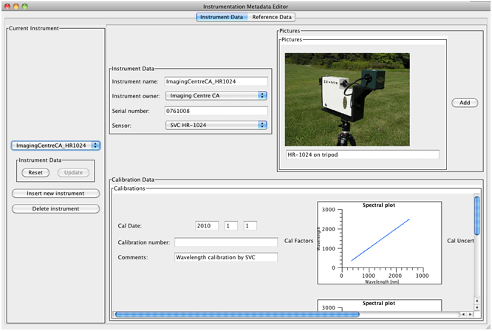

Instrument Selector

%%% Looks different now. Get a new screen dump.

Figure : Instrument Data Editor

The various parts of this dialog and their operation are explained in the following table.

Instrument Selector This dropdown list includes all Instruments in the SPECCHIO Instrument Table. Use this to select which Instrument you wish to view or edit.

Instrument Data There are two related boxes with this title. One shows the data for the Instrument Selected by the Instrument Selector. You can modifiy the data displayed in this box. The other has two buttons.

 Reset  Click this button to reset the display in the Instrument Data box with information re-read from the database.

 Update  Click this button to write any updated data entered into the fields in the Instrument Data box back to the database. This button is only active for users with Administration permission.

Pictures Any picture of the Instrument uploaded to the database is displayed in this box.

Calibrations This box shows all Calibrations which have been uploaded for this Instrument.

 Insert new instrument  Click this button to create a new Instrument in the database. Set the correct details for this new Instrument in the Instrument Data fields, and then click  Update  to write this new data back into the database. This button is only active if you have Administrator permissions.

 Delete instrument  Click this button to delete the currently displayed Instrument. You must click  OK  in a confirmation dialog box which is displayed before the Instrument is deleted from the database. This button is only active if you have Administrator permissions.

An instrument cannot be deleted while still referenced by one or more Spectra in the database.

Each Instrument can have one or more pictures loaded. JPEG images are supported on all platforms. On some computer systems, GIF, PNG and TIFF may also be supported. It is recommended not to load large images to avoid lengthy upload times. Images should generally be re-sampled to be about 400 to 500 pixels high or wide.

To add a picture to the currently displayed Instrument definition…

|  |
| --- |
| Right click anywhere within the Pictures box. A menu will be displayed.  Click Add picture from this menu. A file selection dialog box is displayed.  Select the image file you wish to upload. The image will appear in the Pictures box with a space for a caption below it.  Click within the caption entry control and type in your required image caption.  Click the  Update  button to load the image and caption to the database. (Larger images may take a short while to upload.) |

Note If you decide against uploading your new selected image, click the  Reset  button. Do not right click and select Remove Image. This may not yield the desired result when  Update  is clicked.

To remove a picture from the currently displayed Instrument definition…

|  |
| --- |
| Right click on the image you wish to remove. A menu will be displayed.  Click Remove picture from this menu. The picture and its caption will disappear from the Pictures box.  Click  Update  to write this change to the database. |

### Instrument Calibrations

Each Instrument has an optional Calibration History with one or more Calibrations. When Spectra from an Instrument are processed, the Instrument’s Calibration History is searched for the most recent Calibration at the time each Spectrum was acquired. If there is no Calibration History, or the acquisition time precedes the date of the first Calibration, the Instrument’s Sensor definition is used instead.

For each Calibration, the following information can be stored.

|  |  |  |
| --- | --- | --- |
| **Field name** | **Format** | **Comment** |
| Calibration date | Date/time selected by date picker | The date on which this Calibration was performed. Where possible, SPECCHIO will use the Calibration with the most recent date and time which is prior to the Acquisition date/time of the Spectrum being processed. |
| Calibration number | Integer | The sequence number of this Calibration. If there is insufficient date information, and a Calibration Number is given in the Spectrum’s Metadata, SPECCHIO will attempt to select a Calibration based on this Calibration sequence number. It usually starts at 0 and is incremented for each new Calibration. However, this is not a SPECCHIO requirement. |
| Comments | Text String | A comment about this Calibration. |
| Calibration wavelengths | Floating point array | Table of wavelengths of the centre of each band. The number of entries in this table must match the number of entries in the Sensor definition for this Instrument. |

Calibrations can be added from a file or manually entered. If added from a file, they are complete Calibrations. If added manually, they are place markers only and do not contain enough information to be used as a Calibration. They should be replaced with a Calibration uploaded from a file when that information is available.

SPECCHIO supports the following formats for loading Instrument Calibrations.

* Unispec SPU files
* SpectraVista SIG files (Only HR-1024 has been tested)

Note ASD calibration files cannot be loaded as SPECCHIO calibration files. The Spectra from these Instruments are adjusted according to the calibration within the ASD Instrument itself and so there is no requirement to load them here.

SPECCHIO reads the centre wavelengths of the instrument bands from these files, but ignores the Spectrum values when reading these files as Calibration files. In normal operations, the same file which is used to load an Instrument Calibration would also be read by the general Campaign Spectra load process (see 6.10Loading Data into SPECCHIO).

Other file formats which also store centre wavelengths of bands (such as Ocean Optics, UniSpec single beam, GER 3700 or APOGEE) are not yet supported by SPECCHIO for Calibration file reading. Attempting to use these file formats may lead to unpredictable results.

To add a new place marker Calibration…

|  |
| --- |
| Right click anywhere within the Calibrations box. A menu is displayed.  Select Add calibration from this menu. A new Calibration with empty information is immediately loaded to the database and displayed.  Enter the required Calibration identification parameters. You cannot enter the actual calibrated values.  Click  Update  to write the new Calibration information back to the database. |

To add a new complete Calibration from a file…

|  |
| --- |
| Right click anywhere within the Calibrations box. A menu is displayed.  Select Add calibration from file from this menu. A file selection dialog is displayed.  Select the Calibration file (Unispec SPU file or SpectraVista SIG file) you wish to upload. |

To remove a Calibration…

|  |
| --- |
| Right click anywhere over the Calibration you wish to remove from this Instrument’s information. A menu is displayed.  Select Remove calibration from this menu. The Calibration information is immediately removed from the database and remove from the display in the Calibrations box. |

Warning Calibration removal is immediate and cannot be undone. Please take care not to select this option for Calibrations you do not wish to remove.

## Reference Panel Administration

Note In order to change or remove Reference Panel information, you must be logged in as an Administrator.

SPECCHIO stores a table of Reference Panel information. The Reference Panels in this list appear in the dropdown list for the Reference Metadata Attribute in the Instrumentation Group. This Metadata Attribute is used in some functions of the Space Processing Netowok described in Chapter , and in particular during the reference panel correction procedure as described in sections 10.4.2 and 10.4.3.

Each Reference Panel record holds the following information.

|  |  |  |
| --- | --- | --- |
| **Field name** | **Format** | **Comment** |
| Reference name | Text string | This name will appear in the dropdown list of Reference Panels, which is used to set the Reference Metadata Attribute in the Instrumentation Group. |
| Reference owner | Selected from dropdown list of Institutes | This Institute list is created in the Create new user account dialog. See . |
| Serial number | Text string | The Reference Panel’s physical serial number. |
| Reference brand | Selected from predefined dropdown list | There is presently only one brand (Spectralon) defined in SPECCHIO. If you require further brands to be added, speak to your System Administrator. |
| Pictures | JPEG image (on some users’ computers, PNG, GIF or TIFF may also be supported.) | Multiple pictures of the Reference Panel may be uploaded to each Reference Panel definition. |
| Calibrations | See section . | Multiple Calibrations make up the Calibration history for each Reference Panel. |

When the SPECCHIO database is installed, the table of Reference Panels is empty.

To open the Reference Panel Administration dialog...

|  |
| --- |
| Select Data Maintenance and Instrumentation Admin. from the menu on the Main Window.  Click in the Reference Data tab. |

The operation of the Reference Panel dialog is analogous to that for Instruments. Refer to section 11.5 Instrument Administration and use the instructions in that section and its sub-section on Calibrations to understand the operation of Reference Panel viewing and maintenance.

### Reference Panel Calibrations

Each Reference Panel can have one or more Calibrations defined. For each Calibration, the following information can be stored.

|  |  |  |
| --- | --- | --- |
| **Field name** | **Format** | **Comment** |
| Calibration date | Date/time selected by date picker | The date on which this Calibration was performed. Where possible, SPECCHIO will use the Calibration with the most recent date and time which is prior to the Acquisition date/time of the Spectrum being processed. |
| Calibration number | Integer | The sequence number of this Calibration. If there is insufficient date information, and a Calibration Number is given in the Spectrum’s Metadata, SPECCHIO will attempt to select a Calibration based on this Calibration sequence number. It usually starts at 0 and is incremented for each new Calibration. However, this is not a SPECCHIO requirement. |
| Comments | Text String | A comment about this Calibration. |
| Calibration table | Table | A table of calibration values at various wavelengths with the following fields.  Wavelength The wavelength in nanometres at which the Calibration values apply  Rho The reflectance factor of the panel at this wavelength, in the range 0 to 1  Sigma The uncertainty estimate of the Rho value, expressed as a standard deviation |

Calibrations can be added from a file or manually entered. If added from a file, they are complete Calibrations. If added manually, they are place markers only and do not contain enough information to be used as a Calibration. They should be replaced with a Calibration uploaded from a file when that information is available. Calibrations do not need to be loaded in chronological order, but they will be used according to their dates.

The Calibration file supplies the Wavelength/Rho/Sigma table. The Calibration date, Calibration number and comments must be manually updated after the table is loaded. This file is formatted as follows…

* A tab separated text file, usually with TXT extension.
* The first line must be a heading line. Its first value must be exactly “wvl” and there must be a heading for the Rho column.
* The entry for each wavelength is on a new line.
* The values on each line are in the sequence Wavelength, Rho and Sigma.
* The Sigma value is optional. However, if it is present, it must be present on all lines, and there must also be a heading for it in the first line of the file.

Note For Spectralon calibration files as provided by LabSphere, if required, uncertainty information must be added by the user to the file before loading.

Example

wvl rho sigma

250 0.98 0.02

251 0.98 0.02

252 0.981 0.02

253 0.98 0.02

254 0.98 0.02

255 0.981 0.02

256 0.98 0.02

257 0.98 0.02

258 0.98 0.02

259 0.981 0.02

260 0.98 0.02

261 0.98 0.02

262 0.978 0.02

263 0.979 0.02

:

:

Before loading a calibration file, a sensor definition fitting the wavelengths of the calibration must be present in the database. In the case of Spectralon reference panels, the sensor definition is the Perkin-Elmer Lambda 19 sensor.

To add a new place marker Calibration…

|  |
| --- |
| Right click anywhere within the Calibrations box. A menu is displayed.  Select Add calibration from this menu. A new Calibration with empty information is immediately loaded to the database and displayed.  Enter the required Calibration identification parameters. You cannot enter the actual calibrated values.  Click  Update  to write the new Calibration information back to the database. |

To add a new complete Calibration from a file…

|  |
| --- |
| Right click anywhere within the Calibrations box. A menu is displayed.  Select Add calibration from file from this menu. A file selection dialog is displayed.  Select the Calibration file you wish to upload. |

To remove a Calibration…

|  |
| --- |
| Right click anywhere over the Calibration you wish to remove from this Instrument’s information. A menu is displayed.  Select Remove calibration from this menu. The Calibration information is immediately removed from the database and remove from the display in the Calibrations box. |

Warning Calibration removal is immediate and cannot be undone. Please take care not to select this option for Calibrations you do not wish to remove.

# Matlab Integration

The Matlab environment is a well-established tool in engineering, research and science. Matlab includes a Java Virtual Machine and thus allows the use of Java classes within Matlab code.

To extract Java code for a Matlab query from the SPECCHIO client...

|  |
| --- |
| Select Data Processing & Output and Browse data hierarchy from the menu on the Main Window. The Data Browser window will open.  Using the Hierarchy Browser, select a Hierarchy node or a selection of Spectra. The Spectra IDs will appear in the Matching Spectra box.  Right click in the Matching Spectra box. A menu will appear.  Select Copy Matlab-ready query to clipboard from the menu.  Switch to the Matlab application (or other application) and paste the query from the clipboard as you require. |

It is also possible to use Build query instead of Browse data hierarchy in the process above. See sections Chapter for more information about using these tools.

For more details on using Matlab with SPECCHIO data, please refer to the SPECCHIO MATLAB Guide **SPECCHIO\_MATLAB\_Guide.pdf**, which is available %%% Where is this doc? There is one on [www.specchio.ch](http://www.specchio.ch) we could refer to. It is a little out of date, but probably still useful. Elaine.

Example Matlab-ready query from Data Hierarchy Browser

The following is copied to the clipboard by the above process.

query = Query('spectrum');

query.setQueryType(Query.SELECT\_QUERY);

query.addColumn('spectrum\_id')

cond = QueryConditionObject('spectrum', 'spectrum\_id');

id\_array = [65,66,67,68,69,70,71,72,73,74,75,76,77,78,79,80,81,82,83,84];

ids\_list = java.util.ArrayList();

for i=1:size(id\_array,2) ids\_list.add(id\_array(i)); end;

cond.setValue(ids\_list);

cond.setOperator('in');

query.add\_condition(cond);

ids = specchio\_client.getSpectrumIdsMatchingQuery(query);

Example Matlab-ready query from Query Builder

The following is copied to the clipboard by the above process.

query = Query('spectrum');

query.setQueryType(Query.SELECT\_QUERY);

query.addColumn('spectrum\_id')

cond = SpectrumQueryCondition('spectrum', 'measurement\_unit\_id');

cond.setValue('0');

cond.setOperator('=');

query.add\_condition(cond);

cond = EAVQueryConditionObject('eav', 'spectrum\_x\_eav', 'File Name', 'string\_val');

cond.setValue('triti%%');

cond.setOperator('like');

query.add\_condition(cond);

cond = SpectrumQueryCondition('spectrum', 'sensor\_id');

cond.setValue('0');

cond.setOperator('=');

query.add\_condition(cond);

cond = SpectrumQueryCondition('spectrum', 'instrument\_id');

cond.setValue('0');

cond.setOperator('=');

query.add\_condition(cond);

ids = specchio\_client.getSpectrumIdsMatchingQuery(query);

# Tutorial

The tutorial is comprised of four parts illustrating the functionality of SPECCHIO:

Part 1: Loading, Editing and Retrieving Data:  
The folder and directory structure of a sampling campaign, the creation of a new campaign, loading of data, editing of metadata and data retrieval is shown on a vegetation example. The data set contains ASD spectra of New Zealand native plants.

Part 2: Handling of GER Files:  
The automatic splitting of GER files into target and reference radiances upon loading is demonstrated using a RSL GER3700 dataset.

Part 3: Directional Data:  
The handling of directional data including sun angle and sensor geometry calculation and automated linking of target to reference spectra is demonstrated using RSL FIGOS goniometer data.

Part 4: Data Querying, Processing and Exploration

Each part contains several exercises that are listed in a logical order. In order to support the learning process every exercise lists the relevant sections in the User Guide.

All tutorial data are available for downloading on [www.specchio.ch](http://www.specchio.ch). %%% Is this true? Wouldn’t it be a UOW test database, as below? Elaine

The test data sets used for the specific tutorial parts are explicitly specified at the start of the respective section.

## SPECCHIO Online Test Database

%%% Will UOW set up a test database for Users to learn the system? Elaine

Relevant section: 6.4

An online test database is provided on db.specchio.ch. Please use this database for the tutorial exercise and all other tests you would like to carry out.

%%% What are the restrictions of such a database – e.g. does it support Publishing to ANDS? Is it cleaned out and reset on a regular basis so it remains usable? Who to contact if there’s a problem or you want it hosed out?

To change you database connection to the test database, select ‘Database‘->‘Connect to database’ from the main menu.

Connect to the test database by entering ‘specchio\_test’ in the database connection dialog (cf. ).

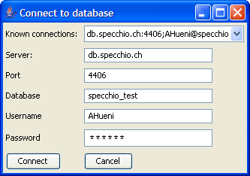

Figure 98: Connecting to the specchio\_test database

### Creating Campaigns on the Test Database

%%% What conventions are going to be used in the UOW database? Should they be documented here? Will they be the same as Andy’s database conventions? Elaine

In order to keep things organised, always include your name in the campaign name by using the following template: <your name>\_<campaign name>, e.g. Andy\_veg\_example. This will make it easier to find your campaigns in the Query Builder where you can see all campaigns of the other users as well (Note that the Query Browser includes a switch that will show only your own data).

### Downloading Test Data Sets

%%% Do we want Users to download from here? Elaine

The data sets used in this tutorial are available on the internet: <http://specchio.ch/tutorial_data.php>.

The following data sets are provided as ZIP archives:

* vegetation\_example.zip
* ger\_example.zip
* gonio\_example.zip

To download the ZIP files click on the links and select ‘Save to Disk’ in the web browser dialog (see Figure 99).

Unzip the ZIP files to some working directory on your machine, e.g. create a new folder called ‘SPECCHIO\_data’ and unzip all datasets into this directory.

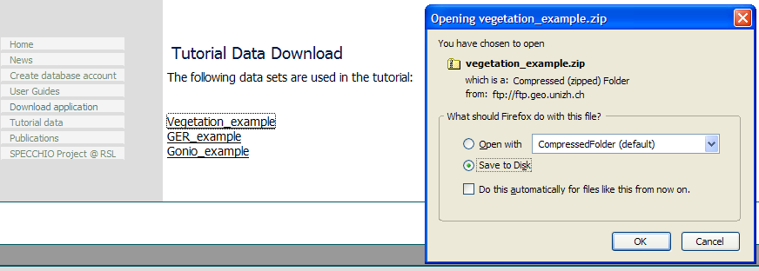

Figure 99: Tutorial data download page

## Part 1: Loading, Editing and Retrieving Data

Data set: Vegetation\_example

### Examine the Folder and File Structure

Relevant sections: **Error! Reference source not found.**, **Error! Reference source not found.**

Open a filing system window and browse the directory structure of the ‘Vegetation\_example’ folder.

It contains three species folders: Blackfern, Cabbage tree and Lemonwood. Open each of these species folders and examine the contents of the site directories contained in them. Blackfern has only one sample site while Lemonwood and Cabbage tree have three resp. two. Also browse inside the site directories to find the ASD binary files (cf. Figure 100).



Figure 100: Folder and file structure of the Vegetation\_example campaign

### Creating a new Campaign and Loading the Spectra

Relevant sections: 6.5, 1.1

Create a new campaign by selecting ‘Data Input ‘->‘Create new campaign’. In the new dialog, enter <your name>\_veg\_example as campaign name, e.g. ahueni\_veg\_example. Set the Main directory to the Vegetation example folder (cf. Figure 101).

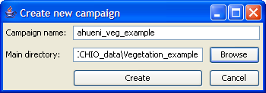

Figure 101: Creation of a new campaign for the vegetation example

Press the create button and a message box should pop up informing about the successful creation of the campaign (cf. Figure 102).

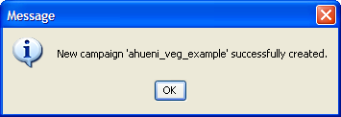

Figure 102: Message box informing on successful campaign creation

Once the campaign has been created load the spectral data of your campaign by selecting ‘Data Input’->’Load campaign data’ and selecting the campaign you just created (cf. Figure 103).

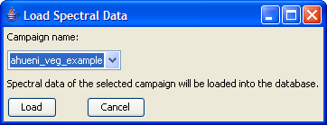

Figure 103: Loading spectral data into a campaign

A message box pops up when the campaign has been loaded (cf. Figure 104). A total of 64 spectral files should now have been loaded into the database.

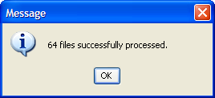

Figure 104: Message box showing the number of processed files during campaign loading

### Get to Know Your Data

Relevant section:

Your data are now ready to be visualised and exported. Open the Query Builder by selecting ‘Data Processing & Output’->’Build query’. In the Spectral Data Browser (the tree like display on the left side of the dialog) select your campaign (tick the box ‘Show only my data’ to restrict the displayed campaigns to your own) and explore the structure. Note that the database has stored the hierarchical structure of the campaign folder and displays it accordingly (cf. ). Also note that as you click around the tree (selecting folders or files) the SQL query and the number of resulting rows on the right side are updated simultaneously. You can also use Ctrl and Shift keys to do multiple selections.

Now select the first 6 spectra of the Blackfern, site1, (the number of resulting rows should be 6) and click on ‘Show report’. A new window will appear looking similar to . Note that a scrollable list containing the metadata is associated with every spectrum. Have a look at the metadata and note the data filled in automatically: filename, capture date, spatial position, measurement unit, sensor name, number of spectral channels, instrument name, owner and serial number.

The strong noise in the water bands is due to the generally high humidity found in New Zealand (maritime climate coupled with high yearly rainfall (up to 10 metres in Fjordland)).

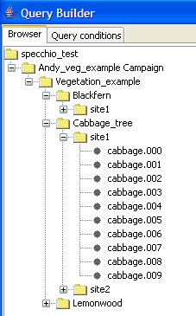

Figure 105: Vegetation example campaign shown in the Spectral Data Browser of the Query Builder

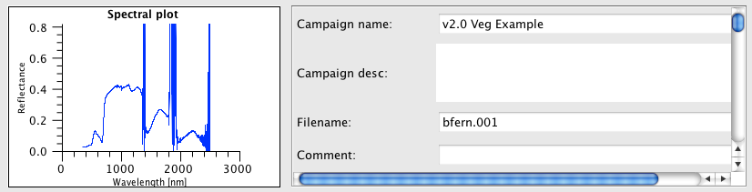

Figure 106: Part of the report on Blackfern spectra

### Exporting Data to CSV

Relevant sections: ,

Select File Export in the Query Builder (first select some data as described in ). Specify CSV as file format, an output directory (use the Browse button to select a directory) and a base filename and then press ‘OK’ (cf. ) (see also ).

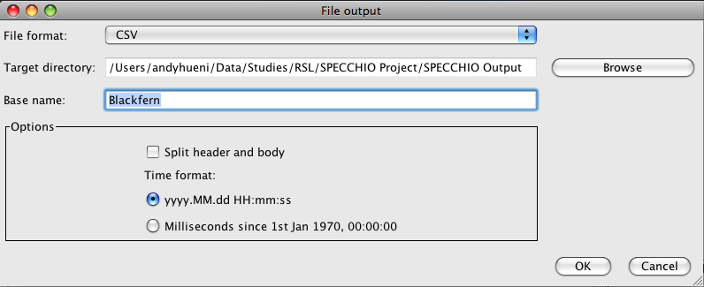

Figure 107: File export dialog

A message box will appear once the export is finished.

Use your file system browser to have a look at the output file that has been written into the output directory you specified (cf. ). The file name is partly auto-generated and includes the following parts:

* blackfern: the base name you specified
* INR\_ASD: name of the instrument used to sample the data
* ASD FS FR-3: the sensor type

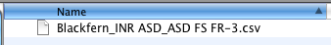

Figure 108: Exported CSV file

CSV files can be conveniently loaded into spreadsheet and statistics applications. Alternatively you can view them in a text editor.

CSV files can be split into header and body, where the header contains all metadata and the body consists of the channel and spectral information.

shows a spectral plot of the first six Blackfern spectra in Microsoft Excel. The first column contains the central wavelength of the bands in nanometres.

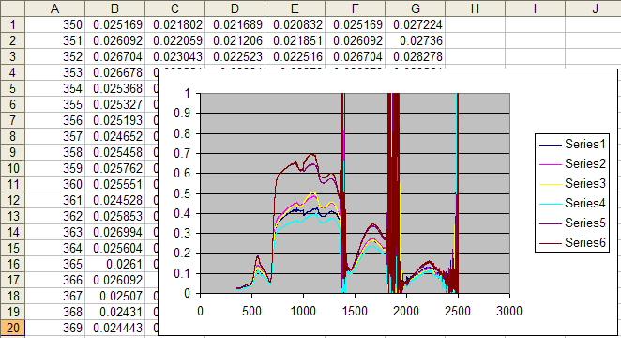

Figure 109: Example of a spectral (XY) plot in Microsoft Excel

### Exporting Data to ENVI Spectral Libraries

Relevant sections: ,

Note This exercise assumes that you have access to ENVI. If this is not the case you may skip it.

As a first step repeat the process of file exporting as described for CSV Files in 13.2.4 but change the file format to ENVI SLB.

To open SLB files in ENVI, start ENVI and select ‘Spectral’->’Spectral Libraries’->Spectral Library Viewer’. Specify an input file by selecting the .slb file (cf. Figure 110).

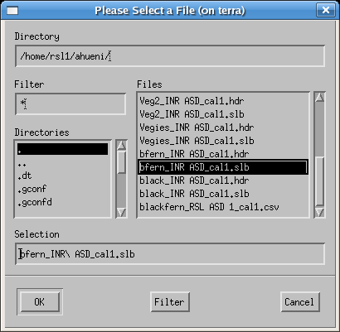

Figure 110: Selecting an slb file to load as spectral library

The spectra names can then be displayed in the Spectral Library viewer (cf. ) and plotted as Spectral Library Plots. Note that the maximum range of the Y axis must be set to 1 manually as otherwise only noise will be visible (cf. ).

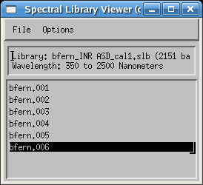

Figure 111: Spectra listed in the Spectral Library Viewer

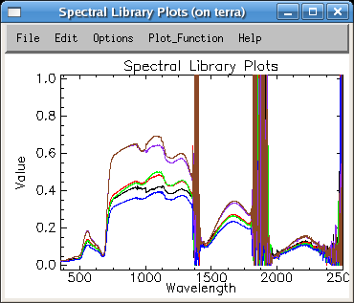

Figure 112: Blackfern spectra as Spectral Library Plots

### Editing Metadata

Relevant section:

Open the metadata editor by selecting ‘Data Input’->’Edit metadata’ from the main menu and select your campaign. Note that in the ‘Campaign Data’ tab your name is automatically listed as Investigator.

Enter some description into the description text field, e.g. ‘Just a test’. Note that as soon as you change some data in the metadata editor the relevant ‘Update’ button (in this case the button in the campaign data section) gets activated (cf. ).

Perform the update by clicking on the update button. This stores your changes in the database. The update is done when the ‘Update’ button reverts to being grey and inactive.

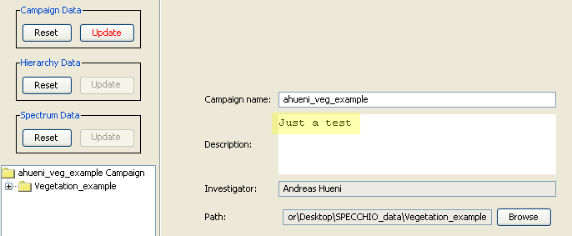

Figure 113: Editing the description of a campaign

Switch to the ‘Spectrum Data’ tab and select the ‘Blackfern’ folder in the Spectral Data Browser (cf. Figure 114).

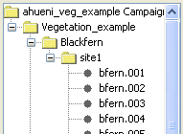

Figure 114: Selecting 'Blackfern' in the Spectral Data Browser of the Metadata Editor

By selecting multiple spectra (e.g. by selecting a folder or several single spectra) you automatically enter the so called ‘group update modus’. All data that you enter will apply to all the selected spectra. Note that some fields are not editable but greyed and inactive. These fields contain already individual spectrum metadata and are therefore disabled.

As all the spectra under the Blackfern hierarchy are of the same plant species and entering the plant names can be done for all spectra with a single operation. To enter a new name, click ‘Add’ in the ‘Names’ section. First type the common name ‘Blackfern’, then specify the type as ‘Common’ from the list (cf. ). In a similar manner enter the Latin name: ‘Cyathea medullaris’.

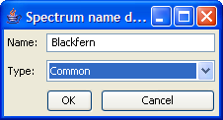

Figure 115: Entering a common name

The names now appear as shown in Figure 116. Note that the ‘Update’ button of the ‘Spectrum Data’ section has been activated. Perform now the update on the database by clicking the ‘Update’ button.

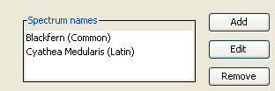

Figure 116: Spectrum names

All three species (Blackfern, Cabbage Tree and Lemonwood) are typical for New Zealand forests. They all share a common landcover type. To set the landcover for all spectra, first select the top folder called ‘Vegetation\_example’.

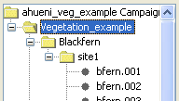

Figure 117: Selecting the top folder 'Vegetation\_example'

Now select the landcover type ‘Deciduous Forest’ in the CORINE landcover tree (cf. ). Press ‘Update’ to apply the selected landcover type to all spectra of this campaign.

You can now check the fact that indeed all spectra have this landcover type set by selecting single spectra in the Spectral Data Browser.

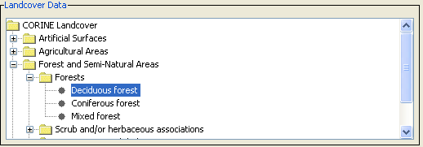

Figure 118: Specification of the landcover

Pictures taken at the sampling sites can be entered into the spectral database. Pictures for Blackfern and Lemonwood are provided in the vegetation\_example.zip file. You will find the pictures alongside with the Vegetation\_example folder in the directory where you un-zipping the data.

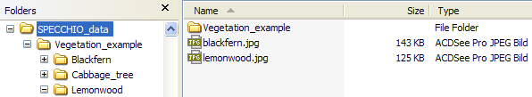

Figure 119: Location of the species pictures

To apply the Blackfern picture to all Blackfern spectra select the Blackfern hierarchy in the Spectral Data Browser. Click ‘Add’ in the Pictures section, browse to the Tutorial folder and select blackfern.jpg. To enter a caption, simply type it into the editable field below the picture (cf. Figure 120). Then update the database.

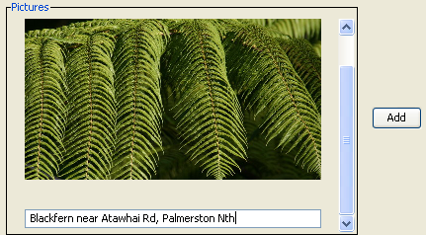

Figure 120: Example of a picture with a caption

In a similar manner insert the supplied lemonwood.jpg picture for all Lemonwood spectra.

Note that performing group updates not only speeds up the input process but also minimizes the amount of data stored in the database. All spectra in the selected group are referencing a single entry in the database, thus avoiding data redundancy.

A general problem of spectral data collections is the quality and trustability of the data. This is especially true if the data were collected by third parties and the sampling conditions are unknown. One way to improve the usability and shareability of spectral data is to include more metadata. SPECCHIO addresses this by the means of metadata quality levels (cf. **Error! Reference source not found.**).

In the Metadata Editor activate the checkboxes ‘Highlight mandatory fields’ and ‘Show quality compliance in tree’. Select the bfern.001 spectrum in the Spectral Data Browser and set the required quality level of this spectrum to B (cf. ).



Figure 121: Required quality level set to B

All required field should now be highlighted. Update the spectrum on the database. If the quality compliance is not shown in the tree, have it displayed properly by selecting your campaign explicitly again in the ‘Campaign Selection’ of the Metadata Editor (cf. **Error! Reference source not found.**). All non-complying spectra plus the containing hierarchies are marked with an asterisk (cf. Figure 122).

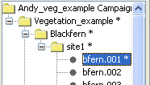

Figure 122: Non quality compliance indicated by asterisks

Fill in the missing metadata for the bfern.001 spectrum:

* Cloud cover: 1 okta or less, but not zero
* Beam geometry: Hemispherical-conical (CASE 8)
* Sampling Environment: Field
* Target Homogeneity: homogenous
* Sensor zenith: 0
* Sensor azimuth: 180 (this is equivalent to the principal plane opposite the sun)
* Sensor distance: 1
* Illumination zenith: 40
* Illumination azimuth: 0 (In the Southern hemisphere the sun stands in the North at midday)
* Target type: Add a new target type by clicking the ‘Add’ button, then specify the target type as ‘Tree’ and set it’s abundance = 100   
    
  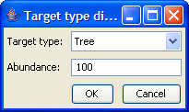

After updating the spectrum in the database, the non-compliance indicators in the spectral data browser should be removed.

## Part 2: GER Files

Data set: GER\_example

Relevant sections: , , , ,

The GER files are contained in the GER\_example folder. Explore the folder. You will notice that there are 10 files as created by the GER instrument. Create a new campaign to hold GER files (cf. ).

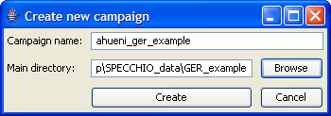

Figure 123: Creation of a GER example campaign

After creating the campaign load the spectral data into the database by selecting ‘Data Input’->’Load campaign data’ and selecting the campaign you just created (cf. Figure 124).

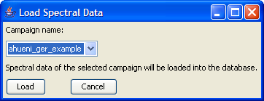

Figure 124: Loading spectral data into the GER campaign

Open the Query Builder. Open the tree of the GER campaign and study the contents. The files have been automatically split into target and reference spectra (cf. Figure 125). Remember that GER instruments write the sampled radiances of target and white reference into the same file. The names of the corresponding targets and references are identical, e.g. target GR083005.080 is associated with reference GR083005.080.

|  |  |
| --- | --- |
|  |  |

Figure 125: GER files split into target and reference spectra (left) and report showing target and reference spectra (right)

Targets and references are linked internally by a datalink on spectrum level (cf. 4.7). Open the Metadata Editor and display the spectrum data for one of the GER target spectra. Note that a link referring to the reference spectrum of the type Spectralon has been created (cf. Figure 126).

These datalinks are used during radiance to reflectance conversion.

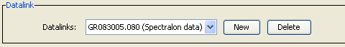

Figure 126: Automatically created link between target and reference spectra

## Part 3: Directional Data

Data set: Gonio\_example

Relevant sections: , ,

This exercise uses FIGOS goniometer data. FIGOS is used at RSL to acquire spectrodirectional measurements in 66 points arranged on a hemisphere. For more information please refer to Schopfer et al. (2007).

Goniometer data is provided in the Gonio\_example folder. It contains two subfolders: one holding the targets and one the references. The spectra of targets and references have been manually moved to these folders. This separation should be carried out before the data is loaded into SPECCHIO (alternatively all data can be loaded and the unwanted spectra removed using the Data Remover tool). It must also be noted that any surplus measurements must also be removed, i.e. the system expects 66 directional measurements maximum. SPECCHIO can however deal with gaps in the data as will be demonstrated hereafter.

Create a new campaign for goniometer data and load the campaign data.

If you explore the data in the Metadata Editor, you will find that the Measurement unit has been set to Radiance and the FOV to 3 degrees. Use a group update to set the Beam geometry of all spectra of this campaign to ‘Hemispherical-conical (CASE 8)’.

In the Metadata Editor select the special function ‘Link targets to references’ (cf. **Error! Reference source not found.**). In the ‘Link Target to Reference’ dialog select the target and reference directories of the goniometer campaign as inputs (cf. ) and press ‘Link’. The datalinks have now been created.

In the Metadata Editor explore the datalink settings (cf. ). You should find that the targets triticaa.001 and triticaa.002 are referencing the triticaa.000 white reference spectrum. Targets triticaa.003 – triticaa.009 reference triticaa.006 and so on and so forth. The linking mechanism is based on the spectrum capture time and does not depend on the spectrum file name.

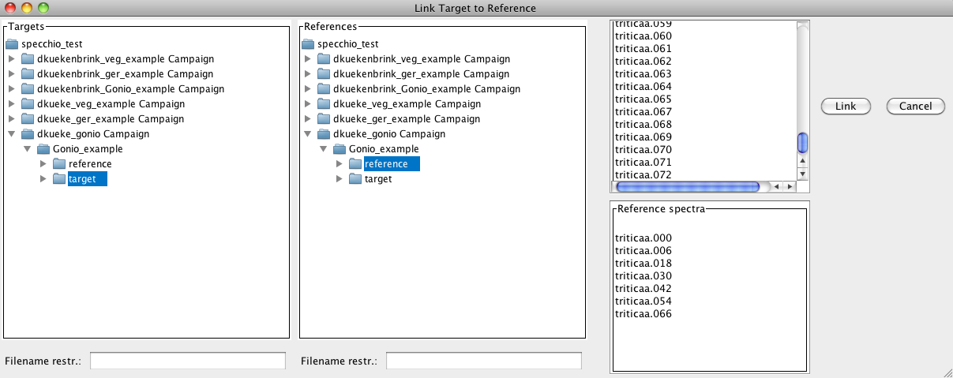

Figure 127: Specifying target and reference directories

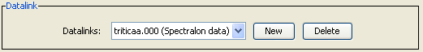

Figure 128: Example of an automatic created datalink

The illumination geometry (i.e. the sun zenith angle and azimuth) can be calculated automatically if the spatial position (latitude and longitude) and the capture time in UTC are known.

For the given dataset we assume that the time is local time and not UTC. This can be corrected by the special function ‘Correct local time to UTC’ (cf. ). In the time correction dialog select the Gonio\_example folder because the time shift should be applied to both target and reference spectra. The time difference to GMT is 2 hrs (East) as the sampling took place during summer in Switzerland, i.e. daylight saving applies (cf. ).

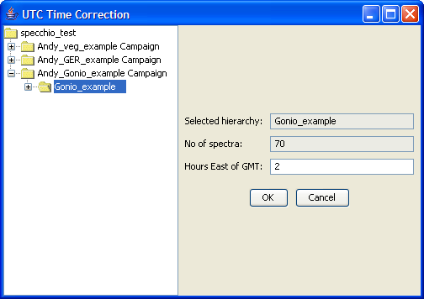

Figure 129: Applying a time shift to goniometer data

As a next step the coordinates of the sampling area must be defined. A position of N47° 22.400’ E08° 32.438’ is assumed. Positions must be entered as floating point degrees (GARMIN hddd.ddddd° format). This yields: N47.37333° E08.54063°.

In the Metadata Editor select the Gonio\_example hierarchy in the Spectral Data Browser. As the position applies to all spectra of the campaign a group update should be carried out. Now enter the latitude (47.37333) and longitude (-8.54063). Longitudes East of Greenwich are negative.

Having entered position and time (do not forget to press the ‘Update’ button), the calculation of the illumination geometry can be carried out by clicking the ‘Calc Sun Angles’ button (cf. ).

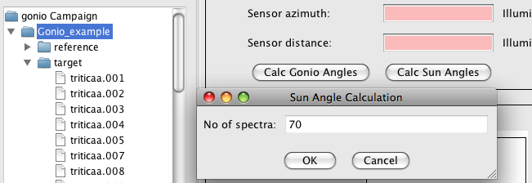

Figure 130: Sun angle calculation for goniometer data

Use the Spectral Browser of the Metadata Editor to check the sun angles that have been calculated. Every spectrum has been assigned slightly differing sun angles according to the individual capturing time.

The angles of the goniometer can be calculated for each spectrum using the ‘Calc Gonio Angles’ function (cf. ). Select the target hierarchy and click the ‘Calc Gonio Angles’ button. On the left side of the dialog the number of spectra in the selected hierarchy is displayed (63 spectra). There are three spectra missing from the normal total of 66. If you study the names of the target spectra it seems that the missing spectra numbers are: 55, 56 and 57. Specify the gaps as 55,56,57 and press ‘Insert gaps’. The total number of positions is shown in the field ‘Spectra + dummies’, i.e. 66 in this case. Press ‘Calculate’. The list above the ‘Calculate’ button now contains the positions (starting at zero), the calculated angles and the spectrum filenames. Scroll down till you find the inserted dummies called ‘gap dummy’ (cf. ).

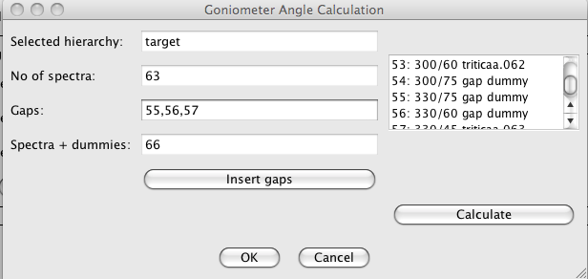

Figure 131: Inserted gaps and resulting angles

At this point you would have to refer to your field protocol in order to confirm that the gaps you specified did occur at the calculated angles. Let us assume that number 57 actually exists but number 60 is missing. Change the gap specification to: 55,56,60. Press ‘Insert gaps’ and ‘Calculate’ and check the list again. Once you are satisfied with the calculated angles press ‘Ok’ to store the angles in the database. Use the Metadata Editor to check that the angles have indeed been saved and are now correctly displayed.

E.g. for the spectrum triticaa.040 you should find a sensor zenith of 30° and azimuth = 270° (cf. Figure 132).

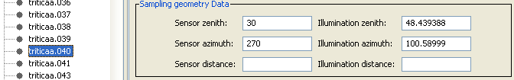

Figure 132: Calculated sensor zenith and azimuth angles

## Part 4: Data Querying, Processing and Exploration

### Converting Radiances to Reflectances

Data set: GER\_example

The GER example data set contains reference and target measurements that have been linked automatically during data load. Our goal is the conversion of target radiances to reflectances using the respective function of the Space Network Processor.

Open the Query Builder, browse to your GER example, select the targets hierarchy () and press the ‘Process’ button.

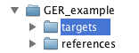

Figure 133: Selection of the target hierarchy of the GER example data set

A Space Network Processor window will open, containing a space holding the ten target spectra (Figure 134). The dimensionality of the space is 647, which is equal to the number of bands of the GER instrument.

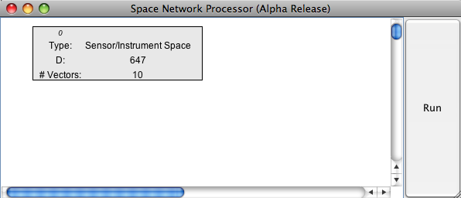

Figure 134: Space Network Processor window with space containing the target spectra

Add ‘Radiance to Reflectance Transformation’ as a new processing module to the processing plane by clicking the menu button over the processing plane and selecting the module.

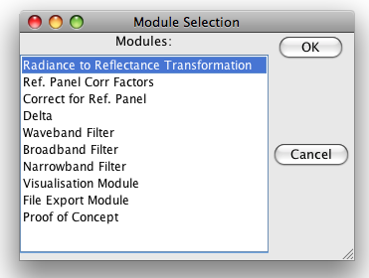

Figure 135: Selection of the ‘Radiance to Reflectance Transformation’ module

Connect the new module with the input space (space 0) by clicking the menu button over the module and selecting ‘Set Input Spaces’ in the module menu (Figure 136) and choosing space number 0 as input space (Figure 137).

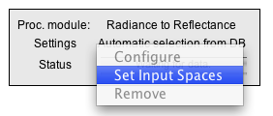

Figure 136: Module menu

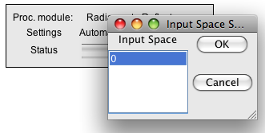

Figure 137: Input space selection for the ‘Radiance to Reflectance Transformation’ module

A new space is added to the processing plane automatically, containing to output of the ‘Radiance to Reflectance Transformation’ module (Figure 138).

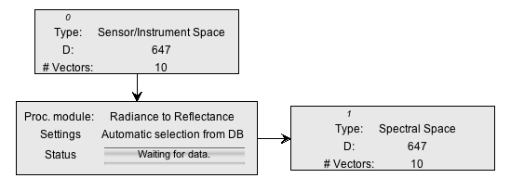

Figure 138: Input and output spaces of the ‘Radiance to Reflectance Transformation’ module

Now, we would like to see what this transformation is actually doing by plotting the input and output spectra.

Add two new modules of the type ‘Visualisation Module’ to the processing plane, configure them as ‘Spectral Line Plot’ and connect them with the input space (space 0) and the output space (space 1) respectively. Your Space Processing Network should now be similar to the one shown in .

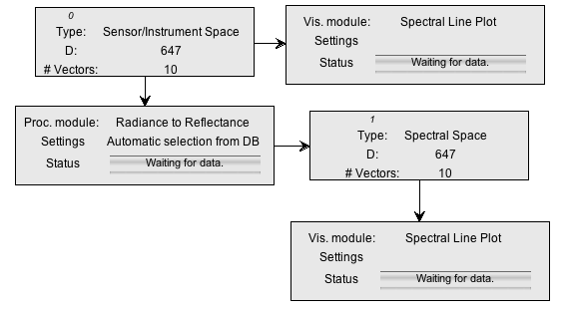

Figure 139: Space Processing Network for radiance to reflectance transformation and visualisation

Press the ‘Run’ button of the Space Network Processor and two spectral plots should appear (Figure 140).

|  |  |
| --- | --- |
|  |  |

Figure 140: Spectral plots of radiance and calculated reflectance

The calculated reflectances show the typical features of a vegetation spectrum (green peak, red edge, water absorption features). The high reflectance in the UV-Blue of the first few bands is an artefact of the instrument and indicates an unreliable calibration of the according channels.

### Data Queries

Data set: all campaigns loaded to the database.

If you worked through the whole tutorial a total of three new campaigns should now be loaded to the database. Note that you have access to campaigns other persons entered in the database. Queries on the database can thus return more rows than you might expect!

Open the Query Builder and switch to the ‘Query conditions’ tab.

In the wildcard field of the Campaign name type in your first or last name followed by the percentage sign, e.g. ‘hueni%’. Alternatively, select your name from the investigators list.

The number of resulting rows should be 154 (if all 3 tutorial data sets were loaded).

Select ‘Hemispherical-conical (CASE 8)’ as beam geometry The number of rows should drop to 70 and the autobuilt SQL statement looks similar to:

SELECT distinct count(\*) FROM spectrum, campaign WHERE campaign.user\_id = '6' AND spectrum.date >= 20050531105830 AND spectrum.date <= 20120224110223 AND spectrum.measurement\_type\_id = '2' AND spectrum.campaign\_id = campaign.campaign\_id

As a matter of fact, the spectra selected by this query all belong to the goniometer campaign that you created in this tutorial. The same result set is returned when the goniometer campaign is selected implicitly.

The result set can be further restricted by e.g. sampling geometry conditions. Narrow the search for spectra with zenith angles between 0º and 30º by entering a sensor zenith angle of 15 and a buffer size of 15 and sensor azimuth of 90 with buffer size 90 (cf. Figure 141).

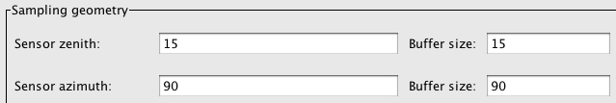

Figure 141: Specifying a sensor zenith/azimuth angles and buffer values

The resulting SQL statement should look like:

SELECT distinct count(\*) FROM spectrum, campaign, sampling\_geometry WHERE campaign.user\_id = '6' AND spectrum.date >= 20050531105830 AND spectrum.date <= 20120224110223 AND (sampling\_geometry.sensor\_zenith >= 0.0 AND sampling\_geometry.sensor\_zenith <= 30.0) AND (sampling\_geometry.sensor\_azimuth >= 0.0 AND sampling\_geometry.sensor\_azimuth <= 180.0) AND spectrum.measurement\_type\_id = '2' AND spectrum.campaign\_id = campaign.campaign\_id AND spectrum.sampling\_geometry\_id = sampling\_geometry.sampling\_geometry\_id

The number of resulting rows should be 17.

Press the ‘Process’ button in the Query Builder to load the selected data into the Space Network Processor. Add a new Visualisation Module, configure it as ‘Gonio Hemisphere Explorer’ and connect it with the input space (Figure 142).

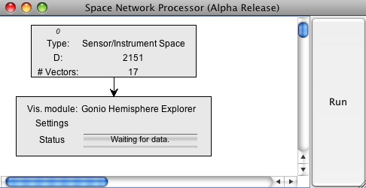

Figure 142: Gonio Hemisphere Explorer connected to the input space

Press the ‘Run’ button of the Space Network Processor. A Gonio Hemisphere Explorer window will open (Figure 143).

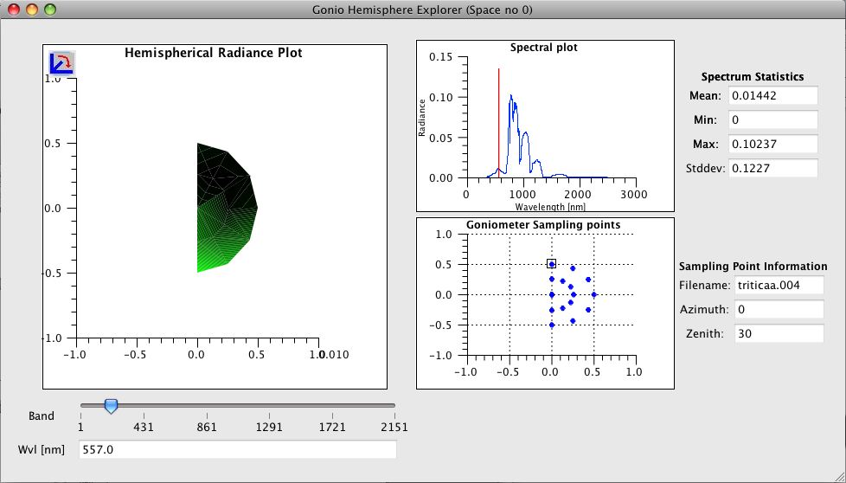

Figure 143: Gonio Hemisphere Explorer showing the data points selected in the Query Browser

Note that according to the selection in the Query Browser, only a limited number of points are displayed. The Gonio Hemisphere Explorer can handle any number of spectrodirectional data points and could thus be used on data stemming from different goniometer systems as well.

The data comprises spectrodirectional measurements of a wheat field (triticale). The hemispherical plot nicely illustrates the backward scattering of vegetation canopies (highest radiances are observed in the principal plane). The illumination source is at azimuth position 180° in the shown plot.

# References

Astronomical Applications Department of the U.S. Naval Observatory, 2003. *Universal Time.* [Online]   
Available at: http://aa.usno.navy.mil/faq/docs/UT.php  
[Accessed 1 May 2013].

Australian Research Council, 2008. *Australian and New Zealand Standard Research Classification (ANZSRC).* [Online]   
Available at: http://www.abs.gov.au/ausstats/abs@.nsf/mf/1297.0  
[Accessed May 2013].

Hueni, A., 2006. *Field Spectroradiometer Data: Acquisition, Organisation, Processing and Analysis on the Example of New Zealand Native Plants,* Palmerston North, Massey University: Institute of Natural Resources.

Hüni, A. & Kneubühler, M., 2007. *SPECCHIO: A System for Storing and Sharing Spectroradiometer Data.* [Online]   
Available at: http://spie.org/x18220.xml  
[Accessed 2007].

Hueni, A. & Kneubuehler, M., 2009. *SPECCHIO: A Free Spectral Data Management and Processing System.* San Diego, CA, s.n.

Hueni, A., Kneubuehler, M., Nieke, J. & Itten, K., 2009. *Processing Extension for the Spectral Database SPECCHIO.* Tel Aviv, Israel, s.n.

Hueni, A., Kneubuehler, M. & Schaepman, M., 2010. *International Geoscience and Remote Sensing Symposium.* Hawaii, USA, s.n.

Hueni, A., Malthus, T., Kneubuehler, M. & Schaepman, M., 2011. Data Exchange Between Distributed Spectral Databases. *Computers & Geosciences 37,* pp. 861-873.

Hüni, A. et al., 2007. *2nd Generation of RSL's Spectrum Database "SPECCHIO".* Davos, Switzerland, s.n.

Hüni, A. et al., 2007. *Metadata of Spectral Data Collections.* Bruges, Belgium, s.n.

Hueni, A. et al., 2009. The Spectral Database SPECCHIO for Improved Long Term Ssability and Data Sharing. *Computers & Geosciences 35(3)*, pp. 557-565.

Hueni, A. et al., 2009. *Visualisation, Processing and Storage of Spectrodirectional Data Based on the Spectral Database SPECCHIO.* Cape Town, South Africa, s.n.

Hueni, A. et al., 2008. *Pre-processing of Dual-view FIGOS data: Towards Operational BRDF Retrieval.* Beijing, China, s.n.

Hueni, A. & Tuohy, M., 2006. Spectroradiometer Data Structuring, Pre-Processing and Analysis - An IT Based Approach. *Journal of Spatial Science 51(2),* pp. 93-102.

Landgrebe, D., 1997. *On Information Extraction Principles for Hyperspectral Data,* West Lafayette, IN: Purdue University.

Schaepman-Strub, G., Schaepman, M. & al., e., 2006. Reflectance Quantities in Optical Remote Sensing - Definitions and Case Studies. *Remote Sensing of Environment 103,* pp. 27-42.

Schopfer, J., 2008. *Spectrodirectional Ground-based Remote Sensing Using Dual-view Goniometry,* Zurich: Remote Sensing Laboratories.

Schopfer, J., Dangel, S. & al., e., 2007. *Dual Field-of-View Goniometer System FIGOS.* Davos, Switzerland, s.n.

# Document History

|  |  |  |  |
| --- | --- | --- | --- |
| **Version** | **Date** | **Author** | **Remark** |
| 0.1 | 15.12.2006 | A. Hueni | First document version |
| 1.0 | 14.02.2007 | A. Hueni | Bug fixes and added features |
| 1.1 | 18.10.2007 | A. Hueni | Added txt file reader, multi-user capabilities, db\_config.txt file, Admin functions. |
| 1.2 | 29.05.2008 | A. Hueni | Added spectral plot, campaign export, metadata editor ehnacements. |
| 1.3 | 15.06.2008 | A. Hueni | Added campaign import function. |
| 2.0 | 12.03.2009 | A. Hueni | Major update: Added reference panel handling, processing extension, Instrument and reference panel tools. Updated export/import. |
| 2.1 | 02.09.2010 | A. Hueni | Added instrument settings, metadata enhancements, time selection, SVC-HR1024 instrument, instrument calibration, Apogee support. |
| 2.2.0 | 02.05.2012 | A. Hueni  D. Kuekenbrink | Added FGI HDF file support, generic metadata, target-reference link improvements, metadata editor enhancements, ASD binary file format, metadata date/time selection, beam geometries. |
| 2.2.1 |  | A. Hueni  D. Kuekenbrink | Upgrade direct irradiance calculation for MFR-7, query builder/hierarchy browser split, space processing improvements, mixed directory data loading, UniSpec file loader, SPECPR file loader. |
| 3.0 | %%% TBD | Peter Roberts (Intersect) | UOW/Intersect overhaul: Database now referenced via HTTP front end, ANDS Collection export, %%% |

1. Regular Expressions Tutorial

Regular expressions are widely used across the computer industry when string matching is required. They permit a rich array of sophisticated matching functionality.

A complete explanation of regular expressions is beyond the scope of this tutorial. Readers with a desire to see a complete list of all options should see the Java tutorial at <http://docs.oracle.com/javase/tutorial/essential/regex/index.html>.

The following is a quick summary of the most useful regular expression functions for SPECCHIO Users.

|  |  |  |  |
| --- | --- | --- | --- |
| Simple string |  | A simple string containing no special characters will match that string, regardless of where within the target string it occurs. | mpl will match the string example at the fourth character. |
| Start of string | ^ | The character ^ will match the beginning of the string. | ^exa will match example, but ^xa will not. |
| End of string | $ | The character $ will match the end of the string. | le$ will match example, but pl$ will not. |
| Any character | . | The period character will match any character. | a.c will match abc, aac, adc, a7c and a-c but it will not match ac or abbc. |
| Repeated character | \* | Asterisk causes the matching to zero or more repetitions of the preceding character. | ab\*c will match ac, abc, abbc or abbbc, but will not match a7c or ahc. It will match aac at the second character and acc at the first character, because there are zero characters between the a and c in those strings. |
| Repeated characters | + | The plus sign causes the matching to one or more repetitions of the previous character. | ab+c will match abc, abbc or abbbc but will not match ac. |
| Alternate characters | [ ] | Strings enclosed within square brackets will match any one of the characters within the brackets. | a[123]b will match a1b, a2b or a3b only. It will not match ab or any other substring. |
| Character ranges | [-] | Use – between [] to match one of range of characters. | [0-9] matches any digit.  [a-z] matches any letter.  [a-z0-9] matches any digit or letter. |
| Escape character | \ | In order to match a special character, precede it with the backslash character.  Special characters are [\^$.|?\*+(){}  Putting \ before other characters often has a special meaning, so should be avoided. | \\ will match \  \. will match .  \\* will match \*  \[ will match [ |
| Combinations |  | Any of the above search methods can be combined. | ^.c will match any string with c as its second character.  ^abc$ will match the string abc only. abcd or aabc will not be matched.  1[abcd]+2 will match any combination of the characters a, b, c or d which occurs between the digits 1 and 2.  [\[\]] will match either [ or ].  \.+ will match any run of periods.  [0-9]+ will match any integer number.  [0-9]+\.[0-9]\* will match any number with a decimal point. |

1. Predefined Manufacturer Table



1. Predefined Sensor Table

